
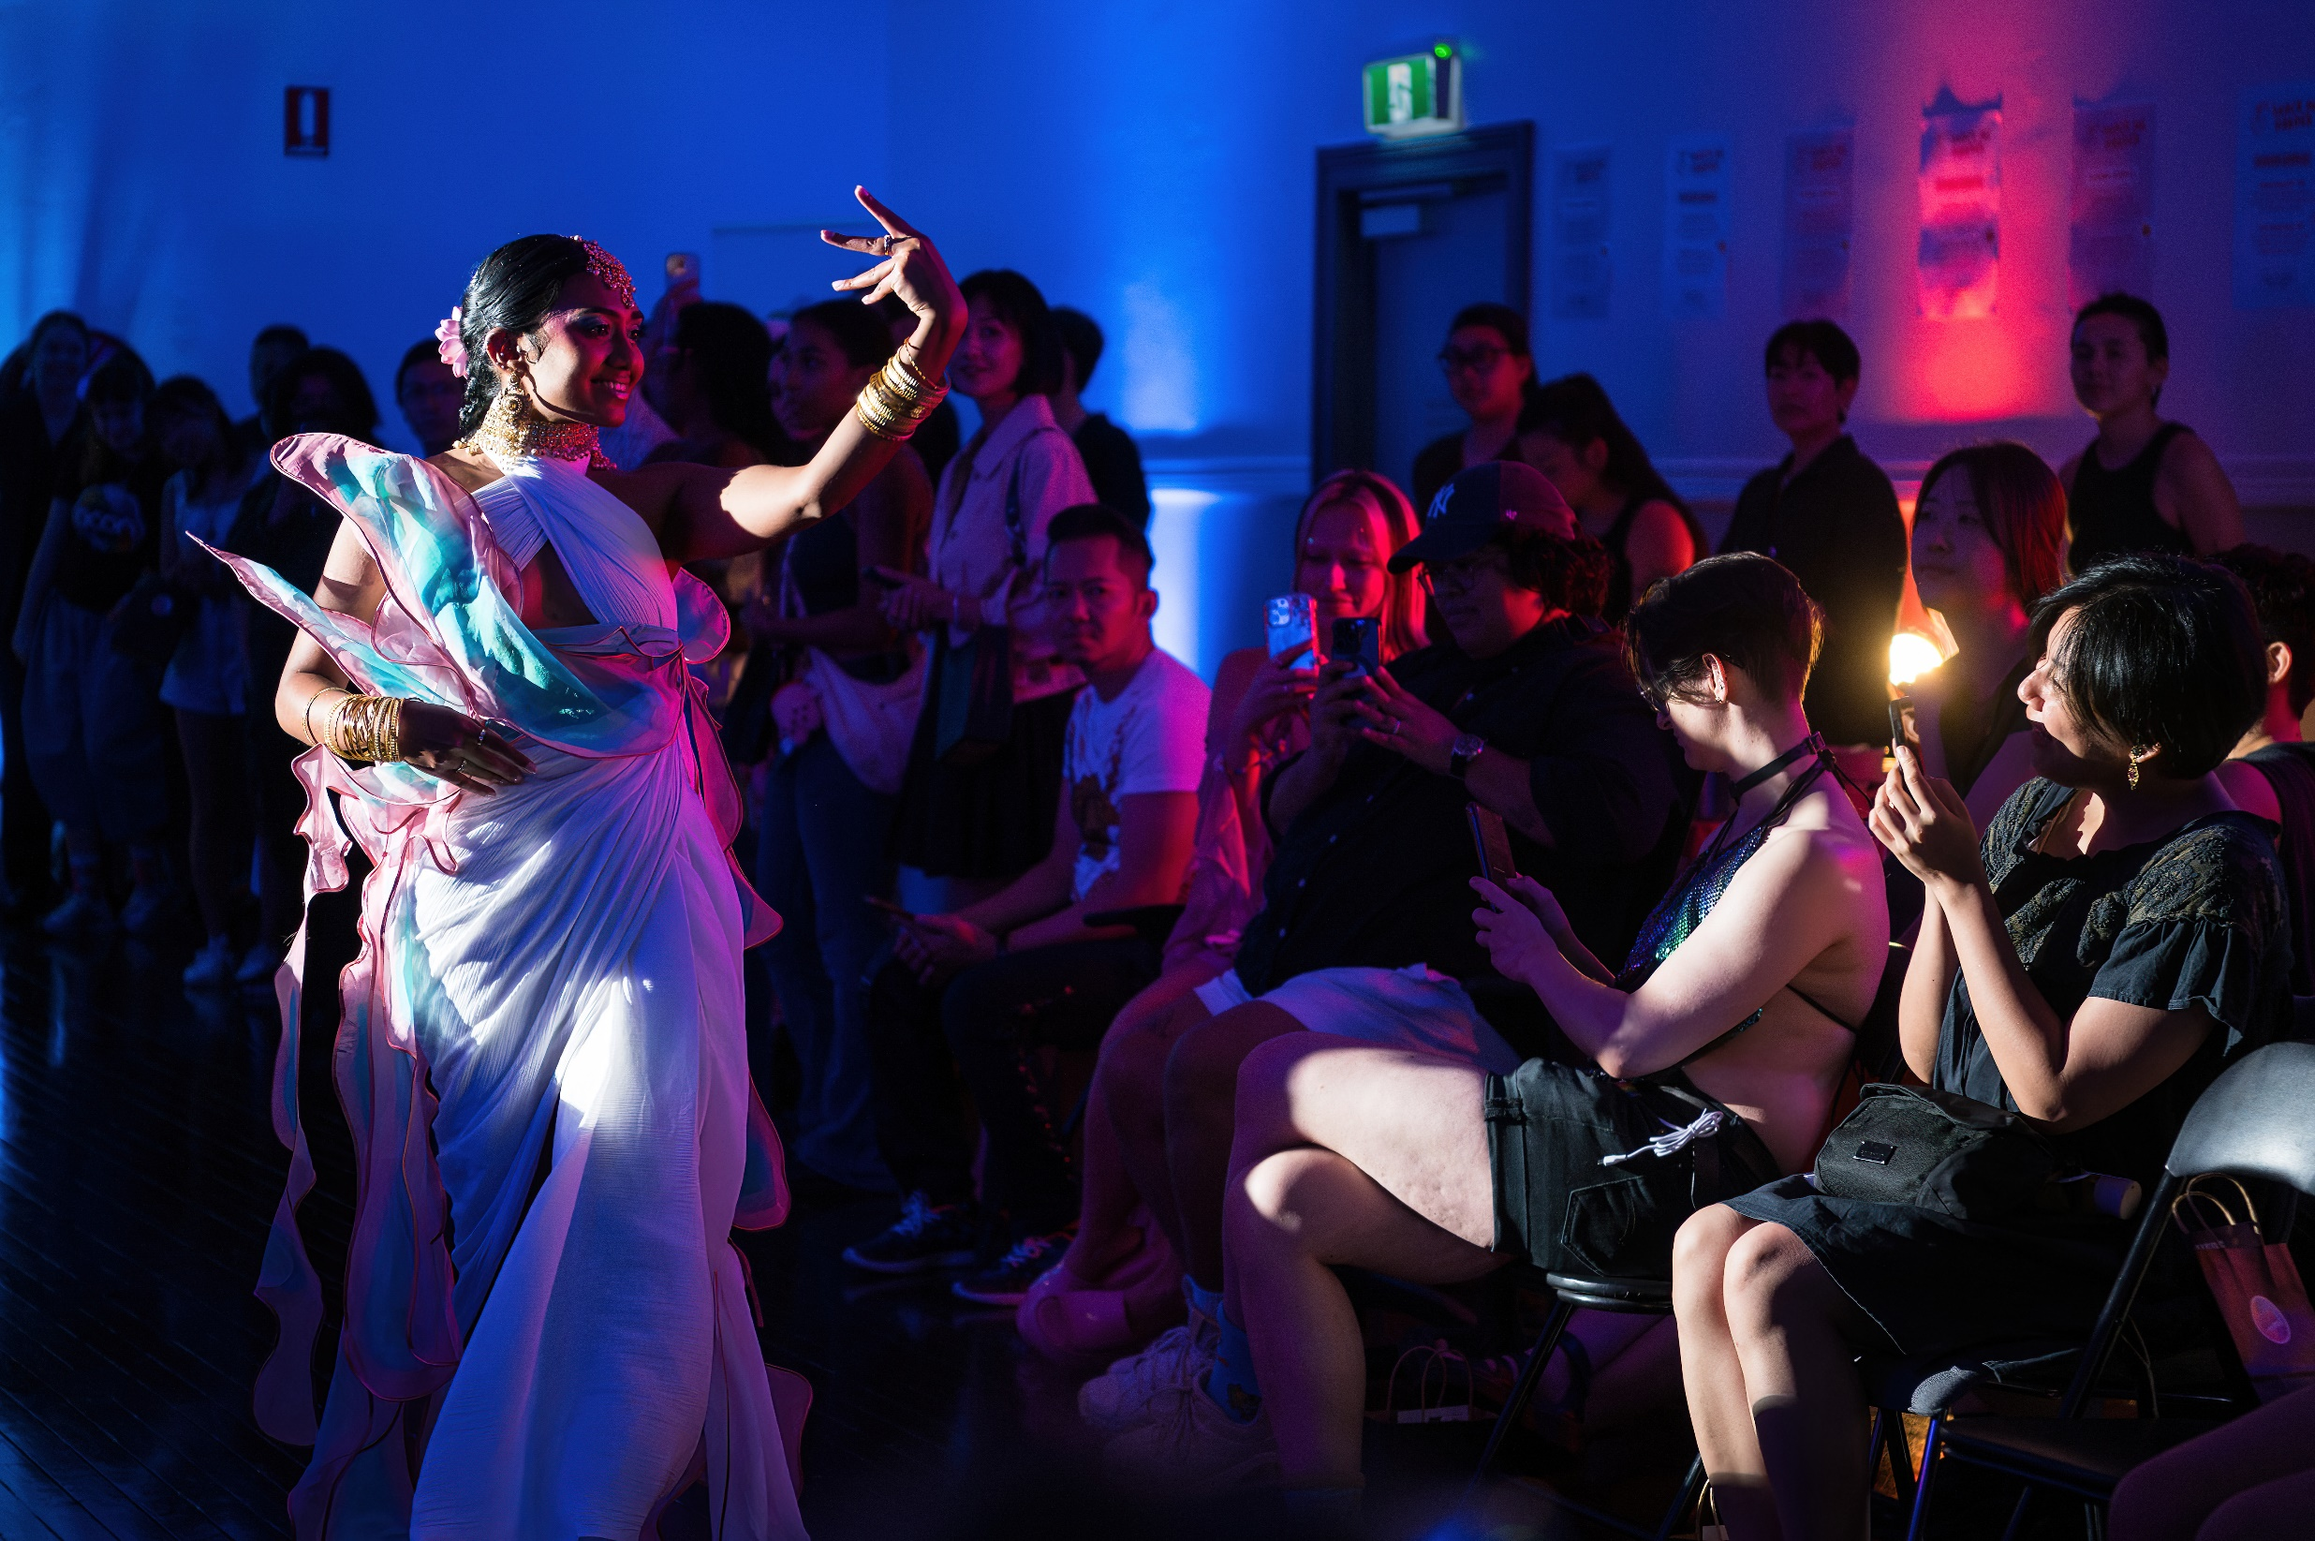
Worship B’day,
Workship Queer Collective,
photo by Rhiannon Hopley (detail) 2025
Cultural Connections EOI
OPEN: 7 July, 9am – 4 August, 3pm 2025

The Cultural Connections program provides funding to artists and community leaders from Aboriginal and Torres Strait Islander background, People of Colour and people who identify as culturally diverse for creative projects.
Arabic
.نحن نتكلم لغتك .للتحدث مع مترجم مجاني اتصل بالرقم 450 131 .اطلب منهم الاتصال بمجلس الغرب الداخلي على الرقم 5000 9392
Vietnamese
Chúng tôi nói ngôn ngữ của quý vị. Muốn nói chuyện có thông dịch viên miễn phí, hãy gọi số 131 450. Yêu
cầu họ gọi cho Hội đồng Thành phố Inner West qua số 9392 5000.

Nepali
हामी तपाईंको भाषा बोल्छौं। नि:शुल्क दोभाषेसँग कुरा गर्न 131 450 मा फोन गर्नुहोस्। उनीहरूलाई 9392 5000 मा इनर वेस्ट काउन्सिल (Inner West Council) लाई फोन गर्न लगाउनुहोस्।

Tamil
நாங்கள் உங்கள் மொழியில் பேசுகிறோம். எங்கள் மொழிபெயர்ப்பாளரிடம் இலவசமாக பேசுவதற்கு 131 450 என்ற எண்ணில் அழையுங்கள். அவர்களை இன்னர் வெஸ்ட் கவுன்சிலை 9392 5000 என்ற எண்ணில் அழைக்கச் சொல்லுங்கள்.

Hindi
हम आपकी भाषा में बात करते हैं. निःशुल्क दुभाषिया से बात करने के लिए 131450 पर कॉल करें। उन्हें इनर वेस्ट काउंसिल को 93925000 पर कॉल करने के लिए कहें।

Traditional Chinese
我们说普通话。如需免费传译服务，请致电131 450，然后请传译员致电9392 5000接通 Inner West市政府。

Simplified Chinese
我们说普通话。如需免费传译服务，请致电131 450，然后请传译员致电9392 5000接通 Inner West市政府。

Introduction
Located on the unceded land of the Gadigal-Wangal clans of the Sydney basin the Inner West is framed by the Parramatta and Goolay’yari (Cooks) rivers and is home to over 190,939 residents across five wards: Djarrawunang (Ashfield), Baludarri (Balmain), Gulgadya (Leichhardt), Midjuburi (Marrickville) and Damun (Stanmore).

The area continues to be home to many Aboriginal and Torres Strait Islander people and is the birthplace of the Aboriginal owned and run arts organisation, Boomalli Aboriginal Artists Cooperative. Council welcomes and embraces Aboriginal and Torres Strait Islander people’s experiences and perspectives. The Inner West has a strong history of welcoming cultural diversity with many established and emerging communities residing in the Inner West.

The Cultural Connections program provides opportunities to artists and community leaders from Aboriginal and Torres Strait Islander background, People of Colour and people who identify as culturally diverse. The program provides up to $8,000 in funding, along with one-on-one support to deliver a creative project.

In line with Council’s Gender Equity Strategy, proposals from women and gender diverse applicants are encouraged, as are proposals from people with disability. Council acknowledges the possible intersectionality between these groups. Funded groups will work with Council in a safe space to develop and deliver their projects. This unique program offers tailored support to successful applicants.

Aims /objectives
This program is an opportunity for community to collaborate with Council and to access resources to encourage:
- diverse representation in the arts
- cross-cultural understanding
- arts participation for children and young people with a cultural perspective
- recognition of cultural diversity as an asset and contributor to
innovative arts practice
- sharing stories about our local area and who we are.

This Expression of Interest (EOI) supports Council’s commitment to the Reconciliation Action Plan, Disability Inclusion Action Plan, and Cultural Plan (see Appendix). Applicants are invited to respond to issues identified in these plans.

Applications
Applicants can apply for up to $8,000 for proposed projects (the total available funding pool is $40,000). This expression of interest will be assessed by a panel of creatives and arts sector leaders who are Aboriginal and Torres Strait Islander, CALD or PoC, alongside Council staff.

What your application needs to show
Applications will be assessed against the following criteria:
• The individual or groups’ skills and experience to deliver the project (20%)
• How well your project meets two or more of the EOI aims (30%)
• The benefits of the project to community (30%)
• How practical and achievable the project is within the proposed budget (this
includes clear documentation of what you intend to spend the money on, with quotes for any items over $500) (20%).

Eligibility Criteria / Who can apply?
• Applicants must reside in the Inner West or be undertaking projects that
benefit the Inner West community
• Applicants do not need to identify as a creative, but projects must have a creative outcome
• Australian residents or permanent residents aged 18+
• Unincorporated groups or non-Australian residents must be auspiced by an incorporated not-for-profit (NFP) organisation
- Legally registered, incorporated Not-For-Profit organisations or groups
- If working with children, a valid Working with Children Check must be provided
• All applications must be submitted online through Smarty Grants
• Only one application per person/group is permitted
- Successful applicants will be required to enter a contract with Council and supply relevant insurances (Public Liability Insurance $20mil)
- The panel will consider the spread of new and returning applicants to the program each year.

Budget

The budget must show the need for the total money asked for. Budgets need to include all project income (money coming in from Council / other places) and expenditure (money going out). Please add any in-kind contributions (things you will do for free).

Council supports fair wages for creatives. Consider using peak body guidelines to set fees: NAVA Code of Practice, MEAA (film / entertainment) and ASA (writers and illustrators). If you do not have Public Liability Insurance, you can include the cost of purchasing this in your budget.

Any expected ticketing income must be included on the application budget area under “income” and generated income needs to be explained (what the income will be spent on). Council prefers to fund projects that are free or low cost for community. Costs associated with improving the accessibility of your project can be included in your budget.
Inner West Council offers free or subsidised access to venues through the Creative Town Halls program. If you wish to use a town hall venue, please apply for this here and attach confirmation to your Cultural Connections application.

Documentation

Successful applicants’ projects will be documented on Council’s website as a resource for others to engage with. A professional photographer will attend part of your project to document the outcome. See the Appendix at the end of this document for more information about this.

Support and Accessibility
Please get in touch to discuss any access needs you have about this Expression of Interest or your proposal. Council is committed to showcasing diverse voices from our community and welcome those who may need access regarding disability, language barriers and navigating grant application processes.

Successful applicants will be provided with tailored support, which may include:

- project planning
• navigating ticketing processes
• drafting risk plans
• marketing plans
• printing
• event support
• navigating Council processes
• rehearsal space/venue scouting
• proof reading.

Contact
For enquiries or to discuss your proposal please email:
Raffaela Cavadini – Creative Producer
raffaela.cavadini@innerwest.nsw.gov.au
Tel: 9335 2293

Useful Information / Appendix:

What types of projects will be funded?
Types of projects can include:

- workshops
• forums / panels
• audio recordings / podcast
• a series of works (written / visual)
• a photographic journal

• performance
• film
• animation
• illustrations
• presentations
- development work

Proposals with outcomes shared in English and other languages are encouraged, as well as in accessible formats.

Timeline
EOI round opens via smartygrants:  https://innerwest.smartygrants.com.au/CulturalConnections20252026 | 9am, Monday  7 July 2025
EOI round closes | 3pm, Monday  4 August 2025
Assessment Panel meet to review applications against eligibility  and assessment criteria | August 2025
Applicants notified of their proposal status | August / September 2025
Agreements signed and returned with invoices | September 2025
Invoices processed | September 2025
Projects delivered | October 2025 – June 2026
Projects acquitted (reported on) and documentation provided | June 2026
Projects documented on Council’s website | July/ August 2026

Documentation Requirements for Successful Applicants
The acquittal form (documentation you provide at the end of your project) must include:
• A showcase of the project that meets Council’s file size and quality standards (e.g. sound file, recording, illustration). If documentable through photography, Council will provide and fund a professional photographer for part of the project (i.e. one hour during your core programming)
• A short description of the project and outcome, plus artist names, social media links, and a high resolution promotional image.

This documentation will be shared on Council’s website and must be in a compatible format (e.g. YouTube video, mp3, pdf, jpeg). All costs related to documentation and sharing (except photography) must be covered in the application budget.

At completion of the project applicants will be asked to provide written information on the acquittal form - reporting on the project, including expenses, outcomes and feedback.

Other Requirements for Successful Applicants

- Before your project takes place you will be asked to complete a Risk Plan. A template as well as support will be provided to complete this task.
- You may be asked to participate in promoting your project on Council’s social media, this could be through film or photographs and voice recording.
- All applicants are required to attach Council’s “Supported by Logo” onto all marketing materials and send this to Council before distribution and promotion begins.
- Council is able to provide some printing of promotional posters or flyers (from Councils print room) – materials need to be in pdf format and provided 3 weeks before the project date.

Specific relationship to Council Plans and Strategies
Objectives of EOI | Cultural Strategy 2022-2025
- OB1: Representation of people from  Aboriginal and Torres Strait Islander, People  of Colour and culturally diverse  backgrounds in the arts / Inner West.  - OB4: Recognition of cultural diversity as an asset and contributor to innovative arts practice | 3.3.1 Evaluate and redesign Council events/  activations programming, using place-based community capacity building.  2.1.1 Support increased equity, diversity and representation in local cultural funding and programming.  3.1.4 Showcase local innovation and creative risk  taking in programming, including new technologies, young people and emerging artists.
- OB1: Representation of people from  Aboriginal and Torres Strait Islander,  People of Colour and culturally diverse backgrounds in the arts / Inner West | 1.2.3 Increase representation of Aboriginal artists in Council Grants and arts and cultural programming.  1.3.1 Create opportunities to connect to and  celebrate diverse Aboriginal arts and cultural  practice.  1.4.1 Demonstrate Aboriginal leadership and  curation in Council projects and programs.
- OB1: Representation of people from  Aboriginal and Torres Strait Islander,  People of Colour and culturally diverse backgrounds in the arts / Inner West.  - OB2: An increase in cross cultural understanding | 5.1.5 Facilitate discussions and incubate new ideas  on local and global issues through creative  programs and partnerships.
- OB2: An increase in cross cultural understanding  - OB5: Sharing stories about our local area and who we are  - OB4: Recognition of cultural diversity as an asset and contributor to innovative arts practice | 2.1.1 Support increased equity, diversity and representation in local cultural funding and programming.  2.1.3 Promote cultural programs and initiatives that  make everyone feel welcome, including through the Refugee Welcome Centre.  2.2.1. Share local cultures, heritage, identities and  stories to support greater understanding and connection, including people of all ages.
- OB3: Arts participation for children and  young people with a cultural perspective | 5.3.2. Increase opportunities for children and young people to engage in Council’s cultural programs.  3.1.4 Showcase local innovation and creative risk  taking in programming, including new technologies, young people and emerging artists

