
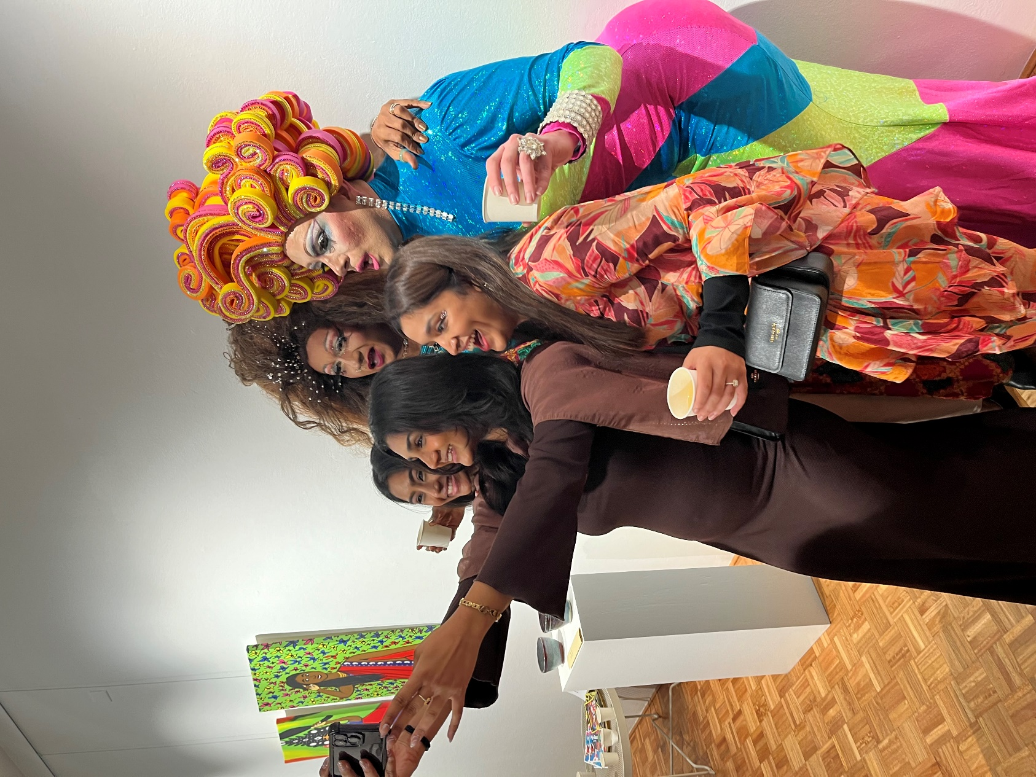

Cultural Connections EOI
OPEN: 8 July, 9am – 5 August, 3pm 2024

Satrang exhibition by Trikone Australia 2024

The Cultural Connections Expression of Interest provides funding to artists and community leaders from Aboriginal and Torres Strait Islander background, People of Colour and people who identify as culturally diverse for creative projects.
Arabic
.نحن نتكلم لغتك .للتحدث مع مترجم مجاني اتصل بالرقم 450 131 .اطلب منهم الاتصال بمجلس الغرب الداخلي على الرقم 5000 9392
Vietnamese
Chúng tôi nói ngôn ngữ của quý vị. Muốn nói chuyện có thông dịch viên miễn phí, hãy gọi số 131 450. Yêu cầu họ gọi cho Hội đồng Thành phố Inner West qua số 9392 5000.

Nepali
हामी तपाईंको भाषा बोल्छौं। नि:शुल्क दोभाषेसँग कुरा गर्न 131 450 मा फोन गर्नुहोस्। उनीहरूलाई 9392 5000 मा इनर वेस्ट काउन्सिल (Inner West Council) लाई फोन गर्न लगाउनुहोस्।

Tamil
நாங்கள் உங்கள் மொழியில் பேசுகிறோம். எங்கள் மொழிபெயர்ப்பாளரிடம் இலவசமாக பேசுவதற்கு 131 450 என்ற எண்ணில் அழையுங்கள். அவர்களை இன்னர் வெஸ்ட் கவுன்சிலை 9392 5000 என்ற எண்ணில் அழைக்கச் சொல்லுங்கள்.

Hindi
हम आपकी भाषा में बात करते हैं. निःशुल्क दुभाषिया से बात करने के लिए 131450 पर कॉल करें। उन्हें इनर वेस्ट काउंसिल को 93925000 पर कॉल करने के लिए कहें।

Traditional Chinese
我们说普通话。如需免费传译服务，请致电131 450，然后请传译员致电9392 5000接通 Inner West市政府。

Simplified Chinese
我们说普通话。如需免费传译服务，请致电131 450，然后请传译员致电9392 5000接通 Inner West市政府。

Introduction
Located on the unceded land of the Gadigal-Wangal clans of the Eora Nation the inner-west is framed by the Parramatta and Cooks rivers and is home to over 201,880 residents across five wards: Djarrawunang (Ashfield), Baludarri (Balmain), Gulgadya (Leichhardt), Midjuburi (Marrickville) and Damun (Stanmore).

The area continues to be home to many Aboriginal and Torres Strait Islander people and is the birthplace of the Aboriginal owned and run arts organisation, Boomalli Aboriginal Artists Cooperative. Council welcomes and embraces Aboriginal and Torres Strait Islander people’s experiences and perspectives. The Inner West has a strong history of welcoming cultural diversity with many established and emerging communities residing in the Inner West.

Artists from diverse backgrounds are invited to apply for funds for creative projects. People can apply for up to $8,000 to run a project between September 2024 – June 2025, projects can vary but must have a creative outcome, benefit the community and be delivered in the Inner West.

This Expression of Interest provides opportunities to artists and community leaders from Aboriginal and Torres Strait Islander background, People of Colour and people who identify as culturally diverse. In line with Council’s Gender Equity Strategy proposals from women and gender diverse applicants are encouraged, as are proposals from people with disability – Council acknowledges the possible intersectionality between these groups. Funded groups will work with Council in a safe space to develop and deliver their projects.

Aims /objectives
This EOI is an opportunity for community to collaborate with Council and to access resources to encourage:
- diverse representation in the arts
- an increase in cross cultural understanding
- engagement of children and young people in arts programming
with a cultural perspective
- recognition of cultural diversity as an asset and contributor to
innovative arts
- the development of the story about our local area and who we are.

This EOI supports Council’s commitment to the Reconciliation Action Plan, Disability Inclusion Action Plan, Cultural Strategy and Inner West Arts and Music Recovery Plan (see Appendix). Applicants are invited to respond to issues identified in these plans to assist Council in addressing these in creative and community driven approaches.

Applications
There is $40,000 available - applicants can apply for up to $8,000 for proposed projects. This expression of interest will be assessed by a panel of Aboriginal and Torres Strait Islander, CALD, PoC stakeholders from within the industry and Council staff – encouraging participation in democracy and decision making at a local government level.
All projects must have a creative / arts outcome and benefit community. Proposals with outcomes shared in English and other languages are encouraged as well as in accessible formats.

What your application needs to show
Applications will be assessed against the following criteria:
• The individual or team’s skills and experience to deliver the project (20%)
• How well your project meets the EOI aims (30%)
• The benefits of the project to community (30%)
• How practical and achievable the project is within the proposed budget (this
includes clear documentation of what you intend to spend the money on with quotes for any items over $500) (20%)

Eligibility Criteria / Who can apply?
• Applicants must reside in the Inner West or be undertaking projects that
benefit the Inner West community
• Applicants do not need to identify as an artist or creative, however the
proposal must have a creative outcome
• Australian residents or permanent residents aged 18+
• Unincorporated groups or non-Australian residents must be auspiced by an incorporated not-for-profit organisation
- Legally registered, incorporated not-for-profit organisations or groups
- If working with children a valid /current Working with Children Check (WWCC)
must be provided
• All applications must be submitted online through smartygrants
• Only one application per person/group is permitted
- Successful applicants will be required to enter a contract with Council and to supply relevant insurances or licenses (e.g. Public Liability Insurance)

Budget

The budget must show the need for the total money asked for, including all project income (money coming in from Council or other places) and expenditure (money going out). Please add any in-kind contributions (things you will do for free). Council supports fair wages for creatives, consider using peak body guidelines to set fees: NAVA Code of Practice *select the menu button on the top left for a list of Fees. MEAA (film and entertainment). ASA (writers and illustrators).

If you do not have Public Liability Insurance and your work is public facing, you can include the cost of purchasing this on your budget.

Any ticketing prices must be included on the application budget area under “income” and any generated income needs to be explained (what the income will be spent on). Council prefers to fund projects that are free or low cost for community.

Documentation

Successful applicants will be required to document their project which will be shared on Council’s website as a resource for others to engage with. See the Appendix at the end of this document for more information about this.

Support and Accessibility
Please get in touch to discuss any access needs you have about this expression of interest or your proposal.

Council is committed to showcasing diverse voices from our community and welcome those who may need access regarding disability, language barriers and navigating grant application processes - let us know what you need so we can make the adjustments for you.

Contact
For enquiries or to discuss your proposal please email:
Raffaela Cavadini – Community Arts Projects Officer, Living Arts raffaela.cavadini@innerwest.nsw.gov.au
Tel: 9335 2293

Useful Information / Appendix:

What types of projects will be funded?
Types of projects can include:
• workshops
• forums / panels
• audio recordings / podcast
• a series of works (written, oral, visual)
• a photographic journal
• development work
• film
• interviews
• animation
• illustrations
• presentations

Timeline
EOI round opens via smartygrants:  https://innerwest.smartygrants.com.au/CulturalConnections2024-25 | 9am, Monday 8 July 2024
EOI round closes | 3pm, Monday 5 August 2024
Assessment Panel meet to review applications against eligibility  and assessment criteria | August 2024
Applicants notified of their proposal status | August / September 2024
Agreements signed and returned with invoices | September 2024
Invoices processed | September 2024
Projects delivered | Late Sep 2024 – June 2025
Projects acquitted (reported on) and documentation provided | June 2025
Projects documented on Council’s website | July/ August 2025

Documentation Requirements for Successful Applicants
The documentation you provide at the end of your project must include:
• a showcase of the work/ project which meets Council’s standards (file size/ quality – this could be a sound file, recording, photography, illustration etc)
• a short description of the project and outcome to accompany the work as well as artists names, social media links and a promotional image 1800px by 750px.

This documentation will be shared on Council’s website and will need to be compatible with Council’s website (e.g. YouTube video, mp3, pdf, jpeg). All associated costs with documenting the project and sharing this outcome (film, audio recording, photography etc) need to be covered in the application budget.

At completion of the project applicants will be asked to provide written information on an acquittal form - reporting on the project, including expenses, outcomes and feedback.

Specific relationship to Council Plans and Strategies
Objectives of EOI | Arts and Music Recovery Plan | Cultural Strategy 2022-2025
- OB1: Representation of people from  Aboriginal and Torres Strait Islander,  People of Colour and culturally diverse backgrounds in the arts / Inner West.  - OB4: Recognition of cultural diversity as  an asset and contributor to innovative  arts | - Events delivered by Council should  prioritise engagement of local creatives to support the creative economy and community wellbeing. | 3.3.1. Evaluate and redesign Council events/activations programming, using place-based community capacity building. 2.1.1 Increased equity, diversity and representation in local cultural funding  and programming.  3.1.3) Showcase local innovation and  creative risk taking in programming,  including new technologies, young people and emerging artists
- OB1: Representation of people  from Aboriginal and Torres Strait  Islander, People of Colour and  culturally diverse backgrounds in the  arts / Inner West | 4. Focus on development and practice of Aboriginal artists and creatives. | - 1.3.1 Create opportunities to connect to and celebrate diverse Aboriginal arts and cultural Practice.  1.1.1 Honour Aboriginal survival, culture and connection to local places.  1.2.3 increase representation of Aboriginal artists.  1.3.1 Create opportunities to connect to and celebrate diverse Aboriginal arts and  cultural practice  1.4.1 Demonstrate Aboriginal  leadership
- OB1: Representation of people from  Aboriginal and Torres Strait Islander,  People of Colour and culturally diverse backgrounds in the arts / Inner West.  - OB2: An increase in cross cultural understanding | 13. Lack of employment and visibility  at a local level for artists | 5.1.5 Facilitate discussions and  incubate new ideas on local and  global issues through creative  programs and partnerships
- OB2: An increase in cross cultural understanding  - OB5: The development of the story about our local area and who we are  - OB4: Recognition of cultural diversity as an asset and contributor to innovative arts | 2. Council should have a dedicated  channel to promote our thriving sector  to local audiences and as a destination for Greater Sydney and beyond. These new platforms will ensure our community have  a space to tell their stories. | 2.2.1. Share local cultures, heritage,  identities and stories to support  greater understanding and connection, including people of all ages
- OB3: Engagement of children and  young people in arts programming  with a cultural perspective | 6. Many young people don’t see the arts as a recreational activity or career and may  not be able to access opportunities.  Enhance mentoring, career pathway and creative opportunities within the arts  sector for young people in the Inner West. | 5.3.2. Increase opportunities for  children and young people to engage  in Council’s cultural programs.  3.1.3 Showcase local innovation and  creative risk taking in programming,  including new technologies, young people and emerging artists

