Step 1
Log on the online portal by clicking on the below link, and then clicking on ‘Sign in’
https://bookings.innerwest.nsw.gov.au/Booking/Casual

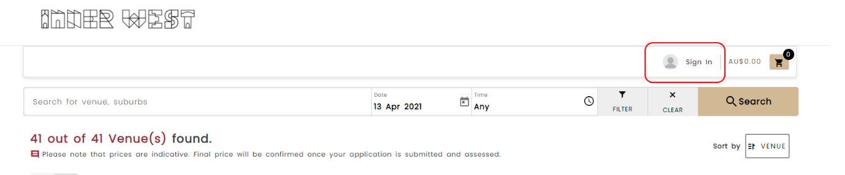

Step 2
Log on using your details
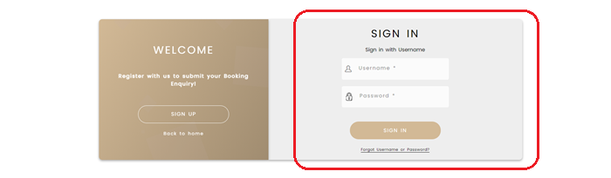
Step 3
From your profile menu select ‘My Bookings’
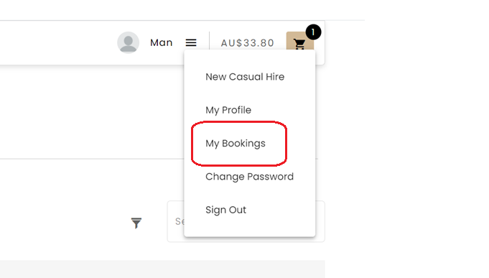
Step 4
In the booking click on the ‘Manage’ tab to access the details page of your booking
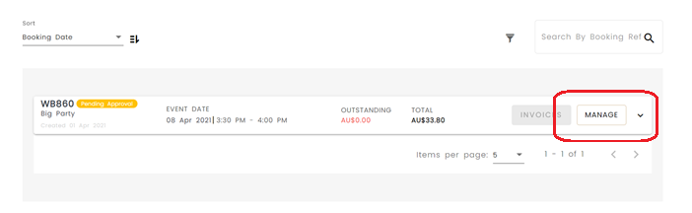
Step 5
Click on the ‘Request Cancellation’ tab in the top right of the booking
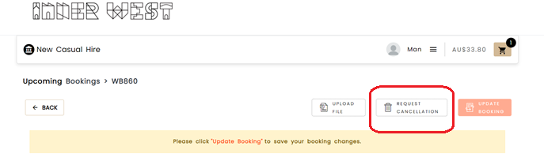

Then click ‘Yes’ if you would like to proceed
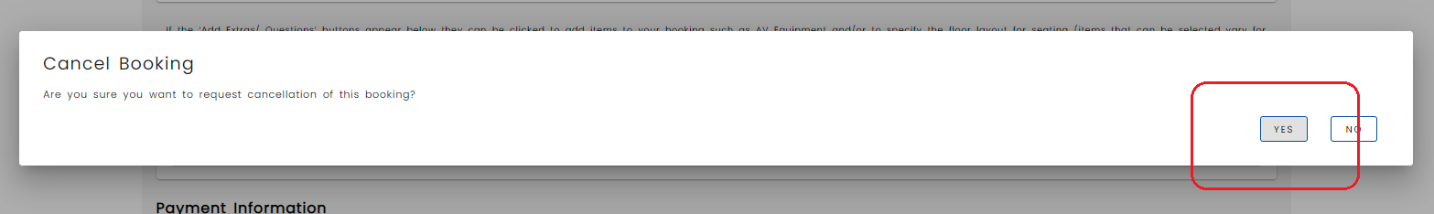

The system will then update the status to ‘Pending Cancel’ and a bookings team officer will review your request and contact you to finalise the request
