Community Awards 2023 Presentation

Young Citizen of the Year 2023

Lillian Davies  Special recognition as young people for social justice  Lillian is a committed and organised young person, always willing to help others in need. Lillian ran evening kiosk events at Burwood Girls High School and helped coordinate the food drive and packing of Christmas hampers at Addison Road. Lillian was also part of a team of local young people who helped organise a ramen stall to raise money for Days for Girls, coordinate an Anti-Racism Forum in 2022 and helped organise a community event raising $10,000 for Mahboba’s Promise. | 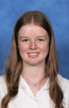
Ruby Hensley  Special recognition as young people for social justice  Despite facing the challenge of a recent family loss, Ruby has a keenly positive attitude and is highly involved in community events. Ruby was part of a team of local young people who helped organise a ramen stall to raise money for Days for Girls, coordinate an Anti-Racism Forum in 2022 and helped organise a community event raising $10,000 for Mahboba’s Promise. | 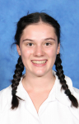
Amy Johnston  Recipient  Amy is a natural leader, advocate and artist who has contributed to driving positive and sustainable social change in the community. Amy is committed to amplifying the voice of students via her student leadership role, as well as taking on additional awareness campaigns and projects. Amy’s talent and determination has enabled greater awareness and understanding of the diverse experiences within community. | 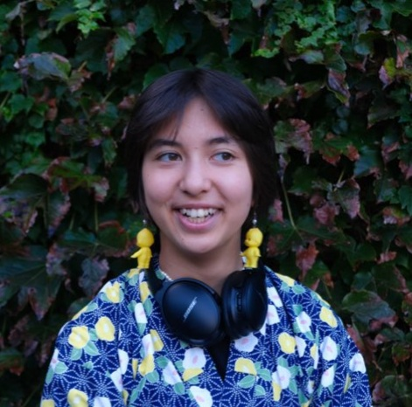
Rose Palmer  Special recognition as young people for social justice  Rose is highly involved in community activities and is very self-motivated, event coaching a local netball team. Rose was part of a team of local young people who helped organise a ramen stall to raise money for Days for Girls, coordinate an Anti-Racism Forum in 2022 and helped organise a community event raising $10,000 for Mahboba’s Promise. | 
Emily Skribinsek  Special recognition as young people for social justice  Emily has overcome chronic illness to still be contributing extensively to her local community. Emily gave up every Friday afternoon to run a Sisters in Society program that helped young refugee women. Emily was also part of a team of local young people who helped organise a ramen stall to raise money for Days for Girls, coordinate an Anti-Racism Forum in 2022 and helped organise a community event raising $10,000 for Mahboba’s Promise. | 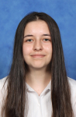

Amy Large Young Volunteer 2023

Kasandra Lim  Kasandra has been a Centre Support Volunteer at the Asylum Seekers Centre in Newtown for one year now and has provided a range of benefits to vulnerable people. Centre Support Volunteers play a vital role in providing general advice and guidance to clients about the Centre’s services and Australian processes. Kasandra has an ability to personally connect with clients with a calm, professional and sensitive manner. | 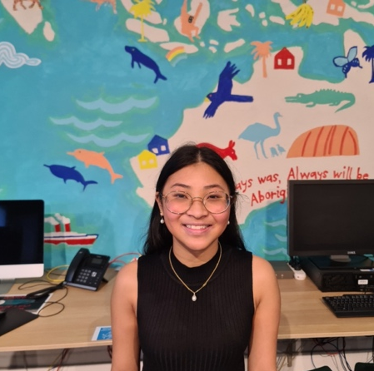
Paddy Ljubic McMorrow  Paddy has been a part of the Addison Road Community Organisation family for a number of year, however ‘officially’ became a volunteer in 2022. Paddy has participated in many events and programs, and is the inaugural Chair of the Addison Road Youth Committee. Paddy is a bright and remarkable person, always finding alternative ways of doing things. | 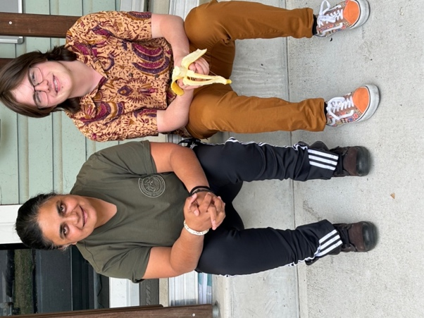
Kiara Tran  Kiara Tran is an emerging local leader, having completed varying volunteer experiences. Over recent years, this has included volunteer music performances as part of ANZAC Day Services, Inner West Music Festival, and more. Kiara has also volunteered with local organisations including Addison Road Community Organisation and Bill Crews Foundation. | 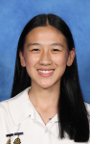

Amy Large Volunteer Team or Group

Addison Road Community Organisation Volunteers  Addison Road Community Organisation are a wide ranging service for the local community with teams working across food pantries, deliveries, transport, gardening, facility management and partnerships. Addison Road have fed over 360,000 people in the last 12 months alone and have diverted 380 tonnes of food from landfill in the process. With over 300 volunteers, they each make a difference every day to the lives of local people with commitment and dedication. | 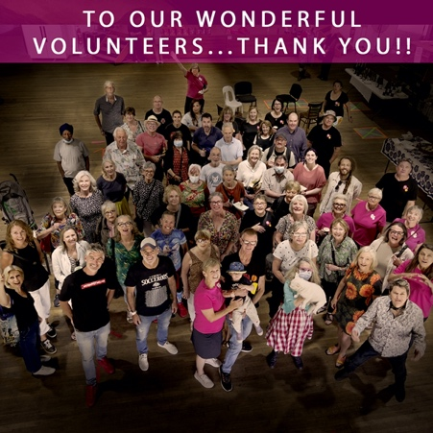
Ashfield Boys High School – Seniors and Students Shop and Chat Program  Ashfield Boys High School have partnered with Inner West Neighbour Aid to deliver the Senior and Students Shop and Chat program to support seniors with their grocery shopping. The participants of this program have demonstrated increased intergenerational and cross-cultural connections whilst directly supporting and enabling local seniors to participate more fully in their community. The student volunteers all display kindness, generosity, maturity and respect in all their interactions. | 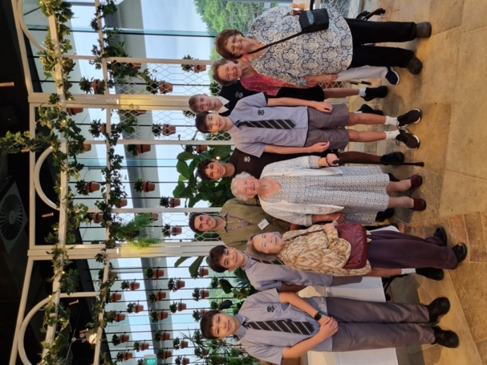
The Balmain Knitters  The Balmain Knitters, coordinated by Jan Christensen and based at Balmain Library, are a tight knit community. The group gather regularly to share a cup of tea and stories whilst talking and learning from each other everything knitting and crocheting. The group has been growing strong for many years and continue to gift items to need in various hospitals and facilities. | 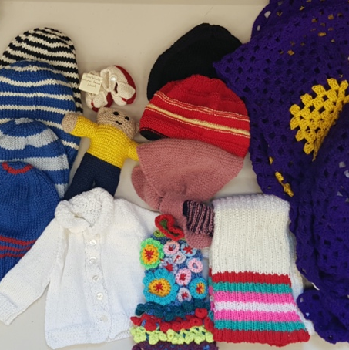
Bill Crews Foundation - Wednesday Night Dinner Van Group
The volunteers of the Wednesday Night Dinner Van group at Bill Crews Foundation have been working together for years and collectively have over 2,000 volunteer hours. Initially volunteering together, the group has since divided into multiple groups as well as serving on Christmas night. The group serves needy and vulnerable guests with a hot meal, tea and coffee and are generous with their time and care with guests.
Inner West Little Athletics Team  The Inner West Little Athletics team is made up of dedicated volunteers, continuing to service the sporting community since 1972. There are many hours of unseen work including registrations, preparing programs and training sessions, organising equipment and uniforms, and coordinating competition nights. The team strive for positivity and inclusion, working to see their athletes improve and achieve. | 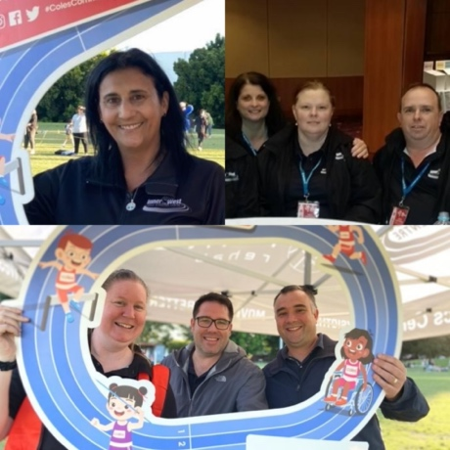
The Soup of Human Kindness at Parliament on King  Parliament on King is a social enterprise staffed by refugees and people seeking asylum. Ravi, owner of Parliament on King, started up The Soup of Human Kindness during the pandemic, recognising that many people were hungry and isolated on the streets of Sydney. Ravi and a strong team of volunteers come together on Saturday evenings to prepare, pack and distribute over 110 meals to those in need. The service has since continued in partnership with other community organisations including One Meal. | 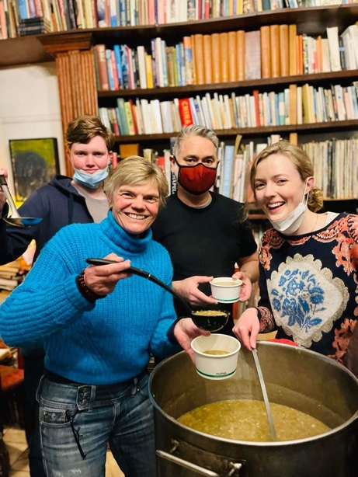
Sydney Multicultural Community Service – Community Visitors  Sydney Multicultural Community Service have been running the Community Visitors Scheme program for more than 20 years. The program is run by more than 150 volunteers and aims to reduce the loneliness and isolation of multicultural and elderly people. Across the team, they speak more than 40 different languages and provide more than 2,000 hours of free social support, visitations and other services annually. | 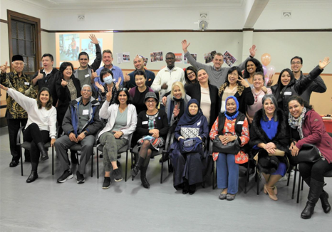

Senior Citizen of the Year 2023

Carrie Foster  Recipient  Carrie is a long-term volunteer at the Hannaford Community Centre in Rozelle who has worked as a tutor in the Tech Health program. Carrie has worked one-on-one with locals over 55 years-of-age to up their computer skills. Carrie is warm, kind and generous is all her interactions with a positive and inquisitive mindset. | 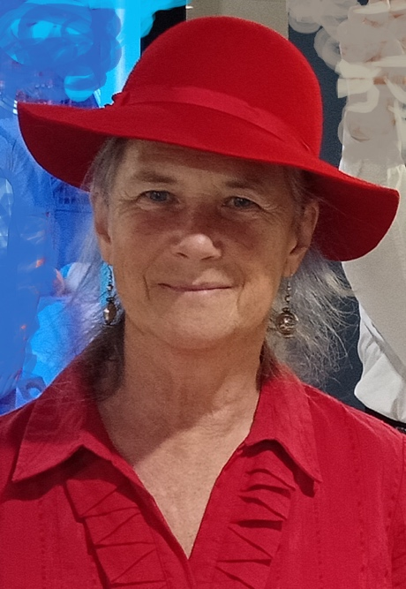
Yao Zi MA  Nominee  Yao Zhi is a long-term volunteer with the Chinese Australian Services Society (CASS), working with the Ashfield Activity Group Social Dance Time. Yao Zhi oversees much of the organisation of this weekly group, as well as group festival celebrations such as Moon Festival and Lunar New Year. | 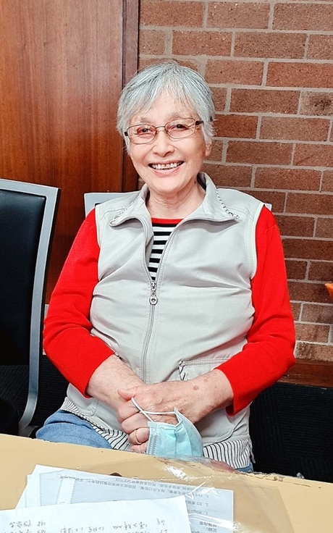
Ha-Huong Nguyen  Special recognition for contribution to local multicultural arts  Ha-Huong has provided countless hours and talent to empower local seniors to improve their quality of life through directing and performing Vietnamese dance and music. Ha-Huong’s work has not only seen groups improve their social, mental and physical wellbeing, but has also resulted in high quality performances at various festivals and community events. | 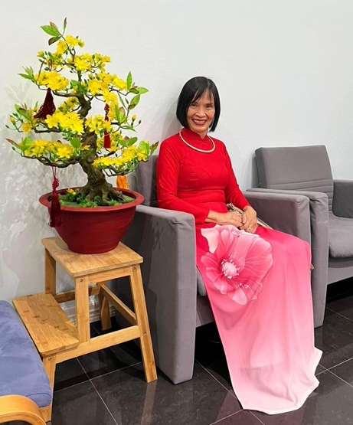
Farid Wilson Silwanis  Nominee  Farid is one of the fantastic volunteers at Sydney Multicultural Community Services, working on the Community Visitors Scheme. Farid is a committed volunteer, providing in-person and virtual visitations to numerous local people. Through his work, he enhances their quality of life, treating them as if they were his own family. | 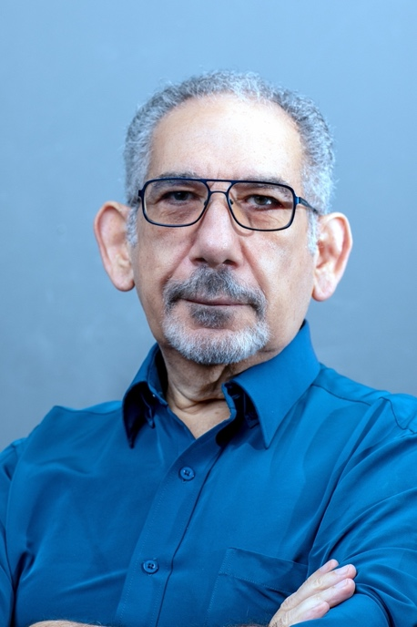

Amy Large Senior Volunteer 2023

Pauline Choy  Pauline joined the Addison Road volunteer team only in recent years, however has been volunteering four days per week ever since. Pauline sees it as a privilege to serve her community and is a driving force like no other, never letting her age slow her down. Pauline has become an integral part of the team and an inspiration to many. | 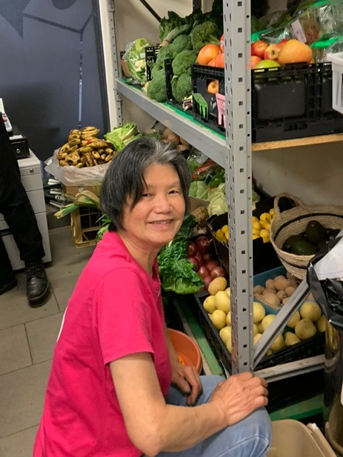
Jie Xiang Li  Jie Xiang has volunteered with the Chinese Australian Services Society since 2015. In this time, Jie Xiang has played a significant role with the Ashfield Activity Group Social Dance Time. She is responsible for the bookkeeping of this group, taking her work seriously with high level organisation and management. Jie Xiang is kind to everyone, and loved and welcome by all participants. | 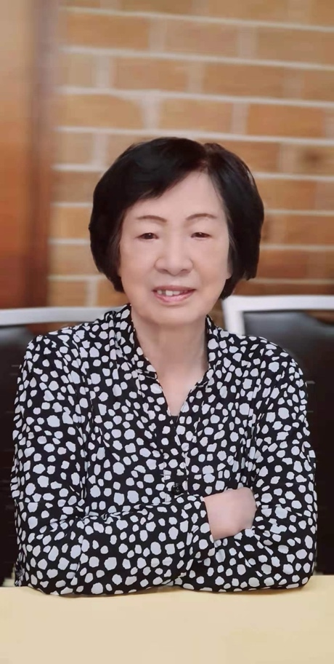
Kay Lim  Kay has been volunteering with Bill Crews Foundation in their Food Service Department for eight years now, gaining 1,500 hours of volunteering. Kay prepares and serves guests, especially key during the Christmas Day lunch. Kay also willingly helps with interpreting for some of the service’s non-English speaking guests. | 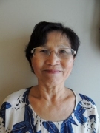
Michael Muhlbauer  Michael is one of the many hard working volunteers at the Horn of Africa Relief and Development Agency (HARDA). Michael has been the secretary for the organisation for over 15 years, in which time, he has tirelessly ensured the effective management of the organisation. Michael is detail-oriented and is always willing to assist whenever and wherever needed. | 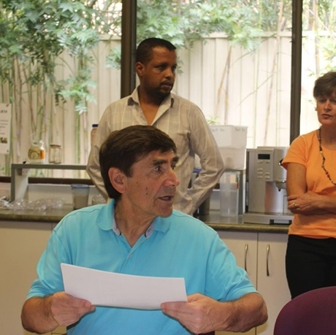
David Rollinson  David is one of the exceptional volunteers at 3Bridges Community. David has worked tirelessly with various clients suffering from dementia and has shown remarkable innovation in his approach to volunteering. In all his work, David shows remarkable patience and uplifts the spirits of those around him. | 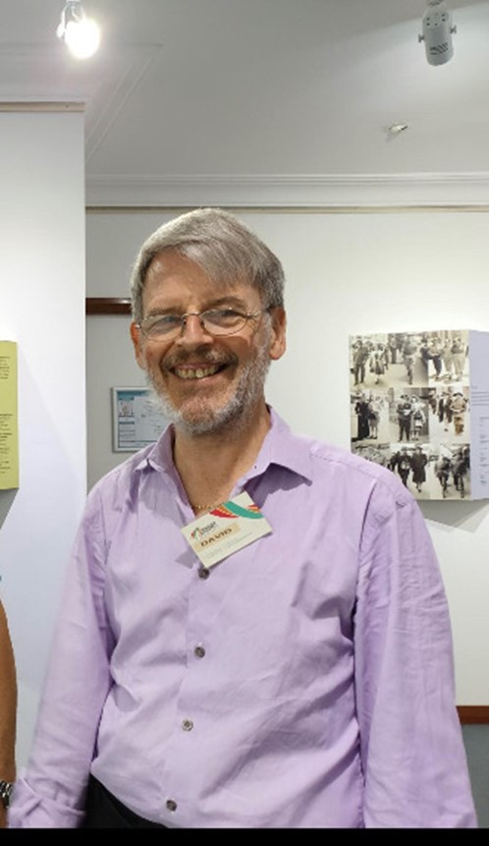
Ray Swinnerton  Ray has been coaching at UNSW Wests Water Polo Club as a volunteer for the better part of 30 years. One of Ray’s many achievements has been coaching the Club’s national league team. Ray brings extensive experience to players, coaching beginners all the way through to the highest level of competition. | 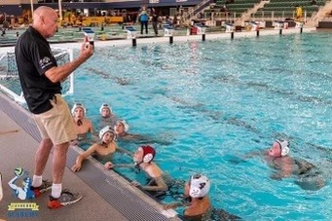
Sajjad Versi  Sajjad has been a volunteer at the Horn of Africa Relief and Development Agency (HARDA) for over 10 years. Since 2015, Sajjad has held the position of President, leading various projects and representing HARDA with government leaders. Despite various challenges, Sajjad’s work allows HARDA’s important work to continue. | 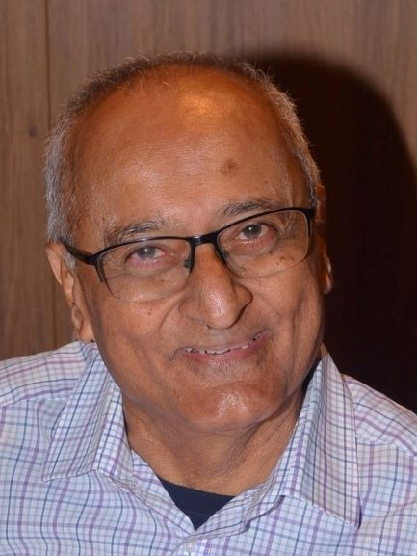
Carolyn Walker  Carolyn is a long-standing volunteer with Western Suburbs Lawn Tennis Association. First joining the club as a junior in 1968, Carolyn has since filled positions including Secretary, President, and Director. Carolyn has been part of the collective team behind the Rally4Ever initiative in collaboration with Council. Carolyn displays a steadfast commitment to the club and the wider local tennis community. | 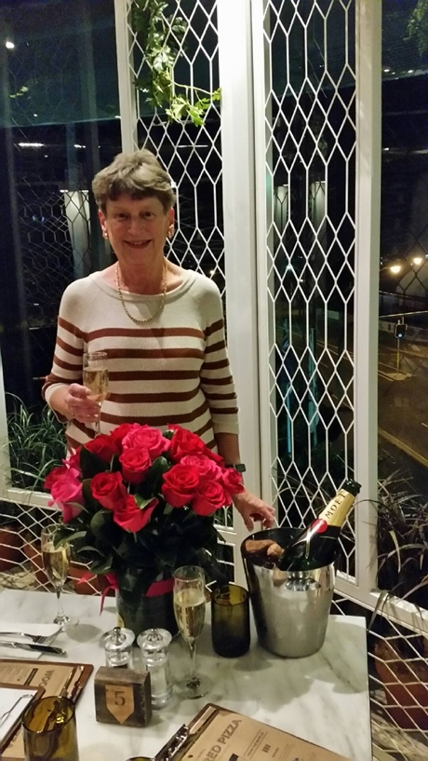
Rick Wayde  Rick has been involved in Western Suburbs District Cricket Club for over 30 years. In this time, he has filled the role of Secretary and has recently become the Club Vice President. Rick has gone above and beyond to support Club members as well as fulfilling the full array of volunteer roles at the Club. | 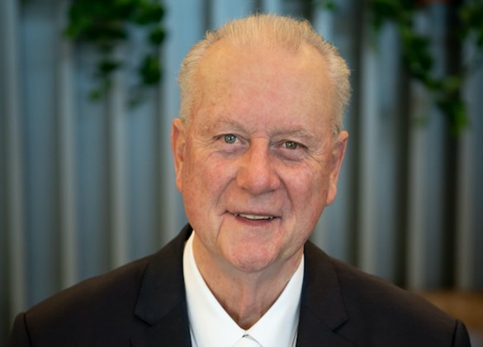
Trish Wyner  Trish is a long-standing volunteer with Dress for Success, based in Marrickville. Trish has given time and dedication to various volunteering endeavours with the organisation, including eight fashion fundraising events in the year. Trish is a quiet achiever, with a fun nature which always lifts the atmosphere in any room. | 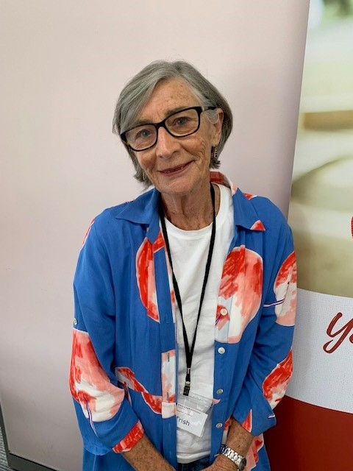

Adult Citizen of the Year 2023

Erin Spencer & Bec Cerio  Special recognition for fostering inclusion  Erin and Bec co-founded and continue to run the local business Sock Drawer Heroes: Australia’s first and largest online store dedicated to gender expression. Erin and Bec have advocated and supported the lives of LGBTQIA+ people through provision of specialist products as well as regular community-connecting activities. | 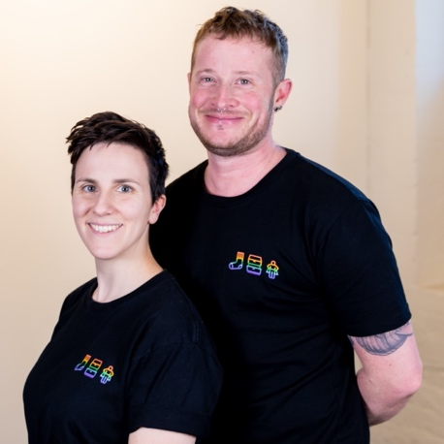
Catherine Delaney  Nominee  Catherine (Cat) is well-known to Balmain locals as she works to collect food and household products, then distributes these to the homeless. Cat welcomes all and thrives spreading the message of the work she does. Cat provides an accessible avenue for local people to provide goods to people in need. | 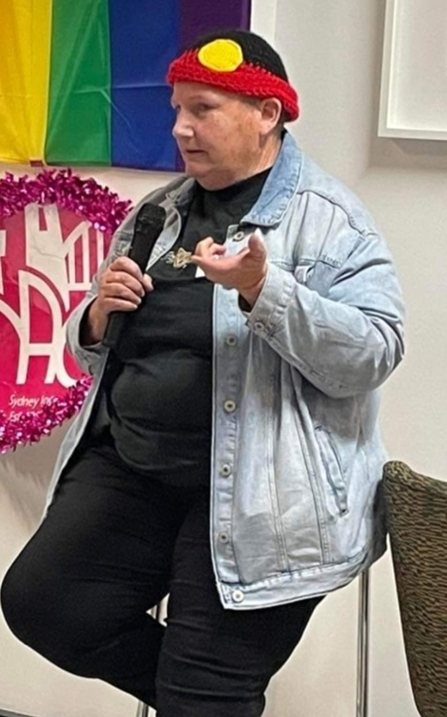
Alan Earls  Nominee  Alan is a vital volunteer working in the Inner West community in suicide prevention, providing a safe space for those suffering to drop-in and receive the support that they need. Alan has an incredible ability to connect with those in a time of crisis as well as educating in mental health first aid. | 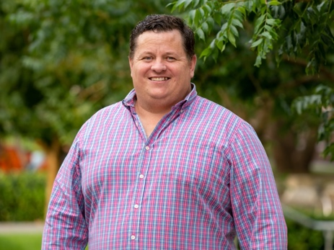
Simone Amelia Jordan  Nominee  Simone is an award-winning writer and music journalist born and raised in the Inner West. In addition to her accolades, she organised youth-focused dance parties and continues to be an active member of the community supporting various local ventures. | 
John Karavasilias  Nominee  John is the founder and managing director of MPSR Group, a local family-owned body repair shop. John has worked tirelessly alongside his wife Sarah to grow the business to what it is today despite multiple challenges. | 
Boe Rambaldini  Recipient  Bundjalung Elder and Inner West local Boe Rambaldini has worked for many years at various levels and in many areas to improve the lives of First Nations people and close the gap. Despite many challenging life experiences, Boe has worked across universities and multiple levels of government create better health outcomes and working conditions for First Nations people.  Image source: Healthy Communities, Mid North Coast | 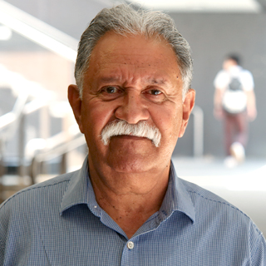
Ben Ross  Nominee  Ben is the founder of local basketball club Little Ballers, based out of Wilkin’s Public School in Marrickville. Ben has worked tirelessly to create a vibrant local sporting club, providing the physical, mental and social benefits of sport to the Inner West community. | 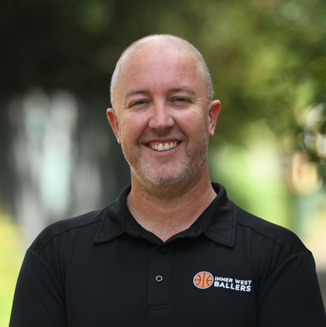
Kath Wawatai  Special recognition for long term commitment to local live music  The Inner West has benefitted immensely from Kath’s work to grow and develop a thriving and continuously growing local music community. Kath has worked with various creative entities and venues to present one off music events, improve facilities, and create opportunities for young creatives to gain valuable experience in the industry. | 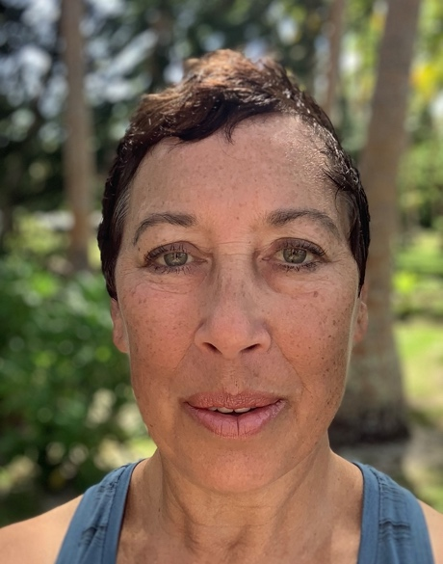
Brooke Watson  Nominee  Brooke is an outstanding leader in education, currently working at St Paul of the Cross Catholic Primary School. Brooke brings vibrancy and passion to her work, seizing every opportunity to shape the hearts and minds of children by implementing the latest research and evidence-based approaches in education. | 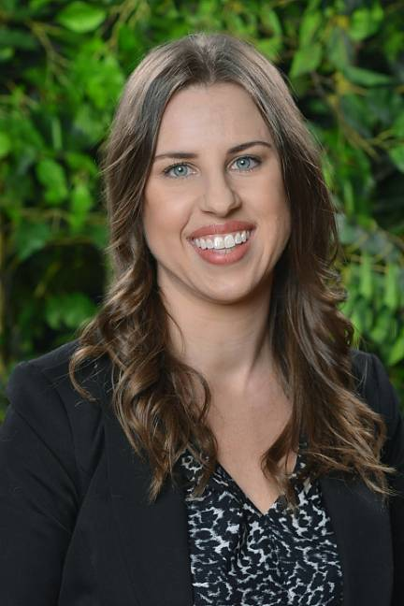

Amy Large Adult Volunteer 2023

Yvette Andrews  Yvette is a longstanding board member of local outfit Reverse Garbage. Yvette has leant her expertise in strategic engagement, communications and community engagement to ensure the longevity and improvement of the organisation. Yvette has worked extensively across Reverse Garbage undertakings, always championing their mission and cause. | 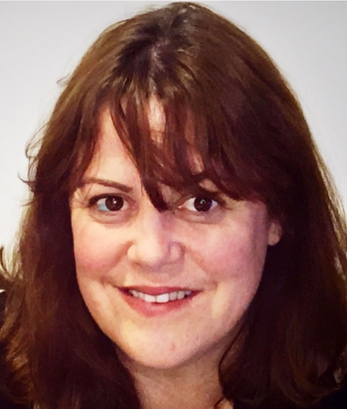
Teigan Butchers (Rainbow Smash)  Teigan, also known as Rainbow Smash, is a trailblazer for LGBTQIA+ inclusion in sports as the President of Inner West Roller Derby League. This has included bringing the club to platforms such as Sydney World Pride, Luna Park and Network 10. Rainbow has an immense passion for the sport, creating a welcoming, safe and inclusive space for all skaters. | 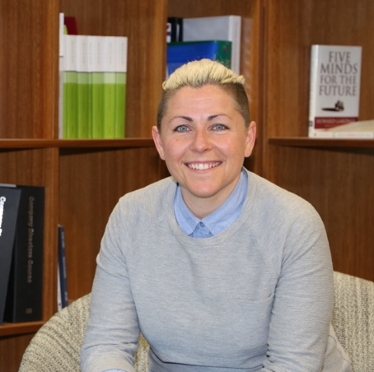
Tiffany Chen  Tiffany has volunteered with the Newtown Breakaways AFL club for over five years as a player, committee member, and now as the Club President. Tiffany has overseen the expansion of the club from women’s only to now also including a men’s team. Tiffany is a role model for the club and is dedicated to ensuring a safe place for all players. | 
Alison Cockrell  Alison is part of Council’s incredible Bushcare team, caring for the local natural environment. Alison donates her time on Sundays contributing to restoration projects reinstating local native vegetation along the Greenway biodiversity corridor. Alison willingly takes on tough tasks and provides a great example to new and young members. | 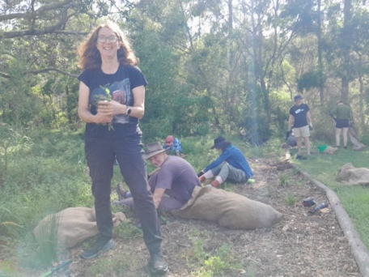
Janet Cooksey  Janet is a keen local volunteer, nominated for her work at Story Factory in Redfern. Janet is a cheerleader for the creative writing students and is always proactive in considering new ways to support the organisation’s mission and team. Janet also completed the most volunteer hours in the organisation across 2022! | 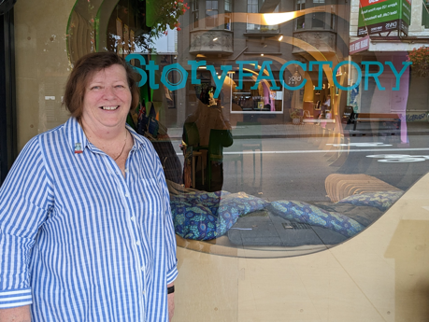
Noel Cuthill  Noel is a new and highly motivated volunteer at Together2 in Rozelle. Since joining in early 2021, Noel has made himself available twice every week. With a friendly smile and warm words, Noel makes a difference in the daily life of many local people, taking the time to talk with each recipient of Together2’s services. | 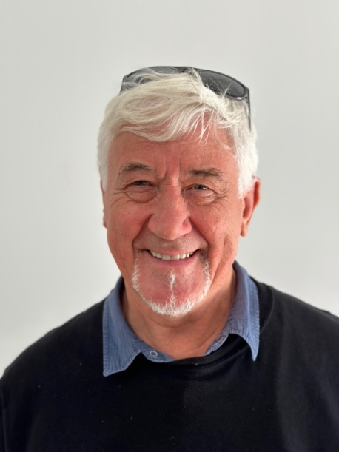
Darryl Hodgson  Local volunteer Darryl is a driving mentor for young people as part of Stepping Stone House, based in Alexandria. Darryl has established himself as a healthy role model within the service, providing valuable time and knowledge in driving and car maintenance, teaching young people these valuable skills. | 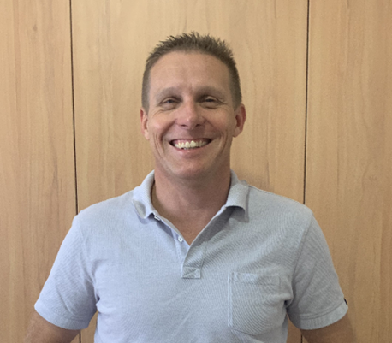
Erica James  Erica is a mentor and inspiration as part of her work with the Universities Women's Cricket Club in Camperdown. Erica has been integral to the delivery of UWCC’s Youth Development Program initiative as well as volunteering with Marrickville Cricket Club. Erica’s enthusiasm and positive energy are infectious and ensure players feel welcome and valued. | 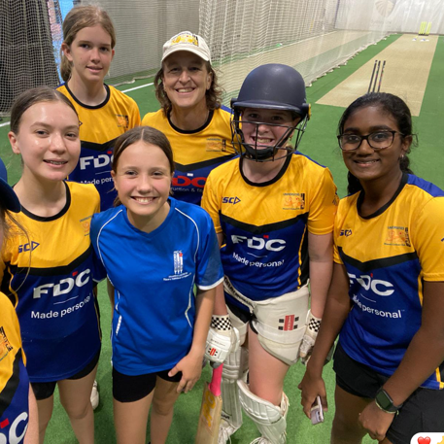
Elliot Kahl  Elliot is one of the fantastic Centre Support Volunteers working out of the Asylum Seekers Centre. Elliot provides vital assistance and guidance for clients, keeping them up to date, informed and supported. Elliot has gone above and beyond to help clients navigate the complex Australian systems to ensure clients secure services and benefits wherever needed. | 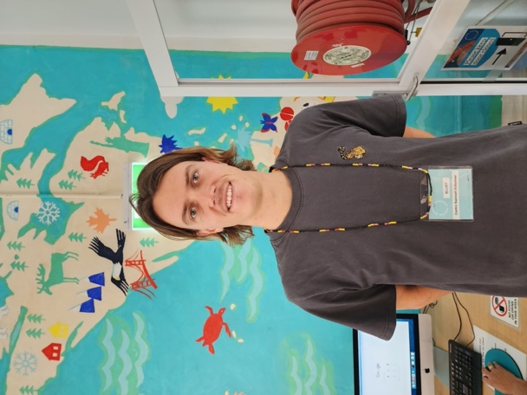
Christine Karadijs  Christine is a multi-talented volunteer as part of Community and Cultural Connections Inc in Marrickville. Christine has organised and lead group outings, functions, food distribution and provided one-on-one support. Through her work, Christine has helped bring about a great deal of happiness, social support and connection between seniors of diverse cultural backgrounds. | 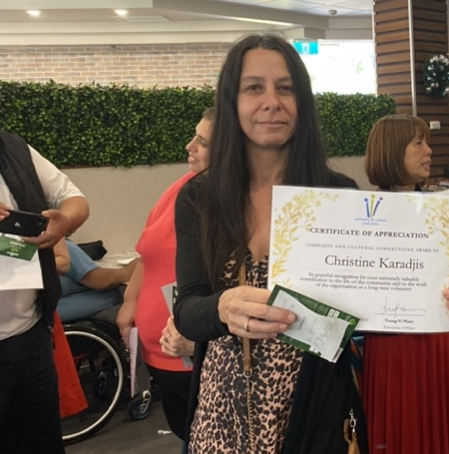
Cara O’Neill  Cara has provided extensive volunteer contributions to the Balmain Water Polo Club. Cara has played a key role in the formation and administration of teams, officiating games, as well as organising and running events. Cara advocates for young members and their participation in both the game itself as well as club activities. | 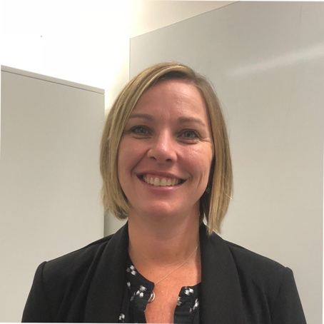
Jitra Sae-Seung  Jitra is one of the fantastic volunteers at Sydney Multicultural Community Services, working on the Community Visitors Scheme. Jitra displays love and care for all the people she visits. She is a great example of working with generosity, warmth and dedication in the community. | 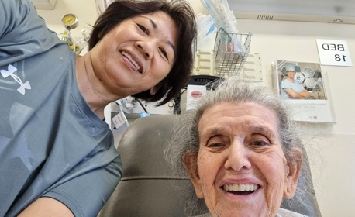
Hugh Sanderson  Hugh is part of Council’s incredible Bushcare team, caring for the local natural environment. Hugh donates his time on Sundays contributing to restoration projects reinstating local native vegetation along the Greenway biodiversity corridor. Hugh is a cornerstone of the group with insightful commentary and uplifting observations. | 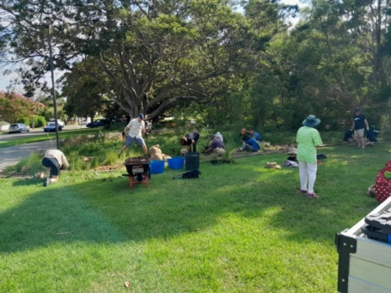
Andrew Sciberras  Andrew has been a crucial member of the Addison Road volunteer team. Andrew helped manage the operations of the Covid Emergency Relief Hub during the pandemic, and has since conducted much work in the community hall. Andrew is an exemplary volunteer, conducting his work with good humour, kindness and positivity. | 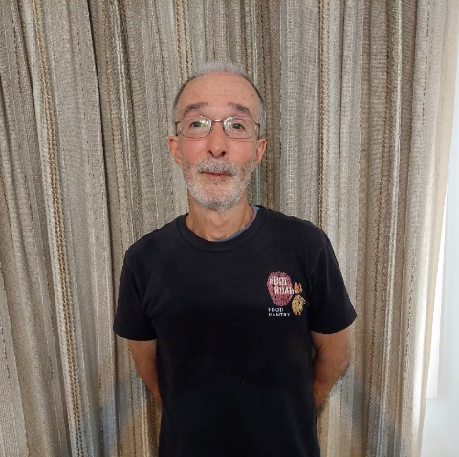
Glen Smith  Glen has been part of the Bill Crews Foundation volunteer team for almost seven years, having completed over 3,000 volunteer hours in that time. Glen works diligently to keep the grounds clean and tidy, as well as caring for the garden, flowers and trees. Glen regularly takes time away from his tasks to be friendly and socialise with guests. | 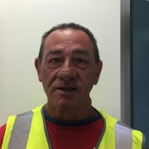
Kimberly Uesiliana  Kimberley has been a significant part of the Newtown Neighbourhood Centre volunteering team. Kimberley has been part of the Individual Social Support program, providing social support to seniors in the community; as well as the Newtopian Outreacher program, providing resources, temporary housing and support services to people experiencing homelessness. | 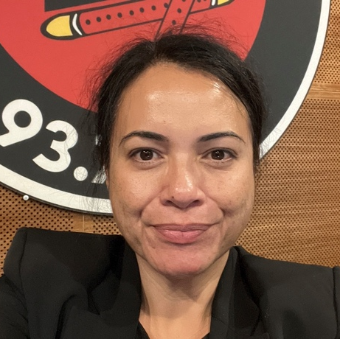
Elizabeth Youssef  Elizabeth is one of the hard working volunteers at Community and Cultural Connections Inc in Marrickville. Elizabeth’s work supports local seniors in the Arabic speaking community, ensuring their continued wellbeing and advocating for their needs. Elizabeth was part of the incredible team at CCCi that delivered additional services during the pandemic. | 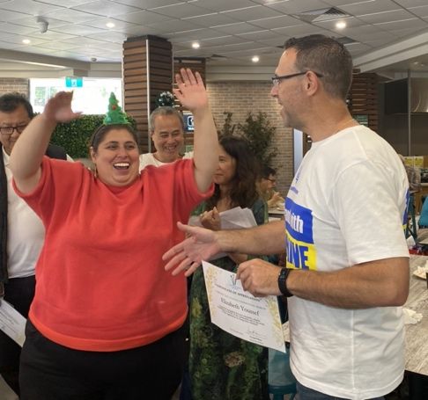

Amy Large

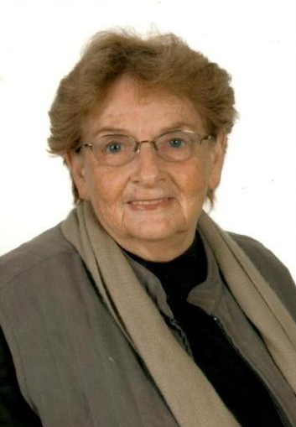 | Amy Large, a long-term Balmain resident, was widely known for her long years of service supporting the community through her volunteer work.  Amy passed away in 2015 leaving a legacy to be proud of.  Thank you to all the volunteers with us this evening, for your contribution to our community.

