
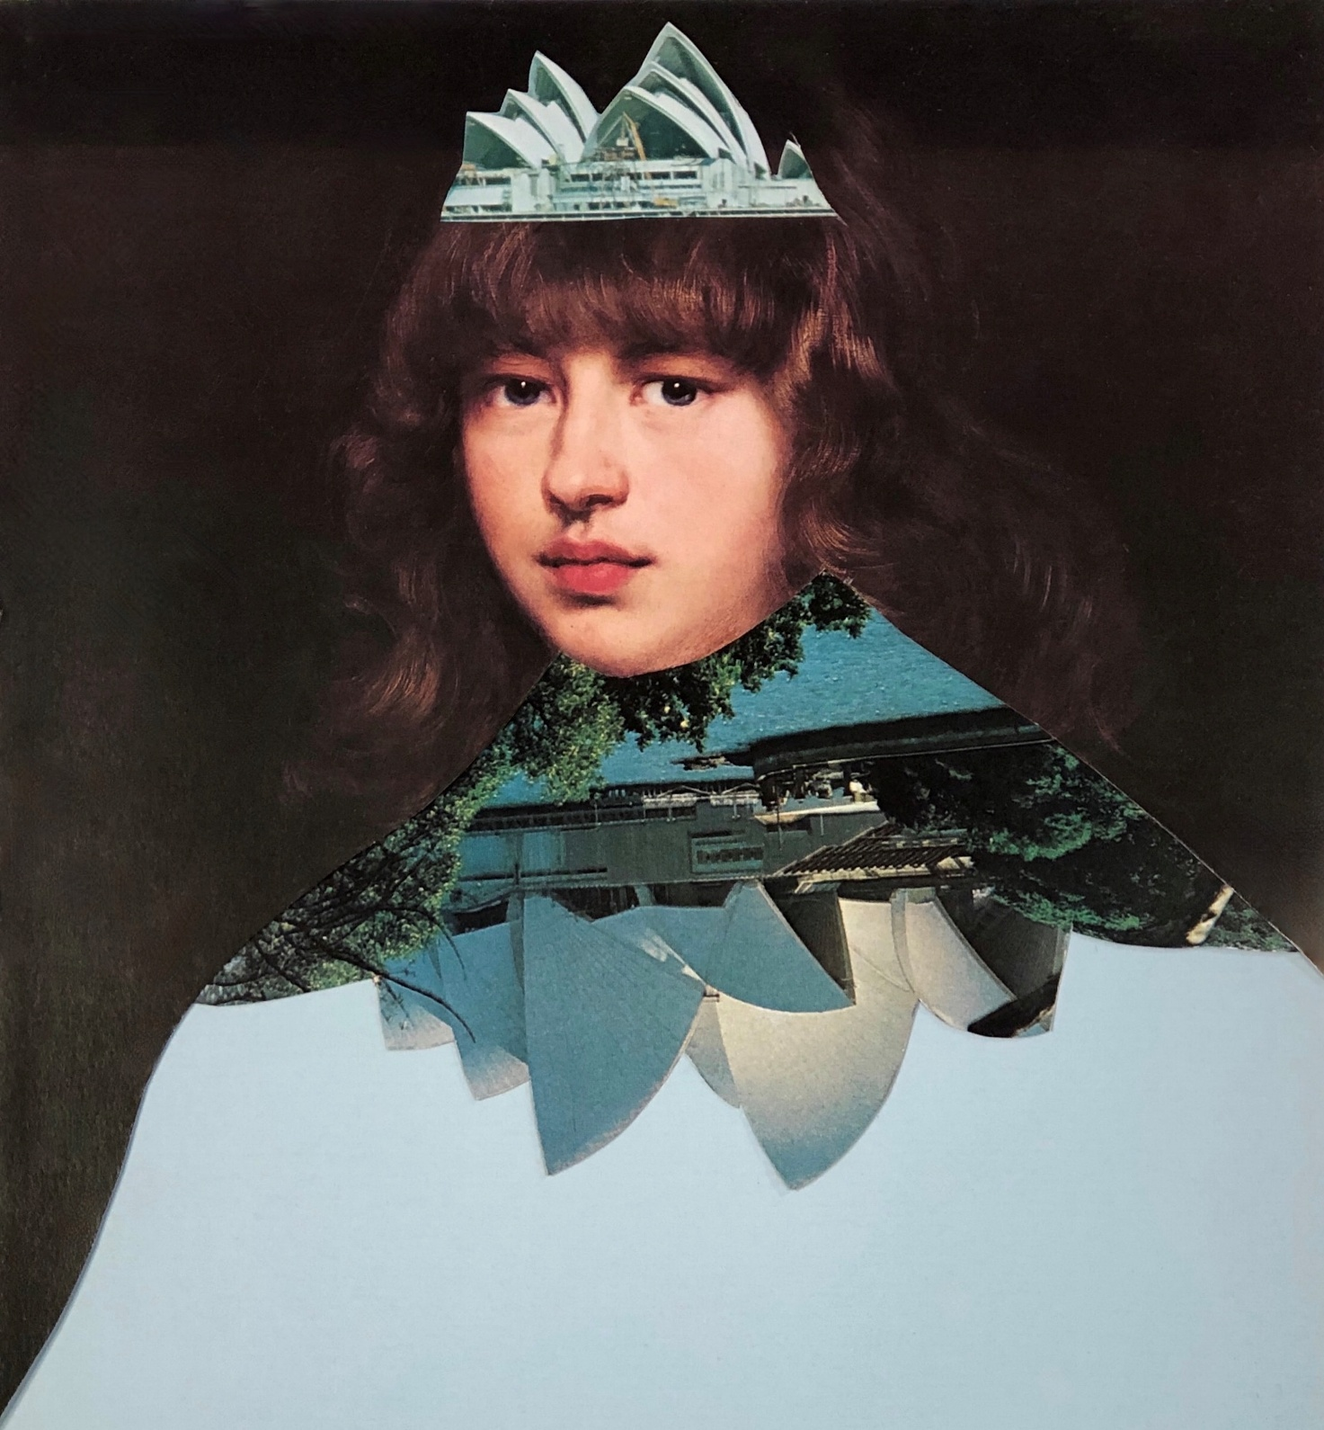

Kathryn Bird, Sidney (2019), paper collage

Background
Chrissie Cotter Gallery (CCG) was established in 1996 as a space for local artists and groups to share their work with the community. Across three decades, the gallery has become an important and much-loved fixture in the Sydney art scene.
Purpose
The Chrissie Cotter Gallery provides a free space for artists, curators, and community groups to exhibit their work and connect with audiences. The program strengthens local culture sharing a diversity of artistic practices and lived experiences with the community.
Aims
The program aims to:
- Provide a no-cost, commission-free venue for artist or community-run exhibitions
- Create professional development pathways and a public profile for emerging artists and curators
- Engage the local community and art lovers from across Sydney with a diverse showcase of contemporary Inner West visual arts practice.
The Gallery
Chrissie Cotter Gallery is located in the heart of the Inner West, on Pidcock Street within the Camperdown Park precinct—just four kilometres from Sydney’s city centre. Nestled in a residential area, the gallery sits between the Camperdown Commons and the local tennis courts.
The standard gallery opening hours during exhibitions are Thursday to Sunday, 11am–4pm. Artists may propose alternate hours or special event open times, subject to approval.
The gallery is a well-equipped, welcoming space featuring:
- A small kitchen
- Accessible toilet facilities
- An accessible lift
- Built-in projector and small sound system
- Hanging and lighting systems, and a ladder
- 5 plinths (various sizes)
- Approximately 17 square metres of hanging space across three walls (ceiling height 3.1 metres) - Visit Council’s website for detailed floor plan.
- Parquetry flooring throughout
The nearest train station is Newtown, approximately a 15-minute walk away, and the gallery is serviced by several local bus routes, including those along Parramatta Road and Missenden Road. Note that no Wi-Fi is available on site
Opportunity
Chrissie Cotter Gallery offers artists, curators and community groups the opportunity to realise ambitious exhibition projects in a respected community gallery with a 30-year history of supporting contemporary visual arts practice.
The exhibition space is offered free of charge, with no commission taken on artwork sales. The gallery is particularly well suited to two-dimensional works, small-scale sculpture and projection-based installations. However, artists are encouraged to propose exhibitions across all mediums and forms of creative expression.
Each exhibition period includes:
- Installation access
- Public exhibition period
- Deinstallation period

Successful applicants will:
- Install and deinstall their own exhibition.
- Staff the gallery during public opening hours.
- Hold a public opening event during the exhibition period.
- Pay a refundable bond of $200 before the exhibition commences.
- Only exhibit work by artists included in the original application unless prior approval is obtained from Inner West Council.
- Be responsible for exhibition-related costs, including events, staffing and artwork insurance.
Inner West Council will:
- Provide the gallery free of charge for a three-week exhibition period, with no commission charged on artwork sales.
- Promote exhibitions through Council's website, social media and other Council communication channels.
- Provide a safe, clean and well-maintained gallery space.
- Provide public liability insurance cover for the exhibition period.
- Supply a venue user guide and exhibitor agreement.
- Provide two parking permits for exhibiting artists.
Exhibition Stipend
Artists may also apply for a stipend payment of $500–$1,000, which will be awarded by the assessment panel to support public programming and/or access initiatives. These optional funds can be used to:
- Deliver public programs such as artist talks, workshops, or community-led events that extend audience engagement
- Support access needs of artists or audiences (e.g. access services or resources/materials that improve the accessibility of your exhibition).
Applicants are encouraged to consider how audiences with diverse access needs may experience the exhibition and any associated public programs.
Applicants must clearly outline how the stipend will be used and how it will increase community impact, access, or participation. Please note: stipend funding is not guaranteed and will be assessed as part of the application process. Successful recipients must provide a brief acquittal report.
Eligibility
Applications are welcome from early-career to established artists, curators, and cultural workers presenting solo, collaborative, or group exhibitions.
Inner West Council encourages submissions from a diverse range of creative practitioners, including people across spectrums of ability, age, cultural identity, gender identity, and sexual orientation.
To be eligible:
- Applicants must be over 18 years old
- Must be an Australian citizen or resident with valid working rights
- Applicants must have the skills and capacity to deliver their proposed exhibition
- Each individual or group may submit one application only
- Applications must be submitted online via SmartyGrants; late or incomplete submissions will not be accepted.
Applications are invited from those who:
- Live in the Inner West local government area
- Have a studio space in the Inner West
- Do not live or work locally but can demonstrate how their exhibition will contribute to the Inner West’s creative, artistic, or cultural life
Assessment Criteria
Applications will be assessed by a panel of creative industry professionals, including Inner West Council staff and at least one external independent peer.
All applications will be evaluated against the following criteria, with weightings applied:
Assessment Criteria | Weight
Artistic and curatorial merit — the quality, integrity, and originality of the proposed exhibition concept | 40%
Community engagement — including benefits to the Inner West community such as:  - Engages audiences and communities  - Contributes to the cultural life of the Inner West  - Reflects diverse perspectives and experiences  - Includes public programs, partnerships or participation opportunities where relevant | 30%
Professional development — how the exhibition will benefit the exhibiting artist(s) or curator(s) practice | 20%
Feasibility — demonstrated capacity to deliver the exhibition as proposed | 10%

How to apply
Applications must be submitted online via SmartyGrants:
🔗 https://innerwest.smartygrants.com.au/CCG2027
As part of your application, you will be asked to provide:
- An exhibition proposal outlining your creative vision and intent.
- CVs or biographies for all exhibiting artists or collaborators.
- Images of recent work relevant to the proposed exhibition.
What Makes a Strong Application?
The most competitive applications typically demonstrate:
- A clear and compelling exhibition concept
- Strong artistic and/or curatorial merit
- High-quality supporting images and relevant experience
- Consideration of how the exhibition contributes to the cultural life of the Inner West community
- Thoughtful public programs, events or access initiatives (where relevant)
Applicants are encouraged to review the assessment criteria when preparing their submission.
Exhibition Stipend (Optional)
Applicants may also apply for an optional stipend of $500–$1,000 to support access initiatives, public programs or community engagement activities associated with their exhibition.
To apply for the optional $500–$1,000 stipend, you must also provide:
- A short statement outlining how the funds will be used and how the stipend will support access, participation, or community impact
- A budget (income and expenditure) showing how the stipend will be allocated and the amount requested
- A draft schedule of any proposed public programming or access activities

Timeline
EOI round opens via Smartygrants:  https://innerwest.smartygrants.com.au/CCG2027 | 9am, Monday  17 August 2026
EOI round closes | 3pm, Monday  14 September 2026
Assessment Panel meet to review applications against eligibility  and assessment criteria | October 2026
Applicants notified  Council confirms date allocations with successful artists. | 31 October 2026
Agreements signed and returned with initial invoices  Seasonal marketing material supplied to IWC | November 2026
Invoices processed for successful stipend recipients | November 2026
Exhibition Season Commences | January 2027

Support and Accessibility
Please get in touch to discuss any access needs you may have in making this application or your exhibition. Council is committed to showcasing diverse voices from our community and welcome those who may need access regarding disability, language barriers and navigating application processes.
Belinda Walter belinda.walter@innerwest.nsw.gov.au or 02 9392 5784
Amylia Harris amylia.harris@innerwest.nsw.gov.au or 02 9392 5702

