Children’s Book Week 2026
Writing competition

Open to children from grades 3-6

There are lots of prizes to be won!

Name: …………………………………………………......................................................

Age: ………………………………………………………………………………………………………

School: ………………………………………………………………………………………………

Class (Please circle): 3 4 5 6

Phone: …………………………………………………………………………………………………

Email ……………………………………………………...........................................................

This competition is managed by Inner West Council Libraries and closes on 4 August 2026. Winners notified by 21 August 2026.

Submit entry forms at any Inner West Council Library or email: bookweek@innerwest.nsw.gov.au.

Extra forms, prize details, terms and conditions: www.innerwest.nsw.gov.au/BookWeek
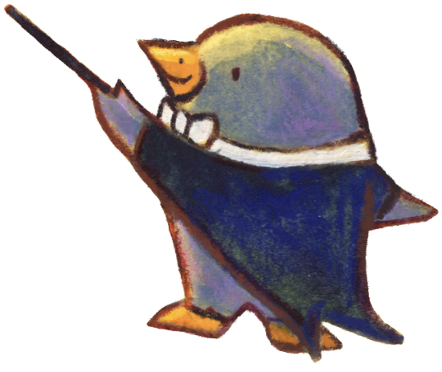



Writing competition
Step into a symphony of stories!

Imagine a world where books burst open and amazing characters
from every kind of story leap out!

Write a short story about a wonderful world filled with colourful characters. (Limit of 3 pages per entry.)

