Children’s Book Week 2026
Drawing competition

Open to children from grades K-2

There are lots of prizes to be won!

Name: …………………………………………………......................................................

Age: ………………………………………………………………………………………………………

School: ………………………………………………………………………………………………

Class (Please circle): K 1 2

Phone: …………………………………………………………………………………………………

Email ……………………………………………………...........................................................

This competition is managed by Inner West Council Libraries and closes on 4 August 2026. Winners notified by 21 August 2026.

Submit entry forms at any Inner West Council Library or email: bookweek@innerwest.nsw.gov.au

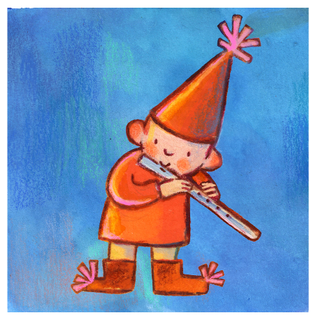
Extra forms, prize details, terms and conditions: www.innerwest.nsw.gov.au/BookWeek



Drawing competition
Step into a symphony of stories! Imagine a world where books burst
open and amazing characters from every kind of story leap out!

Draw a picture of a wonderful world filled with colourful characters.

Describe your drawing in 1 -2 sentences:

