FIRST TIME USER
Step 1
On council’s Home page you may view venues either via the ‘Explore’ option or the ‘Find a venue, park or sporting ground’ option
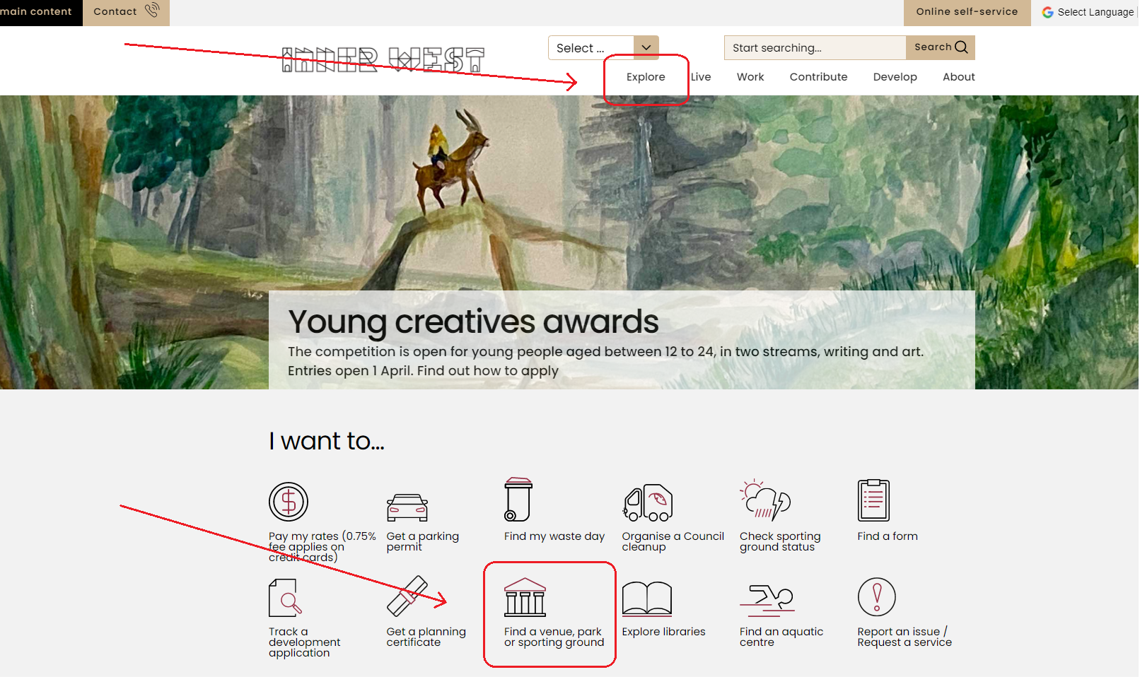
In the ‘Explore’ page you may then select ‘Venues for hire’
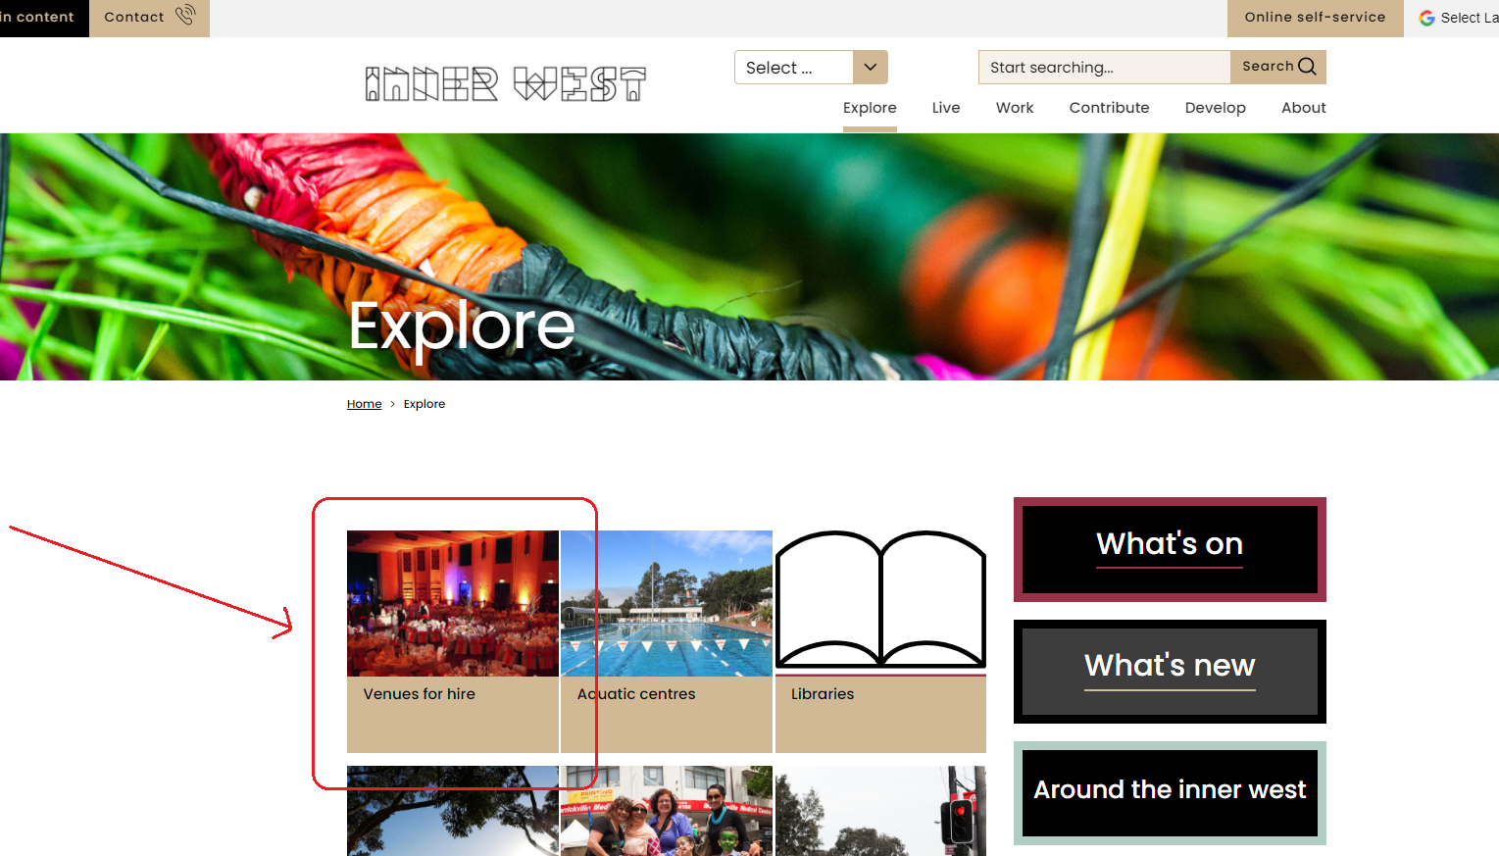
If selecting the ‘Find a venue, park or sporting ground’ option, you will be taken directly to the ‘Venues for hire’ page where you will be able to select the type of venue that you require
Step 2
When in the ‘Venues for hire’ page, select the type of venue that you would like to use by clicking on the image
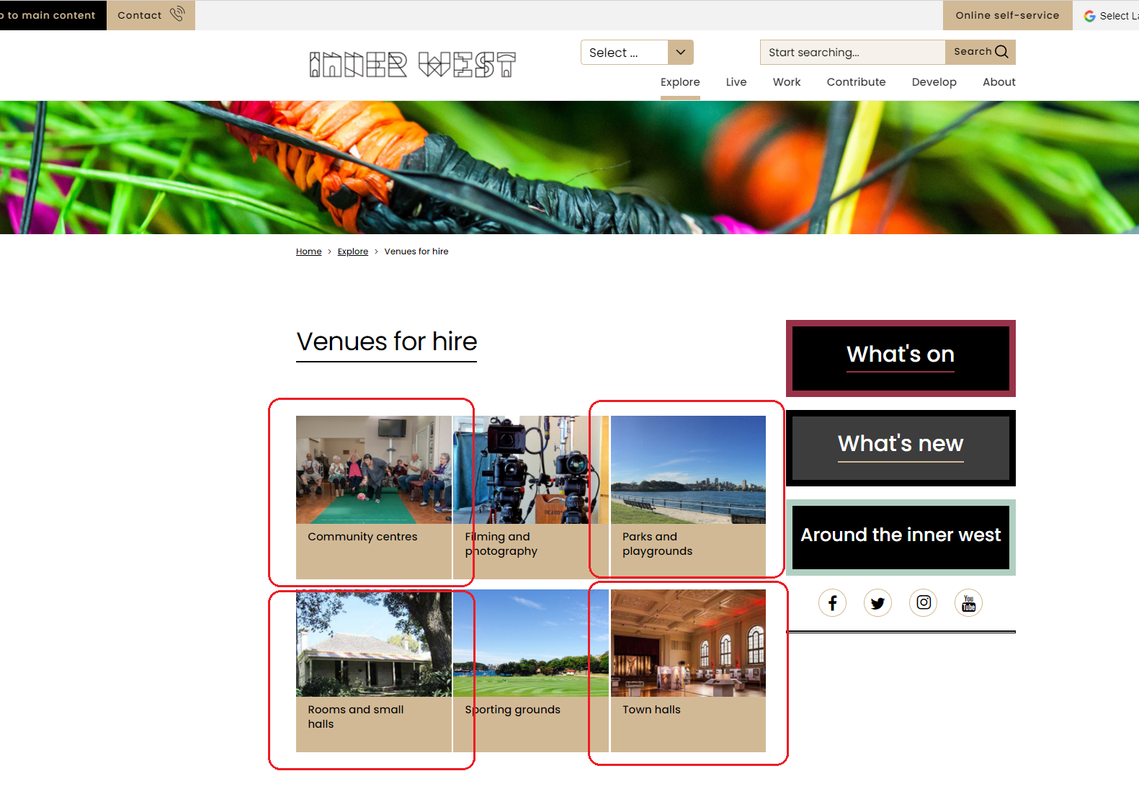
Step 3
Select a venue by clicking on the relevant indoor venue or park that you would like to book
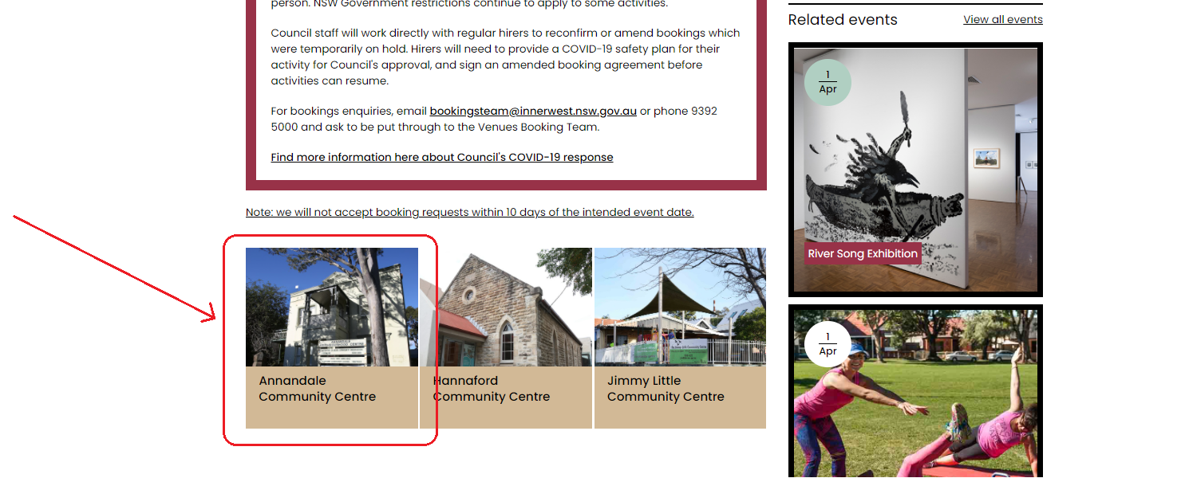
Step 4
At the bottom of the venue information page, click on the “Apply online here” tab to be taken to the booking system


Step 5
When in the booking system, click on ‘Selected date & time’ to open up the date, times and number of attendees’ window where you will select and set these for your booking

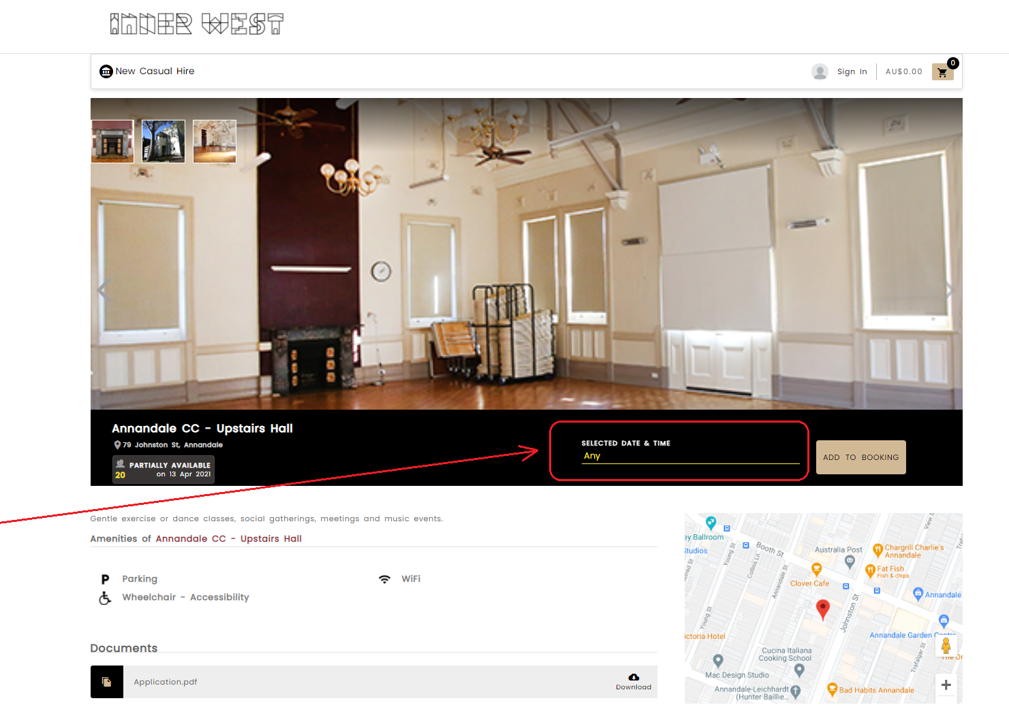

Step 6
Select your requested date (1), number of attendees (2) and times (3) for your proposed event – then clicking ‘Add to booking’ when this is done
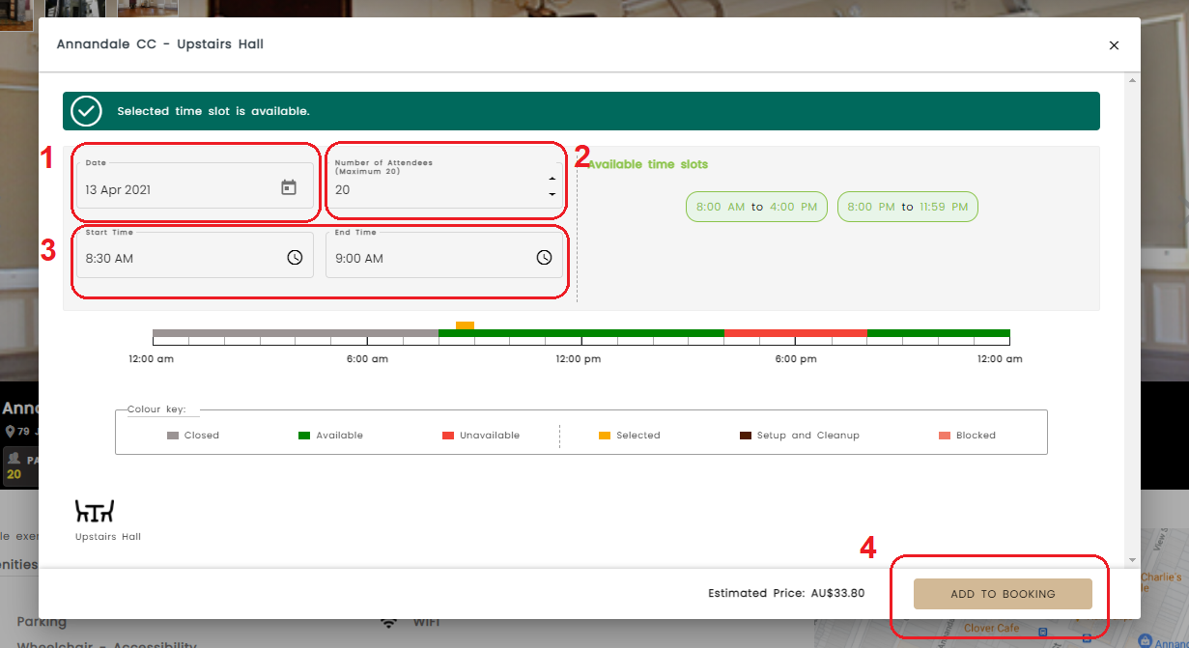

Step 7
The booking system will then take you to a ‘Booking Details’ page where you will need to select your event type and add an event name
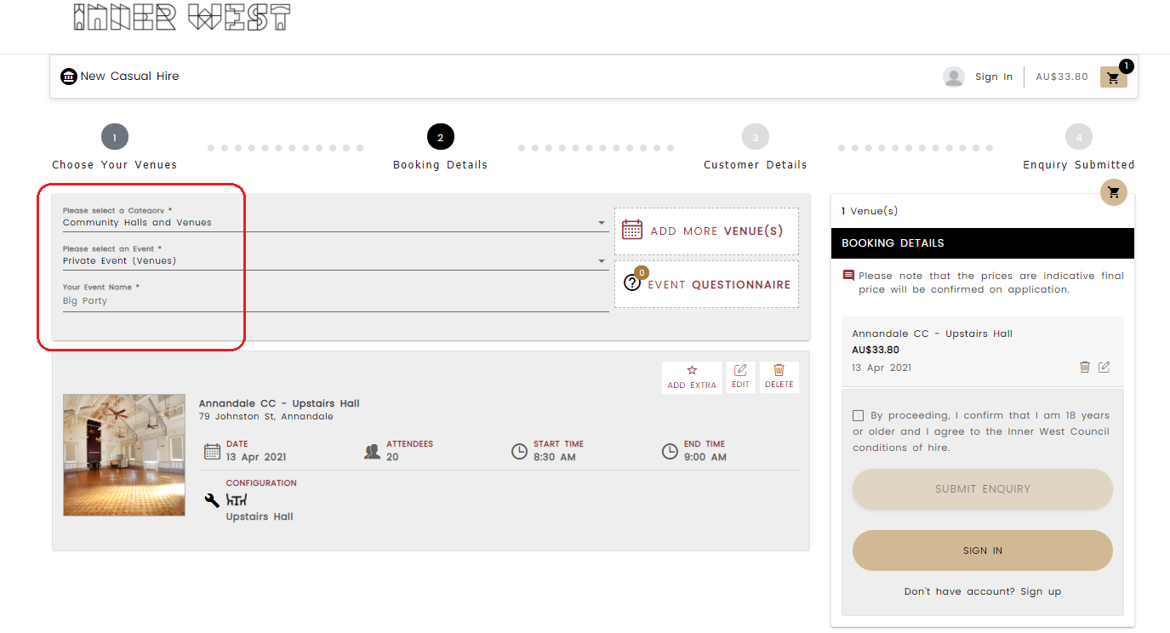
*Note that when selecting an event type, you will be presented (and required to complete), a questionnaire to proceed with the booking
Step 8
When selecting an event type, please complete the presented questionnaire before proceeding, and once completed, click to continue
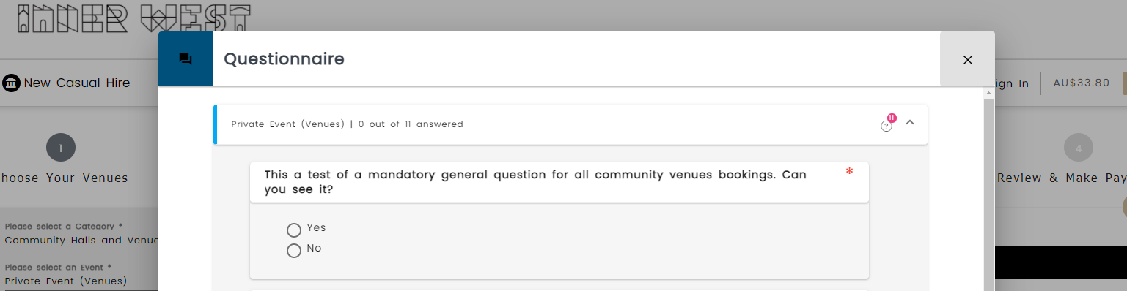
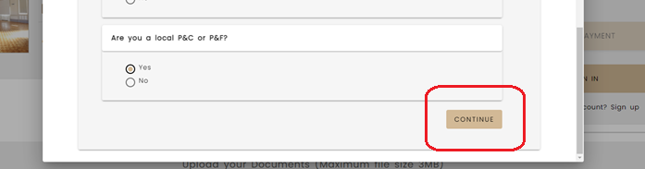

Step 9
Upload any required documents (1) and then tick the age confirmation (2) and ‘Submit enquiry’ (3)
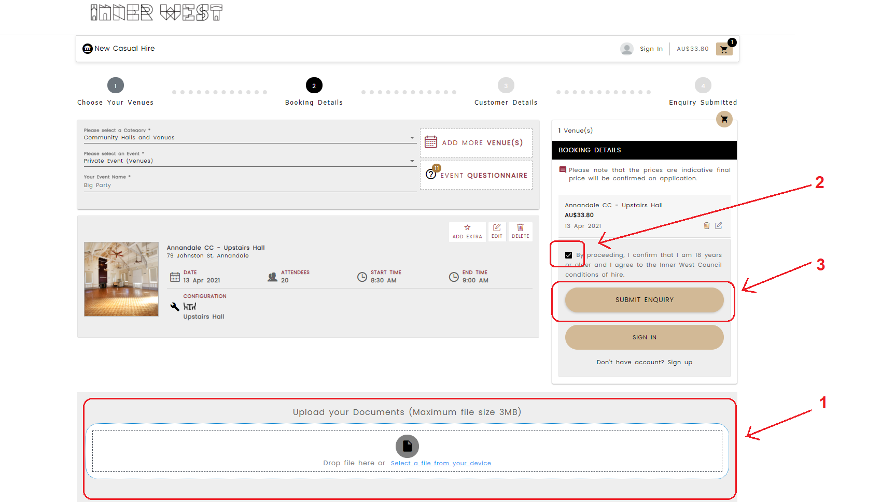
Step 10
Register to submit your booking enquiry by clicking on the ‘sign up’ tab…

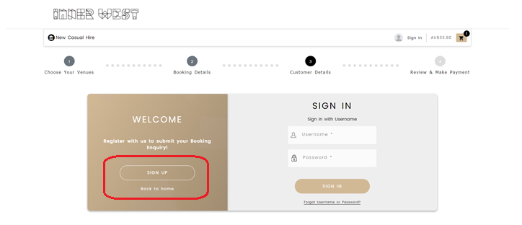

You will need to sign up as an individual customer if you are not applying on behalf of an organisation

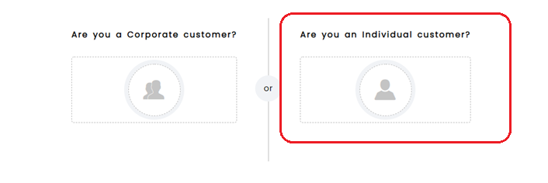

*NOTE: If you wish to sign up on behalf of an organisation or ‘Corporate Client’, please contact our bookings team as you may already have a pre-existing profile in the booking system
Contact us on bookingsteam@innerwest.nsw.gov.au

Step 11
Complete the ‘Customer Details’ section and click ‘Continue’ once completed
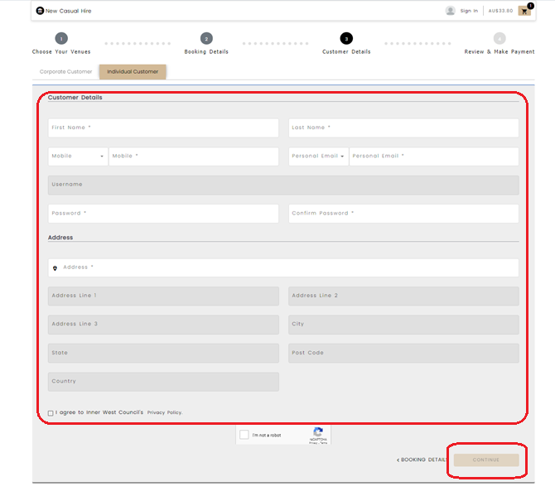
– this will then generate a booking submission number and take you to your new booking profile page (select the “My Bookings” to take you to your bookings history)
