Steps to complete a Street Party Application

- Login to Self-Service Account once you have registered.
https://www.innerwest.nsw.gov.au/about/get-in-touch/online-self-service
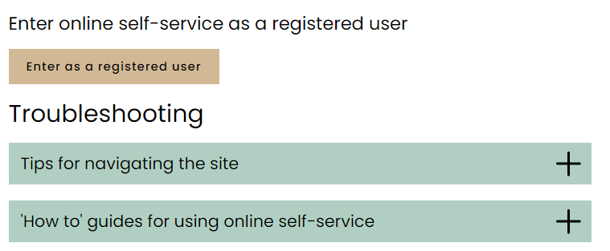
- Once you have logged in, please click on “Public Approvals” under Enquiries Tab
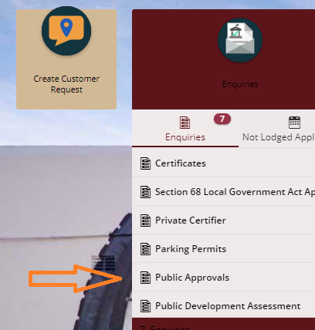

- Choose “Road Related Approval” from the list.
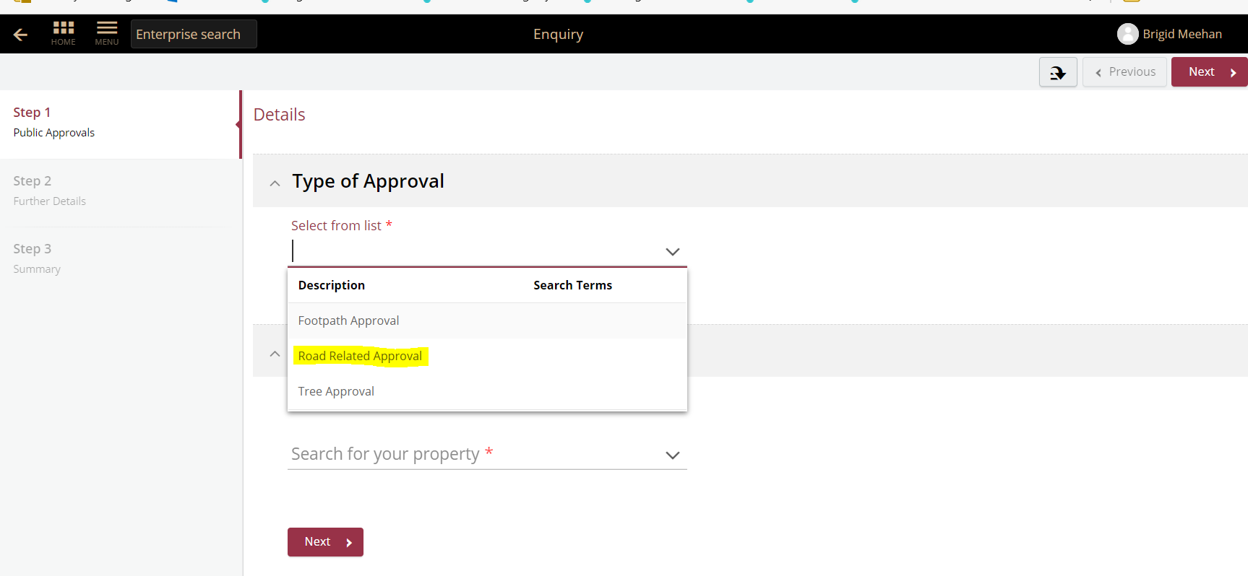

- Choose Appropriate Application, enter property address and click Next
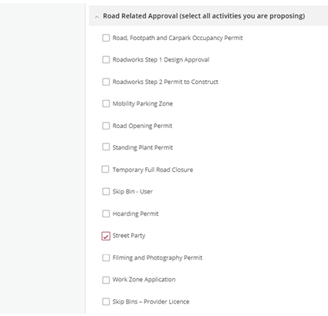
- Enter property address and click Next

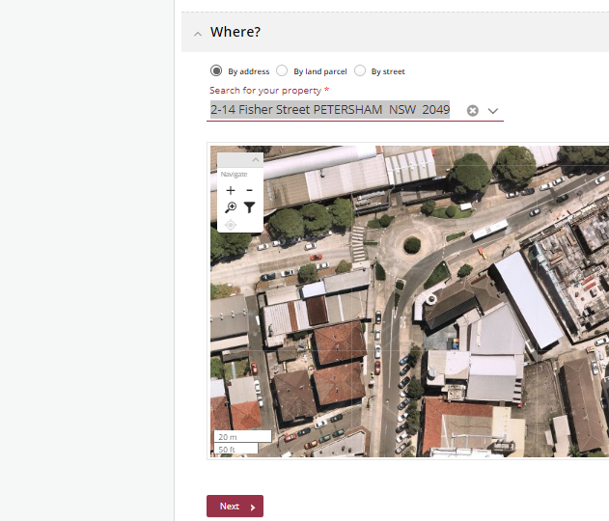
- Please answer the questions for the application and click next – Please note this information appears as Public Record on council application tracking website page. No personal information is displayed on the website.

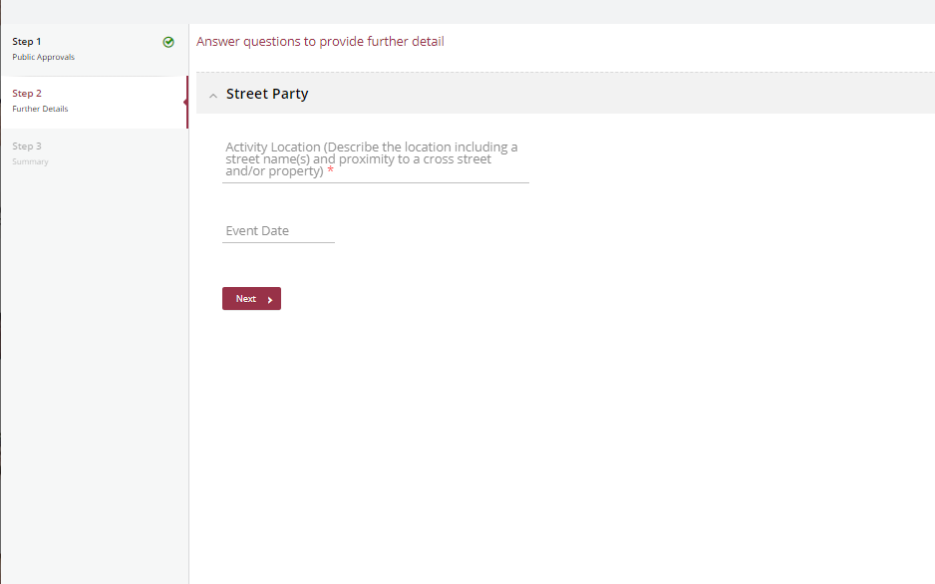
- Based on the information provided, a fee quote will be generated.
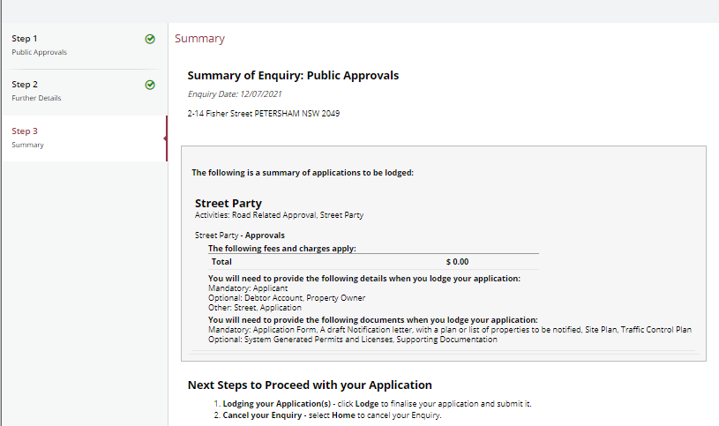
- Please click “Lodge” to continue with the application.
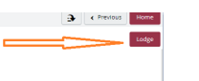

- The Application Summary Page will appear. Click on summary and complete the actions required. Please note the below is an example – every application will ask for different actions.
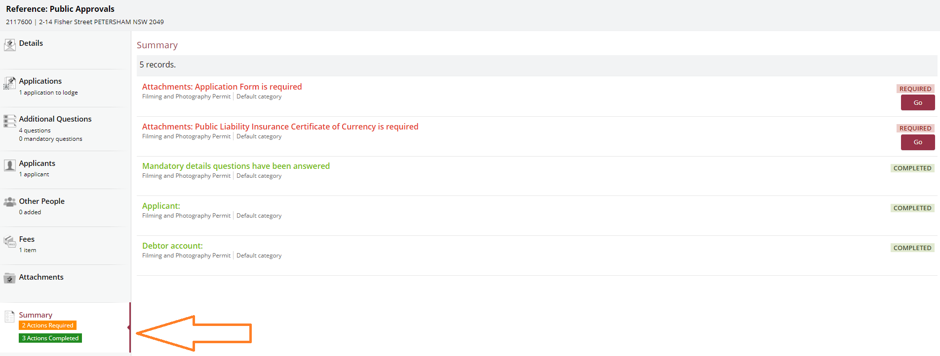
- Once all the information requested has been attached, “Pay Now” Option will appear.
- Click on Pay Now and payment page will appear
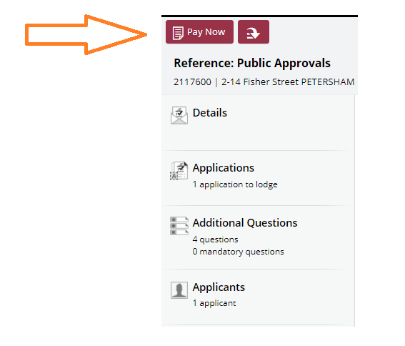
- FINAL STEP: Your Application is NOT LODGED until you complete this step.
Once you have made the payment, the system will take you back to application.
Ensure you click “Finalise and lodge” for application to be lodged.

