# Centre Programs

Annandale Community Centre offers a number of programs for community members. Please contact the centre for further information.

* Community Drawing Group
* Annandale Craft Group
* Tai Chi for Seniors
* Zentangle
* Choir

# Facility Hire

Rooms in Annandale Community Centre are available to hire for a wide variety of activities, events, meetings and programs. For bookings and associated fees and charges, please contact Annandale Community Centre on 9660 2828 or Inner West Council Booking Team on 9392 5000

# Justice of The Peace Service

A Justice of the Peace is available by appointment only. Please call 9660 2828

**Office Hours**

Monday Closed

Tuesday to Thursday 10.00am – 4.00pm

Friday 11.00am – 5.00pm

**Annandale Community Centre**

# Support Groups

**Alcoholics Anonymous**

Mondays 8.00pm

Annandale Town Hall (Back Hall)

No booking required

**Life Force Carers Group**

Tuesdays & Thursdays 5.45 – 7.45pm

(School Terms)

Meeting Room

Ph. 9389 3834

**Narcotics Anonymous**

Thursdays 8.00pm

Annandale Town Hall (Back Hall)

No booking required

*Inner West Council and the Annandale Community Centre support the following groups*

* *Annandale Playgroup*
* *Life Force Foundation*
* *Alcoholics Anonymous*
* *Cumberland Society*
* *Loaded Dog Folk Club*
* *Bluegrass Music*
* *S.H.A.R.E. Tai Chi*
* *Senior Choir*
* *Breastfeeding Association*
* *Narcotics Anonymous*
* *Community Drawing*
* *Annandale Craft Group*
* *NOW Public Transport Inc.*
* *Group of Forty*
* *Zentangle*
* *WHOOSH*

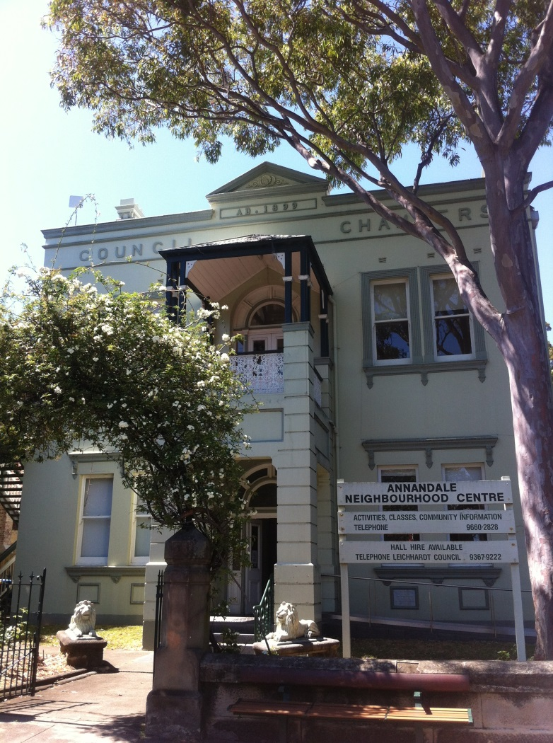



*Annandale Community Centre is a community facility of the Inner West Council*

79 Johnston St Annandale 2038

Ph. 9660 2828

[annandalecc@innerwest.nsw.gov.au](mailto:annandalecc@innerwest.nsw.gov.au)

www.innerwest.nsw.gov.au

**Annandale Community Centre Program**

**Term 3, July to September 2021**



**OCCASIONAL CHILDCARE**

9.00am – 1.30pm

Back Hall

Ph. 9692 9218 (during session times)

**OCCASIONAL CHILDCARE**

9.00am – 1.30pm

Bac

k Hall

Ph. 969

2 9218 (during session times)

**EPIPHANY** 2.30 – 6pm

**EPIPHANY**

2.30 – 6pm

**Thursday**

**Sunday**

**Saturday**

**Friday**

**Wednesday**

**Tuesday**

**Monday**

**Enquiries:**

**Phone the number recorded next to the relevant activity**

**Annandale Community Centre**

**Phone:**

02 9660 2828

**Address:**

79 Johnston St Annandale 2038

**Email:**

[annandalecc@innerwest.nsw.gov.au](mailto:annandalecc@innerwest.nsw.gov.au)

**Office Hours:**

Tuesday to Thursday

10am – 4pm

Friday 11am – 5pm

**CUMBERLAND SOCIETY**

9.00am – 5.00pm

**Upstairs Hall**

(2nd Sun month)

Grant: 0405327634

**SATURDAY** IMPROVISATION GROUP

10.30am – 12.30pm

Upstairs **Hall**

**YOGA-FELDENKRAIS**

9.30 – 10.45am

**Upstairs Hall**

(School Terms)Margery: 9660 5514

**COMMUNITY DRAWING GROUP**

9.00am – 1.00pm

**Upstairs Hall**

Bronwyn: 9392 5758

**NIA MOVEMENT**

11 - 12noon

**Upstairs Hall**

Leichhardt Women’s

Health Centre:

9560 3011

**YOGA-FELDENKRAIS**

6.15pm – 7.30pm

**Upstairs Hall**

(School Terms*)*

Margery: 9660 5514

**YOGA-FELDENKRAIS**

6.15 - 7.30pm

**Upstairs Hall**

(School Terms)

Margery: 9660 5514

**KUROYAMA DOJO**

7 to 9pm weekly

**Upstairs Hall**

Mat: 0410 707 044

**Group**

**GROUP OF FORTY**

12.30pm-3pm

**Upstairs**

4th Sat

Contact: Jane

0423 054 107

**ANNANDALE CRAFT GROUP**

11.00am –4.00pm

**Meeting Room**

Ph. 9660 2828

**BREASTFEEDING ASSOC.**

10am to 12pm

**Meeting Room**

2nd Monday

**Contact: Yulia**

**0403104908**

**AUSTRALIAN LABOUR**

**PARTY**

10am – 11am

3rd Sat of month

**Back Hall**

**LIFE FORCE CARERS SUPPORT**

5.45 – 7.45pm

**Meeting Room**

(School Terms)

Jane: 0412643751

Caro 0425296698

**LIFE FORCE SUPPORT**

5.45 – 7.45pm

**Meeting Room**

*(*School Terms*)*

Contact

Jane: 0412 643 751

Caro:0425 296 698

ZEZ

**SIMON BLOW QIGONG**

4pm to 5pm

**Meeting Room**

Contact: Simon

0421 815 254

The Annandale Community Centre reflects the activities that are regularly occur at the venue.

Casual Hirers can hire the Centre rooms by going to the Inner west Councils Website

**BLUEGRASS MUSIC** 6.30pm – midnight

Meeting Room

7.45pm – midnight

Back Hall

*(1st Saturday of the month)*

Ph. 9456 1090

**BOOMERANG BAGS**

(3rd Sun- month)

1pm – 5pm

Back Hall

Ph: 9569 3132

**WHOOSH AFTERSCHOOL CARE: Back Hall - Monday to Friday 2.30pm - 6pm during School Terms**

Monthly

Council Supported

School Terms

Fortnightly

**S.H.A.R E**

**SENIORS TAI CHI**

11.45am – 12.45pm

Back Hall

Ph: 9533 4422

**THE LOADED DOG FOLK CLUB**

8-11pm Back Hall

(4th Sat of the month)

PH: 9358 4886

**NARCOTICS**

**ANONYMOUS**

**Meetings**

**8pm – 9.30pm**

Back Hall

**ALCOHOLICS**

**ANONYMOUS**

**Meetings**

**8pm – 9.30pm**

Back Hall

**ANNANDALE**

**PLAYGROUP**

9.30am – 11.30am

Back Hall

[annandaleplaygroupnsw@gmail.com](mailto:annandaleplaygroupnsw@gmail.com)

**ANNANDALE**

**PLAYGROUP**

9.30am – 11.30am

Back Hall

[annandaleplaygroupnsw@gmail.com](mailto:annandaleplaygroupnsw@gmail.com)

**ZENTANGLE**

10.30am -12.30pm

Fortnightly

Workshops

RSVP 9392 5043

**STRESS LESS**

**Everyday Wellness**

Free Workshops

**CHOIR**

10.30am – 11.30am

**ANNANDALE**

**PLAYGROUP**

9.30am – 11.30am

Back Hall

[annandaleplaygroup nsw@gmail.com](mailto:annandaleplaygroup%20%20nsw@gmail.com)

**NARCOTICS ANONYMOUS**

8.00 – 9.30pm

Back Hall

**LOADED DOG FOLK CLUB**

8.00 – 11.00pm

Back Hall

*(4th Saturday of the month)*

Ph. 9358 4886

**S.H.A.R.E**

**Seniors Tai Chi**

11.45am – 12.45pm

Back Hall

Ph. 9533 4422

**ALCOHOLICS ANONYMOUS**

8.00pm – 9.3pm

Back Hall