Read Libby eBooks on computer
You can borrow Libby eBooks from Inner West eLibrary and read them on your computer. You do not need to download the file to a computer if you plan to read the eBook in the Libby app on your mobile or tablet device.
Before you start, make sure you have:
- A valid library card
- Internet access
Usually, an eBook can only be borrowed by one person at a time. If a book is on loan, you'll see an option to place a hold on the book. Once you place a hold, it will be added to the "Holds" section of your account. When the book becomes available, you'll receive a notification email.
- Log into the library catalogue and find a book that you’re interested in borrowing.
- Click on View availability
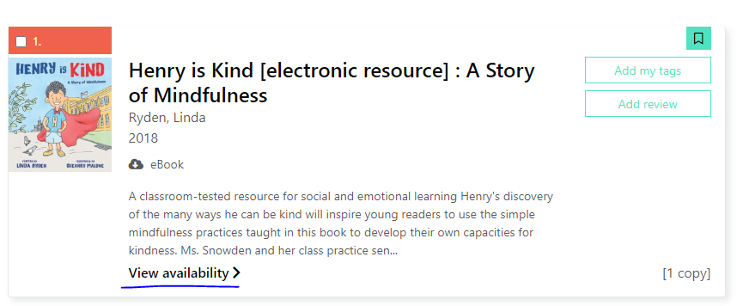

- Click on Borrow this eBook.
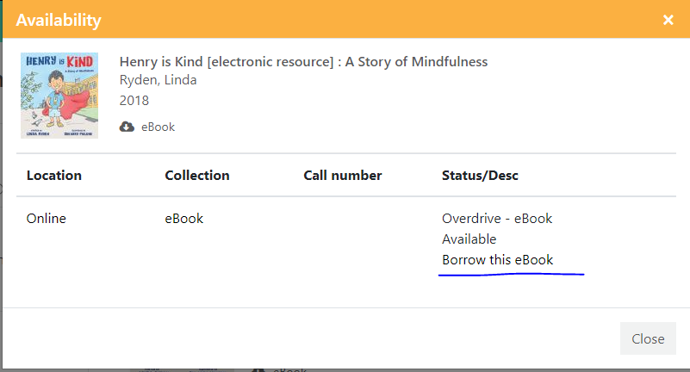
- Click on Continue.
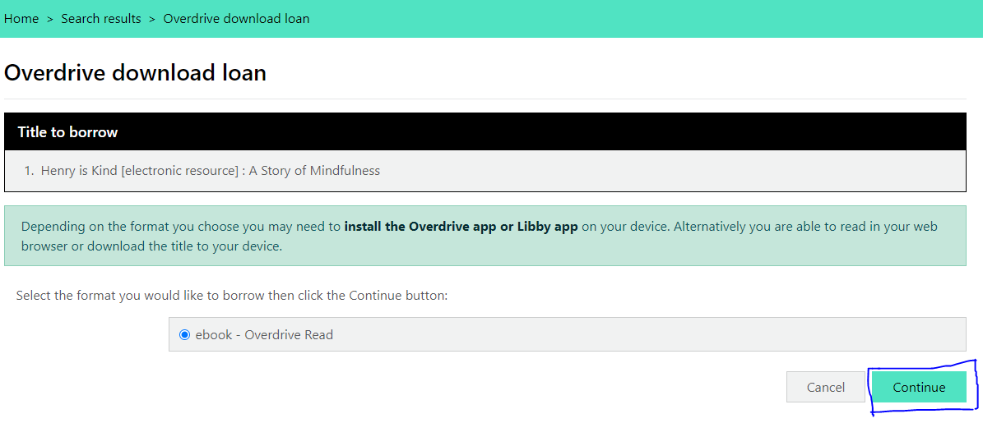

- Click on Download this title now.
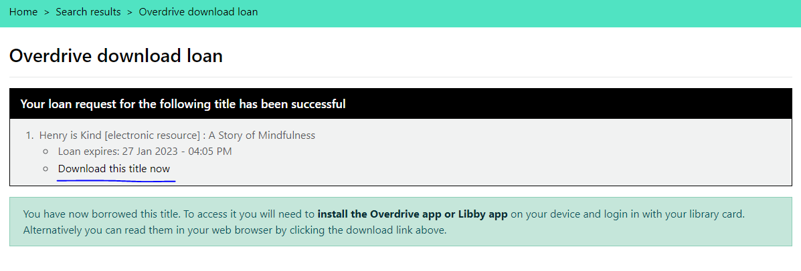
Note: Clicking on Download this title now opens Libby website
- Click on Read Online to read in the web browser.
