Reading BorrowBox eBooks on your eReader
Patrons can borrow eBooks from Inner West eLibrary and read them on their eReader.
Before you start, make sure you have:
- A valid library card
- Internet access
- Adobe Digital Editions Account
Borrowing BorrowBox eBooks from the library catalogue
- Log into the catalogue with your membership number and password/PIN and identify a BorrowBox eBook that you are interested in borrowing.
- Click on View availability.

Notes:
Usually, an eBook can be borrowed by one person at a time. If a book is on loan, you'll see an option to place a hold on the book. When the book becomes available, you'll receive a notification email.
- Click on Borrow this eBook.
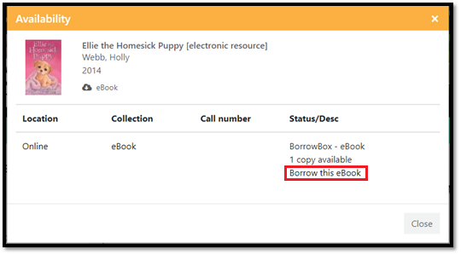
- Click on Continue.

- Click on Download this title now. The title will open in BorrowBox website.
- Click on Download for eReader (Adobe ePub) to download the .acsm file on to your computer.
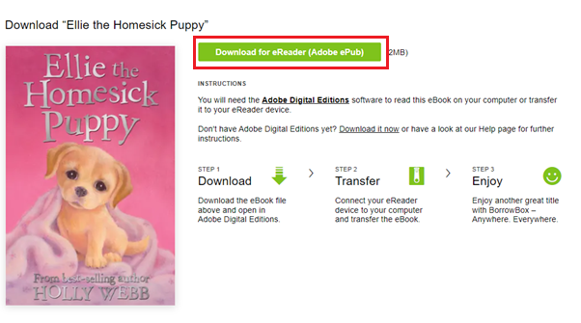

Notes:
Some books may not have a download option, which means that the eBook is not compatible for eReader.
By default, most web browsers download files into the Download folder. Look for the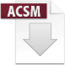.acsm file icon in the Download folder.

Transferring the eBook to an eReader device
- Connect your eReader to your computer using a Micro USB cable.
- Tap Connect on your eReader.
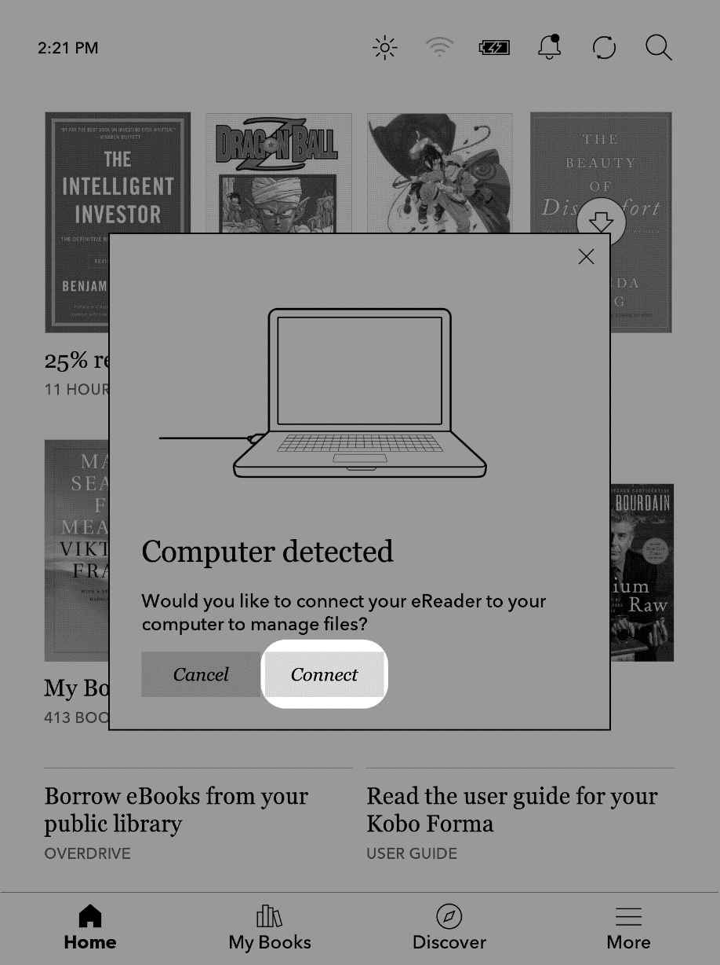

- On your computer:
- Go to the folder where your eBook (the .acsm file) is saved.
- Double-click the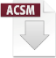.acsm file. The book will open in ADE.
- Click Library at the top of the screen.
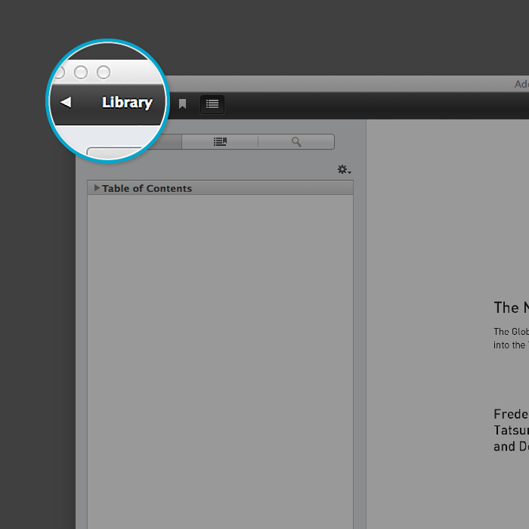

- Click All Items under the Bookshelves menu.
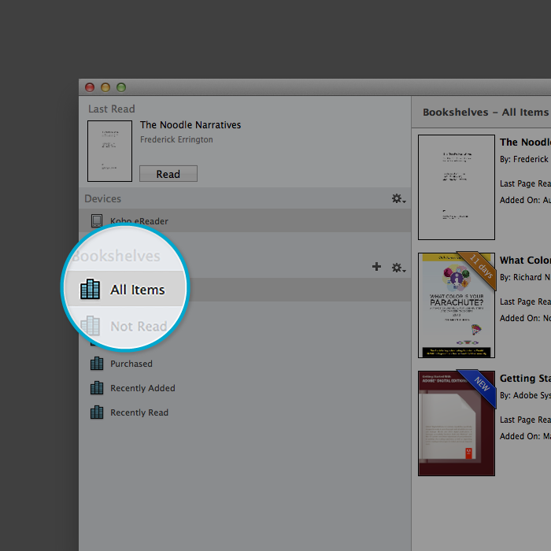
- Click on your new book and drag it to your eReader listed on the left side under Devices.
- Eject your eReader from the computer and unplug the USB cable. Your eReader will show Processing Content message. The library book will appear on your eReader's Home Screen.

Borrowing an eBook from the BorrowBox website
- Sign into the BorrowBox website with your membership number and password/PIN and identify an eBook that you are interested to borrow.
- Click on Borrow.
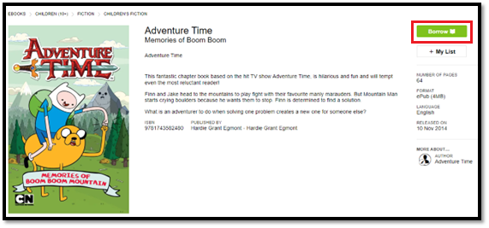
- Click on Confirm Loan.
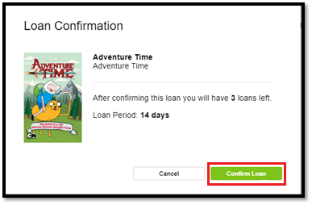
- Click on Read now
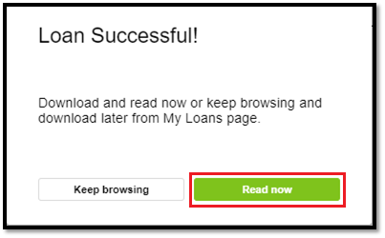
- Click on Download for eReader (Adobe ePub)

Notes:
Some books may not have a download option, which means that the eBook is not compatible for eReader.
By default, most web browsers download files into the Download folder. Look for the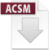.acsm file icon in the Download folder.

Transferring the eBook to an eReader device
Follow the steps given in page 3 of this document.

