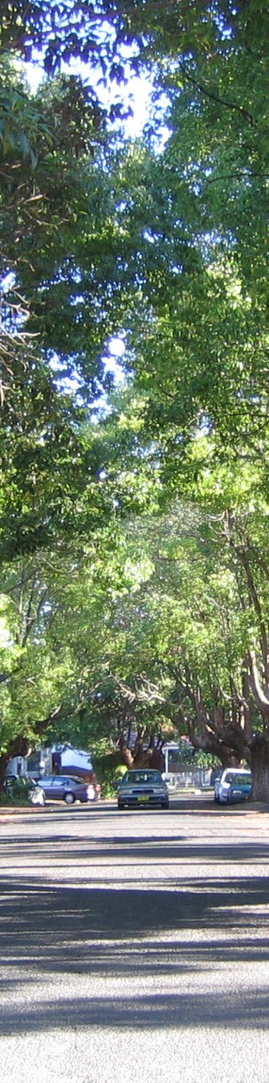Marrickville Urban Forest Strategy

Advanced Issue

Administrative Centre | 2-14 Fisher Street, Petersham PO Box 14 PETERSHAM NSW 2049 | Phone: 9335 2222
council@marrickville.nsw.gov.au | www.marrickville.nsw.gov.au

TABLE OF CONTENTS
EXECUTIVE SUMMARY 1
- INTRODUCTION 3
- VALUES 5
- URBAN FOREST STRATEGY 9
- ACTION PLAN 11
5 APPENDICES 19
5a BACKGROUND 20
5b. GLOSSARY 28
5c. REFERENCE LIST 30
5d. TREE LAW ACTS AND REGULATION 31
Marrickville Council
Urban Forest Strategy

LIST OF FIGURES

Figure 1. Jacarandas in bloom - Cardigan Street, Camperdown 1
Figure 2. Plane Tree Avenue to Williams Parade, Dulwich Hill 3
Figure 3. Jacarandas, Cardigan Street, Camperdown 5
Figure 4. Community usage of parks 6
Figure 5. Large Tree in Petersham Park, Petersham shading playground. 7

Figure 6. Marrickville Road. Street trees planted along main shopping precinct 8
Figure 7. Urban Forest Council Co-ordination 10
Figure 8. Ficus macrophylla - the oldest living tree in Marrickville (1856)
at St Stephen’s Cemetery Newtown 20
Figure 9. Enmore Park, Enmore, c. 1936 (Photographer Unknown, c. 1936, Marrickville
Library Services — Local Studies Images Database 000/000574) 20
Figure 10. Enmore Park, Enmore 20
Figure 11. Henson Park , Marrickville, c. 1936 (Photographer Unknown, c. 1936, Marrickville
Library Services — Local Studies Images Database 000/000858) 21
Figure 12. Henson Park , Marrickville 21
Figure 13. Canonbury Grove, Dulwich Hill, c. 1936 (Photographer Unknown, c. 1936, Marrickville
Library services — Local Studies Images Database 000/000251). 21
Figure 14. Canonbury Grove, Dulwich Hill 21
Figure 15. Corymbia (Eucalyptus) citriodora, Brighton Street, Petersham 22
Figure 16. Flindersia australis, Hopetoun Street, Camperdown 22
Figure 17. New street tree planting along Crystal Street, Marrickville 24
Figure 18. Trees in public and private spaces 24
Figure 19. Ficus microcarpa var ‘Hilli’ at Collyer Playground, Newtown 25
Figure 20. Aerial photo of Day Street, Marrickville 26
Marrickville Council
Urban Forest Strategy

Marrickville Council
Urban Forest Strategy
EXISTING PLANNING INSTRUMENTS AND COUNCIL POLICIES

Policy/Document | Name | Status

LEGISLATION

 | Environmental Planning & Assessment Act 1979 | Current
 | Local Government Act 1993 | Current
 | Roads Act 1993 | Current
 | Electricity Supply Act 1995 | Current
 | Sydney Water Act 1994 | Current
 | Heritage Act 1977 | Current
FORMAL PLANNING INSTRUMENTS

 | State Environmental Planning Policy (infrastructure) 2007 | Current
LEP 2001 | Marrickville Local Environment Plan 2001 | Current (to be replaced)
TPO 2007 | Marrickville Tree Preservation Order 2007 | Current (to be replaced)
LEP 2010 | Marrickville Local Environment Plan 2010 | Draft
LEP 2010: Part A | Development Application Guidelines | Draft
LEP 2010: Part 2.18 | General Provisions - Landscaping | Draft
LEP 2010: Part 2.20 | General Provisions – Tree Management | Draft
MARRICKVILLE COUNCIL POLICIES

 | Street Tree Policy Review and Guidelines 1993 | Current
Policy PR3 | Tree Policy 1995 | Current
Policy PR4 | Protection Of Trees 1995 | Current
Policy PR6 | Tree Management Policy 1996 | Current
 | Urban Forest Policy 2010 — superseding PR3 / PR4 / PR6 | Draft
 | Asset Management Policy 2010 | Current

Draft URBAN FOREST POLICY

Policy Purpose

The purpose of this policy is to establish Council’s commitment to the holistic management of Marrickville’s urban forest. It recognizes the urban forest as an essential, living infrastructure asset and resource that provides a wide range of social, environmental and economic benefits.

This Policy recognises the imperative for Council to commit to maintaining and increasing the benefits provided by the Marrickville urban forest and it provides directional statements intended to guide urban forest management decisions.

Related Legislation, Policies and Documents

- Environmental Planning & Assessment Act 1979
- Local Government Act 1993
- Roads Act 1993
- Electricity Supply Act 1995
- Sydney Water Act 1994
- Heritage Act 1977
- (SEPP) State Environmental Planning Policy (infrastructure) 2007
- Marrickville Local Environment Plan 2001
- Marrickville Tree Preservation Order 2007
- AS 4373 Pruning Of Amenity Trees
- AS 4970 Protection of Trees on Development Sites
- Marrickville Urban Forest Strategy 2010 (Draft)
- Local Government Amendment Planning and Reporting Bill
- Local Government (General) Amendment (Planning and Reporting) Regulation
- Marrickville Asset Management Policy 2010:
- Marrickville Transportation Asset Management Plan
- Marrickville Parks Asset Management Plan
- Marrickville Property Services Asset Management Plan
· Marrickville Car Park Asset Management Plan

Background

The draft Marrickville Urban Forest Strategy 2010 (MUFS) identifies the critical factors influencing the urban forest in Marrickville and defines strategic actions required to maintain and increase
a healthy urban forest and its associated benefits. The policy statements contained within this document relate to the stated strategic actions in the draft MUFS, with the aim of guiding the future management of Marrickville’s urban forest.

This Policy replaces the following Marrickville Council Policies:
- PR.3 – Tree Policy
- PR.4 – Protection Of Trees
- PR.6 – Tree Management Policy
Marrickville Council
Urban Forest Strategy

Marrickville Council
Urban Forest Strategy

Objectives

  - To recognise and acknowledge the urban forest as a vital contributor to the social, ecological
and economic health and well-being of Marrickville and its citizens.

  - To maximise and perpetuate the capacity of Marrickville’s urban forest to provide social,
ecological, economic and amenity benefits.

  - To sustain and increase Marrickville’s urban forest on an intergenerational life cycle basis.

Policy Statment

Urban Forest Protection
  - Council will regulate tree pruning and removal activities through its Tree Management
Development Control Plan.
  - Council will ensure that Development Applications include all requisite information to allow
the comprehensive assessment of potential impacts on trees.
  - Council will ensure the protection of public trees directly affected by a development through
the imposition of appropriate bonds.
  - Council will not permit the removal of trees to allow for the provision of construction
hoardings.

Urban Forest Asset Management
  - Council will Identify and evaluate Marrickville’s urban forest.
  - Council acknowledges trees on public land as infrastructure assets.
  - Council will complete and maintain an inventory of its public tree assets consistent with its
Asset Management Policy.
  - Council will ensure best practice management of its urban forest assets.
  - Council will proactively manage tree risk management issues by establishing and following
guidelines and procedures relating to insurance claims on Council owned trees.

Urban Forest Canopy
  - Council will sustain, replenish and aim to increase urban forest canopy cover in the Marrickville LGA through cyclic annual public tree removal and replacement programmes, capital funding programmes to increase public tree canopy cover and effective planning controls over private land.
  - Council will increase the diversity of suitable tree species planted to include locally endemic, indigenous and exotic species. However the overriding principal will be that tree species are selected according to their overall suitability for chosen planting sites.
  - Council will continue to seek new opportunities for tree planting and will continue to plant
trees in appropriate locations.
  - Assessment of Development Applications will ensure that proposed public realm tree
plantings are compatible with Council’s desired landscape character for a given location.
  - Council will base any decision to remove a tree or trees on one or more of the following:

Marrickville Council
Urban Forest Strategy

- The condition of the tree, where a tree is dead or dying, or where it is assessed that it is dangerous.

- Public infrastructure damage being caused by the tree, which is considered significant and which cannot be overcome by any other means.

- Damage to major structures on private property.

- Any other reason at the discretion of Council's staff, which can be justified either on technical or legal grounds according to particular circumstances.
  - Council will notify and, where appropriate, consult the community about planned tree
removal and planting activities.
  - Exceptional circumstances not withstanding, Council will not prune or remove trees due to the effects of the natural processes of trees and wildlife including; leaf, fruit or sap drop; bird and bat droppings or because branches overhang private properties.

Community Involvement
  - Council will involve the community as a key partner in managing the urban forest in
Marrickville LGA.

Marrickville Council
Urban Forest Strategy

EXECUTIVE SUMMARY

Marrickville Urban Forest Strategy (MUFS) has been prepared by Parks and Reserves, Infrastructure Services. The MUFS is intended to guide the forward planning for the urban forest in Marrickville.

The Urban Forest of Marrickville is an essential component of the built environment and a legacy for future generations. As living organisms in altered physical conditions trees need appropriate management to maximise their benefit to the community and the environment. Adequate resources must be allocated to ensure trees are well managed.

Initial Community and Council consultation was conducted for the preliminary 2007 issues paper. Recently, internal discussions have been conducted with other Council Divisions, Senior
Management and Councillors to co-ordinate with Council’s overarching Draft Community Strategic Plan (CSP) 2010.

Council’s tree policies are currently in a state of flux as earlier strategies were only partially achieved. The objective of the Marrickville Urban Forest Strategy is to redefine, from today’s perspective, an achievable vision for Marrickville’s Urban Forest. The strategy will determine future direction and actions to guide Council until 2016. The strategy will be formatted to enable review every 5 years.

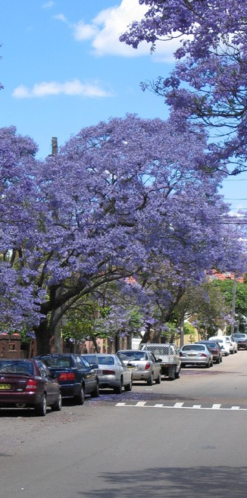
Figure 1. Jacarandas in bloom — Cardigan Street, Camperdown
The CSP outlines a strategy in regard to Marrickville’s Urban Forest as follow:

Strategy

Increase the urban tree canopy through new and replacement tree planting.

The MUFS is being submitted for endorsement by Council in 2010, the final title could be Marrickville Urban Forest Strategy 2011-2016, as this would provide a natural mechanism for review at the appropriate time.

Urban Forest Policy

Council has revised and consolidated its tree policies into a single Urban Forest Policy that sets the agenda for the actions needed to realise the strategy.

ACTIONS

Action 1 —Identification, Evaluation and Monitoring of the Urban Forest
The first step towards managing an asset is the establishment and maintenance of an accurate inventory of that asset. Therefore the strategy looks to develop a “live” asset inventory for all of the Public Tree Assets on Council land and an overview of the percentage canopy cover of the urban forest as a whole across the LGA (both public and private).

Marrickville Council
Urban Forest Strategy

Action 2 — Increase Marrickville’s Urban Forest Canopy
Council’s primary objective is to increase Marrickville’s urban forest. This action identifies mechanisms to maintain and increase the public tree asset and promote the increase of canopy cover (planting of trees) on private land.

Action 3 — Undertake Whole of Life Management
To ensure the optimum useful life span of Marrickville’s new and existing public trees, this action promotes a whole of life management approach to the Public Tree Asset including prioritised management regimes for nominated items such as significant trees.

Action 4 — Involve and Engage the Community in Tree Management
The successful implementation of Marrickville's vision for the urban forest needs community support. To encourage and focus this support Council will seek to educate the community as to the benefits of the urban forest, and how to best increase and maintain the urban forest. Council will also aim involve the community in decision making and care of the urban forest.

Action 5 — Priorities, Resource and Budget for the Urban Forest
Council will set priorities, resourcing options and budgets to implement the MUFS to realise the vision.

Two high priority actions are identified that require substantial budgets and are currently unfunded. These are:

Collection of asset condition data on all public trees, the establishment of a public tree asset inventory and identification of the combined public and private urban forest as a percentage canopy over the LGA.

This component is of primary importance as it establishes the base line from which the planning and management of the UFS is generated.

Preparation of a Street Tree Master Plan.

From the base line of the tree asset inventory the Street Tree Master Plan (STMP) sets out the framework and actions for achieving the MUFS, providing Council with a tool to guide resourcing and formulation of future budgets. It is intended that the STMP would also identify opportunities for increasing the urban forest on State Government & “Not for Profit” Organisation lands. The STMP provides a vehicle for community engagement on the future development of the urban forest.

Marrickville Council
1
Urban Forest Strategy

INTRODUCTION

Attractive trees in the urban landscape make a significant contribution to the quality of life of its inhabitants. On the broad-scale trees contribute to the urban environment aesthetic and improved environmental conditions, on the micro-scale trees provide screening, privacy, interest, shade, traffic calming and habitat.

Urban trees combine to form the urban forest which has been defined in Local Government Associations Urban Forest Policy 2003 as

“Urban Forest is the totality of trees and shrubs on all public and private land in and around urban areas (including bushland, parkland, gardens and street trees) and is measured as a canopy cover percentage of the total area, and is recognised as a primary component of the urban ecosystem”

Currently, the Marrickville landscape includes an interesting mixture of industrial, residential and commercial buildings with a healthy interwoven texture of vegetation.

A perceived point of concern to the community and Council officers is the progressive removal of medium to large trees through the continued process of urban consolidation over the last two
decades, resulting in an overall quantum decline of the large trees (therefore the urban forest) and alteration to the character of Marrickville.

Over time Council has adopted a number of policies, strategies and planning instruments, which direct and prescribe tree management. Most of these documents predate Council’s 2001 Local Environment Plan (LEP), which is itself under review. As Council is currently preparing new LEP & Tree Management DCP, a review of existing tree asset condition and current management
procedure in the Marrickville LGA is considered timely to assist the policy making process. Council is also preparing a Community Strategic Plan to set its direction for the future.

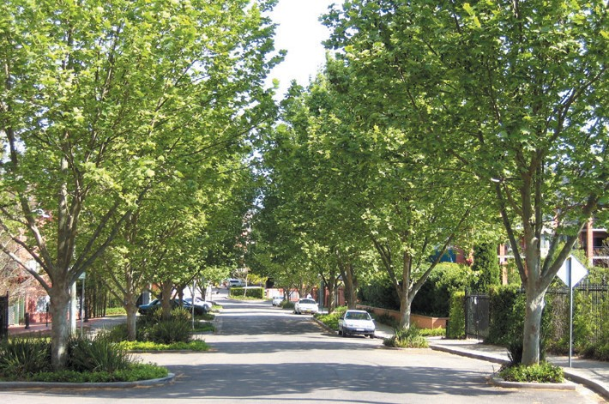

Figure 2. Plane Tree Avenue to Williams Parade, Dulwich Hill

Marrickville Council
1
Urban Forest Strategy

The Draft Community Strategic Plan identifies a well planned sustainable urban environment as a key result of Council’s activities. The Urban Forest being a significant part of the urban environment should be managed to contribute to the achievement of this result.

The vision for Marrickville’s Urban Forest is that:

Marrickville’s Urban Forest is a well managed, intergenerational, resource providing amenity, social, environmental and economic benefits to the community.

The Marrickville Urban Forest Strategy (MUFS) takes this vision and the Draft Urban Forest Policy (preceding this document) enlarges upon them to describe the values, strategic approach and actions to be undertaken to manage and increase the Urban Forest within the Local Government Area (LGA) of Marrickville for the period 2011-2016.

The MUFS also outlines a number of changes to the way Council manages trees both within Council and privately owned lands. The Public Tree Asset will be managed according to the “whole of life” management approach based on industry best practice principles.

The other change of approach results from the concept of the Urban Forest being trees on both private and public land and for the need for the urban forest across the LGA to have a critical mass of percentage canopy cover in order to maximise the environmental benefits for the urban environment such as decreasing urban area heat island effect and air borne pollution.

Marrickville Council
2
Urban Forest Strategy

VALUES

The contribution of the urban forest to community quality of life is considerable within the heavily urbanised environment of Marrickville. With a mix of industrial, commercial and residential
land uses, the existence of major transport routes and the shift to higher density residential developments, the value of the urban forest increases over time. To best manage a valuable asset it is essential to establish it’s value to the community. In relation to the urban forest, the primary values are :

Aesthetic

The urban forest make a substantial contribution to improving the visual amenity of the built environment through:
  - the intrinsic beauty of trees,
  - screening of undesirable views, structures and/or utilities,
  - maintaining culturally significant plantings,
  - creating improved spatial relationships (at various scales),
  - creating consistency in outlook and vista,
  - providing visual diversity and interest, and
  - softening the urban fabric.

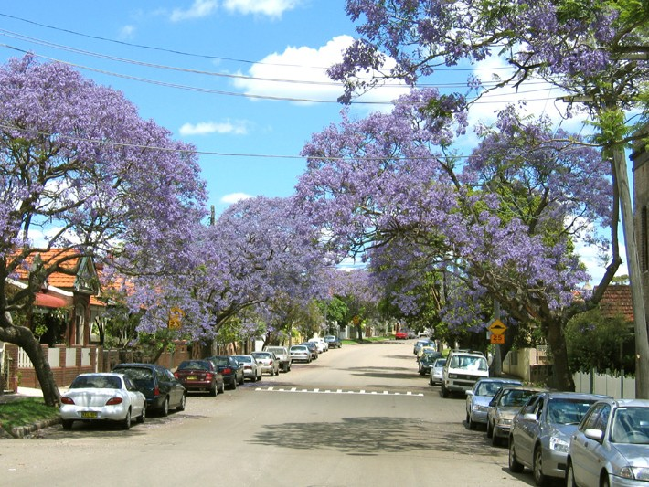

Figure 3. Jacarandas, Cardigan Street, Camperdown

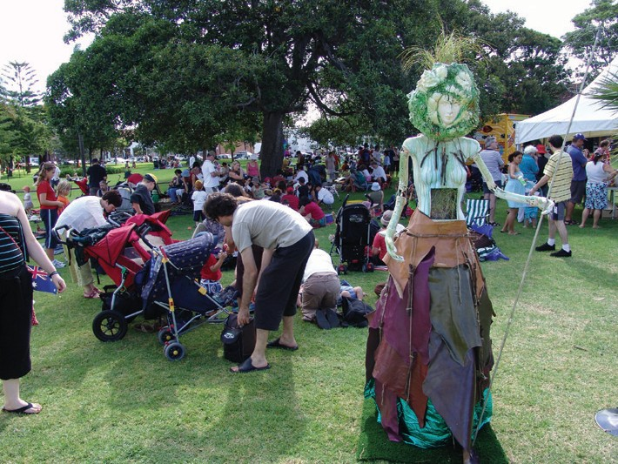
Marrickville Council
2
Urban Forest Strategy

Community

The Urban Forest is integral to community wellbeing through:
    - the creation of a positive and pleasant community identity for all (social justice),
    - marking seasonal change and regeneration (spiritual and cultural attachment),
    - addressing local environmental issues and action (Agenda 21),
    - addressing “Green” living environmental principles with functional applications,
    - a safe and secure living environment, and
    - providing an avenue for environmental education for both the community as a whole and children’s environmental development.

Figure 4. Community usage of parks

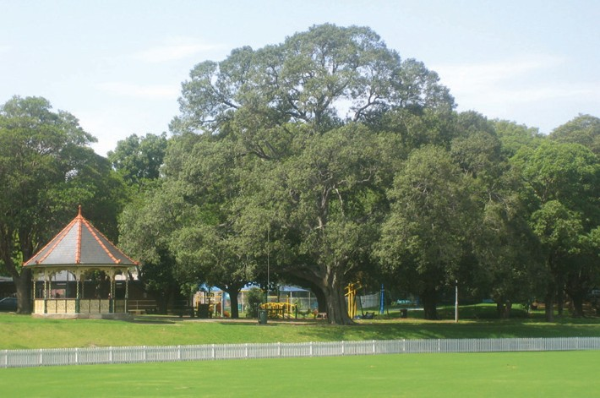
Marrickville Council
2
Urban Forest Strategy

Environmental

The Urban Forest contributes to the Marrickville's environment through:
      - providing shade that reduces the impact of UV solar radiation and glare,
      - point of contact soil and water management
      - improvements to microclimate, through evapotranspiration & shading,
      - protection from rain and hail,
      - reduction of water borne pollutants in urban run-off,
      - air pollution reduction by extracting carbon dioxide, producing oxygen and trapping dust and fine air borne particles,
      - wind amelioration by deflection and reduction of the wind tunnelling effect,
      - increasing the potential for wildlife habitat and biodiversity,
      - improvements to microclimate at ground level which assists other plantings,
      - carbon storage, and
      - reducing ambient urban temperatures to reduce heat island effect

Figure 5. Large Tree in Petersham Park, Petersham shading playground.

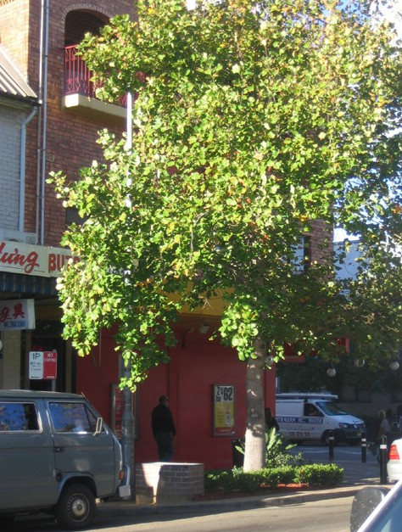
Marrickville Council
2
Urban Forest Strategy

Economic

The Urban Forest brings economic benefits through:
    - increased property values
    - increased profitability of commercial / retail areas
    - reduced energy consumption
    - extend life of shaded pavements

Figure 6 Marrickville Rd. Street trees planted along main shopping precinct

Marrickville Council
3
Urban Forest Strategy

URBAN FOREST STRATEGY

The Draft Community Strategic Plan has a direct influence on the Marrickville Urban Forest Strategy (MUFS). Its Key Result Area (KRA) 3 calls for “A well planned, sustainable urban environment” with an outcome ( 3.6 ) of Marrickville having “a thriving natural environment” and one of the strategies (c) to achieve this outcome is

KRA 3.6 (c) Increase the urban tree canopy through new and replacement tree planting.

This strategy along with the definition of the Urban Forest put forward by the Local Government Associations in its Urban Forest Policy 2003 as previously defined forms the overarching framework for the MUFS.

The MUFS defines the processes and strategic actions to be undertaken for increase and management of the Urban Forest within the Local Government Area (LGA) of Marrickville for the period 2011-2016.

This strategy is related to other Council documents currently being developed including the Marrickville Asset Management Strategy and Policy, Water Management Sub Catchment Management Plans, Parks Biodiversity Strategy, the Marrickville LEP 2010 & Tree Management DCP 2010.

The MUFS makes a number of changes to the way Council manages trees both within Council and privately owned lands. The Public Tree Asset will be managed according to the “whole of life” industry best practice principles such as selection of the right tree for the right place, developing an age group spread within the public tree asset, planting large trees in appropriate locations as well as initiating proactive maintenance activities such as formative pruning from an early age and higher levels of management for nominated trees.

Out of the concept of the Urban Forest comes the aim of maintaining an appropriate percentage canopy cover for the LGA to maximise the many community and environmental benefits contributed by the urban forest. Marrickville’s current % canopy cover has not been measured.

This fundamental gathering of data both for the Public Tree Asset and the canopy cover of
Marrickville are high priority actions identified.

It should be noted that while the MUFS outlines the objectives and strategies for cyclic or recurrent Urban Forest Management operational activities, it does not seek to address (other than looking at best practice) capital funded works such as tree planting associated with road upgrade work (with associated initiatives such as WSUD or structural soils etc).

Marrickville Council
3
Urban Forest Strategy

Conclusion

The Actions Table following identifies and prioritises actions required to implement the
MUFS.

The 5 areas of focus are:
- Identification, Evaluation and Monitoring of the Urban Forest
- Increase Marrickville’s Urban Forest Canopy
- Undertaking Whole of Life Management
- Involving and Engaging the Community
- Priorities, Resource and Budget for the Urban Forest

Where additional funding is likely to be required this has been identified. It is anticipated that the majority of actions to implement the Marrickville UFS can be progressively implemented with existing resources.

However, two high priority actions are identified that require substantial budgets and are
currently unfunded. These are:

  - Collection of asset condition data on all public trees and the establishment of a public tree asset inventory and identification of the combined public and private urban forest as a percentage canopy over the LGA.

This component is of primary importance as it establishes the base line from which the planning and management of the UFS is generated.

  - Preparation of a Street Tree Master Plan.

From the base line of the tree asset inventory the Street Tree Master Plan sets out the framework and actions for achieving the UFS, providing council with a tool to guide resourcing and formulation of future budgets. It is intended that the STMP would also identify opportunities for increasing the UF on State Govt & “Not for Profit” Organisation lands and is the vehicle for engaging the community regarding future urban forest development.

4
Marrickville Council
Urban Forest Strategy
4. ACTIONS

The following MUFS actions have been prioritised with consideration of current staff and funding resources. General indications of additional funding have been put against required outcomes, however formalised project bids will be made through Council's budget process for specific funding.

No. | Priority | Actions | Outcome | Funding
 | HP | High Priority | Require substantial additional funding | ■
 | MP | Medium Priority | Some additional funding required | t
 | LP | Low Priority | Little / no additional funding required — use existing resources | l
1 |  | Action 1: Identification, Evaluation and Monitoring of the Urban Forest
1.1 | HP | Update data base of all Council Trees & maintain ‘live’ Urban Forest data base
 |  | Determine scope of existing street and park data base | Existing data base assessed and missing data identified | l
 |  | Scope tree asset data collection including software and  hardware compatibility for field updating | Scoping of software and hardware carried out | l
 |  | Integration of tree data into Asset Master as live field  updateable asset data set. | Public Tree Asset Inventory completed (Council streets and parks asset) | ■
 |  | Qualitative assessment of Public Tree Asset to guide allocation of management resources. | Quantum of resources required for public tree management  identified | l
 |  |  | Trees Requiring high level maintenance identified | l
1.2 | HP | Assessment of % existing urban forest canopy cover
 |  | Air photo assessment of urban forest from 1980 every decade to 2010 to determine % existing Marrickville canopy cover and change over time — GIS Mapping assessment by specialist consultant | Existing % canopy cover measured  and Benchmark set for:  - public land  - private land ( incl. “Not for Profit” Organisation Lands)  - crown land (SRA, DET, RTA)  - Information provided for State of the Environment Reporting | ■
 |  | Determine realistic % canopy increase (& time scale) and program (council trees) / methods (private trees DA guide with mechanisms for conservation &/ or compensatory planting requirements etc) | - Target % increase identified  - Program set for the provision of increased canopy cover  defined and Council Endorsement gained | l
1.3 | LP | Determine significance of all urban forest trees
 |  | Determine purpose/objectives of significance classification  including additional management / constraints | - Significance classification objectives defined | l
 |  | Determine categories and criteria (on heritage, amenity and arboriculture values) | - Categories and criteria defined | l
 |  | Categorise all urban forest trees to identify significance  ranking | - Urban Forest categorised | t

Urban Forest Strategy 4
Marrickville Council

No. | Priority | Actions | Outcome | Funding
 | HP | High Priority | Require substantial additional funding | ■
 | MP | Medium Priority | Some additional funding required | t
 | LP | Low Priority | Little / no additional funding required — use existing resources | l
1.4 | MP | On-going review of Urban Forest % canopy cover
 |  | Council tree asset condition data collected on agreed frequency 5 years cycle to achieve AMP | Tree asset data assessed on 5 yr basis  — AMP requirements achieved | t
 |  | Undertake repeat GIS Mapping — assessment by specialist consultant – compare with previous mapping results | Mapping repeated trends identified | t
 |  | Monitor LEP/DCP impacts on Urban Forest Canopy Collect data on:  - TPO/Permit applications to prune/remove trees  - Development Applications involving tree removal  - Compensatory planting | Data collected and assessed to identify trends and possible procedural change review | l
 |  | Review tree inventory data - Street and Park trees | Identify tree condition asset trends | ■
 |  | Review performance of Annual Tree planting program (Streets & Parks) and Capital tree planting programs (Streets & Parks) — Canopy increase | Review performed trend identified | ■

4
Marrickville Council
Urban Forest Strategy

No. | Priority | Actions | Outcome | Funding
 | HP | High Priority | Require substantial additional funding | ■
 | MP | Medium Priority | Some additional funding required | t
 | LP | Low Priority | Little / no additional funding required — use existing resources | l
2 |  | Action 2: Increase Marrickville’s Urban Forest Canopy
2.1 | HP | Prepare Street Master Plan (STMP)
 |  | - Design and scope STMP  - Prepare on a landscape units and residential character precincts.  - Also consider sub-catchment units.  - Councillor endorsement of scope  - Determine status of existing data | Brief for STMP prepared | l
 |  | Prepare draft STMP | Commission consultancy for STMP | ■
 |  | Community consultation process on draft STMP | STMP exhibited to community and submissions received and incorporated as appropriate | t
 |  | Adoption of STMP | STMP document complete | l
 |  | Implementation of STMP | Program prepared Refer 2.1.1; 2.1.2; 2.1.3 | l
2.1.1 | MP | Annual tree planting program
 |  | - Undertake annual tree planting program (Streets & Parks)  - To retain existing canopy cover — maintenance planting program of replacement of failed and removed trees and resident requests for new tree planting | Annual tree planting executed | l
2.1.2 | MP | Capital tree planting programs
 |  | - Undertake capital tree planting programs (Streets & Parks)  - To implement canopy increase strategies (STMP, Biodiversity Strategy, park amenity tree forward planting etc) | Infrastructure Capital Works tree planting executed | ■
 |  |  | Biodiversity Tree planting in co-ordination with Environmental Services Biodiversity and habitat planting | t
2.1.3 | MP | Trees on Council’s Operational and Lease Land
 |  | - Prepare lifecycle management, replacement and embellishment plans Council’s Operational Land (Town Halls, Libraries, Child Care Centres, pools etc)  - To identify scope and resources required for sustainable management of Council’s Urban Forest tree assets and opportunities to increase Urban Forest canopy over time | Lifecycle Management Plan Prepared | t
 |  | - Review annual Operating Budget allocations for maintenance of trees on Council’s Operational & Lease Land.  - To ensure adequate resources for maintenance of trees on Council’s Operational and Lease Land | Annual Budget Allocations Reviewed | l
 |  | Capital programs to increase Urban Forest canopy around Council’s facilities | Carry out Capital Works | ■

Urban Forest Strategy 4
Marrickville Council

No. | Priority | Actions | Outcome | Funding
 | HP | High Priority | Require substantial additional funding | ■
 | MP | Medium Priority | Some additional funding required | t
 | LP | Low Priority | Little / no additional funding required — use existing resources | l
2.1.4 | LP | Trees on lands such as State Govt. and “Not for Profit” Organisations
 |  | Opportunities on State Govt. and “Not for Profit” Organisation’s land such as Churches, Schools etc to increase Urban Forest canopy over time communicated to relevant land owners. | Opportunities communicated to Land owners | l
2.2 | MP | Promote Tree Planting in Private land
 |  | LEP and DCP DA and Permit tree removal approvals mandate compensatory planting. To ensure the Urban Forest canopy is sustained and increased if possible on private land | Compensatory planting requirements enforced | l
 |  | Provide Community information to encourage the planting of more trees and the most appropriate trees for the locations. Co-ordinate with existing Council Education and Community involvement programs to promote planting trees | Community programs initiated, input provided | l
 |  | Prepare Community Guideline. | Guides prepared suitable for web and for hard copy distribution to address | l
 |  | DA Guidelines  Guidelines for Developers (web based ) — Protection of Existing Trees with specific requirements as to submissions etc | Guides prepared | l

4
Marrickville Council
Urban Forest Strategy

No. | Priority | Actions | Outcome | Funding
 | HP | High Priority | Require substantial additional funding | ■
 | MP | Medium Priority | Some additional funding required | t
 | LP | Low Priority | Little / no additional funding required — use existing resources | l
3 |  | Action 3: Undertake Whole of Life Management
3.1 | MP | Asset Structure
 |  | Implement a program to establish optimum age class distribution throughout Marrickville | Planting Program Implemented | ■
 |  | Implement life cycle management procedures for all public trees based on AMP condition assessment | Cyclic management program established for all Public Tree Asset. | t
3.2 | MP | Asset Management
 |  | Manage public Urban Forest assets to meet AMP requirements and to comply with legislative and policy commitments | Management practices formulated | l
 |  | Improve management practices for the Public Tree Asset- aim for best practice — cost effective  management of tree assets maintained in good condition | Management practices implemented | t
 |  | Negotiate with utility providers to allow better management of trees. Service agreements with Utilities owners (Electricity, water, sewer, gas, telecommunications etc) for management of trees | Negotiations held and improvements gained | l
3.3 | HP | Prepare Urban Forest Technical Manual
 |  | Public tree pruning guidelines.  Defines scope of pruning works to Council trees  — for public and contractor information (STMP) | Guide prepared | l
 |  | Energy Australia guidelines for work around.  electrical wires Liaise Collaborate with other Councils to improve Industry standard for work around wires | Liaison & collaboration carried out | l
 |  | Public tree risk guidelines and procedures — insurance claims on Council owned trees. Defines scope of works to Council trees to manage risk — for public and  contractor information. Councillor endorsement of vision and scope | Guide prepared | l
 |  | Public tree planting and establishment maintenance guidelines. Defines scope of planting and establishment maintenance works to Council trees — for public and contractor info | Guide prepared | l
 |  | Protocol for high significance trees /Use of ABC in strategic areas/ Life cycle management — Methodology / quality control | Included in STMP | l

Urban Forest Strategy 4
Marrickville Council

No. | Priority | Actions | Outcome | Funding
 | HP | High Priority | Require substantial additional funding | ■
 | MP | Medium Priority | Some additional funding required | t
 | LP | Low Priority | Little / no additional funding required — use existing resources | l
4 |  | Action 4: Involving and Engaging the Community
4.1 | MP | Community Support of MUFS Initiatives
 |  | Joint Parks & Reserves, Environmental Services and Community Development initiative to develop opportunities to stimulate interest in MUFS and encourage increased tree planting.  Identify existing Council programs that could have MUFS components added  Propose other initiatives targeted at raising awareness in MUFS  Propose initiatives that encourage the community to plant trees such as tree give a ways / community planting days/ school arbor day planting etc | Existing Programs identified  Initiatives proposed | l
 |  | Prepare community material/ initiatives Provide the community with information on  - The Urban Forest Strategy (incl tree species lists see 2.3)  - Tree Planting programs  - Opportunities to become involved | Information prepared and disseminated | t
 |  | Implement Community Support Initiatives To inform and educate the community about the importance and relevance of the Urban Forest to improve its sustainability | Initiatives implemented | t
4.2 | HP | Prepare public tree community consultation & notification protocol/policy
 |  | Review existing tree management consultation & notification protocol/policy and assess effectiveness and resources required to implement To assess effectiveness of current practices and To determine baseline community expectations and outcomes | Existing protocols reviewed and recommendations made | l
 |  | Revised community consultation & notification methodology developed in liaison with Community Development. | Consultation carried out and amended protocol/policy prepared. | t
 |  | Present draft protocol/policy to Council | Adoption of public tree community consultation & notification  protocol / policy | l
 |  | Implement protocol/policy  - To inform community of the extent of consultation and  notification.  - To ensure adequate resources are provided | Protocol implemented | l

4
Marrickville Council
Urban Forest Strategy

No. | Priority | Actions | Outcome | Funding
 | HP | High Priority | Require substantial additional funding | ■
 | MP | Medium Priority | Some additional funding required | t
 | LP | Low Priority | Little / no additional funding required — use existing resources | l
4.3 | MP | Community participation in tree planting and maintenance programs
 |  | Identify existing Council programs:  - Council funded programs  - Opportunities for community based programs on public land  - Community based programs on non-public land | Programs Identified | l
 |  | Preliminary community consultation methodology developed in liaison with Community Development and Environmental Services. To determine baseline community expectations and outcomes | Methodology developed | t
 |  | Prepare draft guidelines / agreements for community  / private planting & maintenance of trees on public land (street nature strips, Bush Pockets etc). Councillor endorsement of vision and scope | Draft Guidelines / Agreements prepared | t
 |  | Community consultation methodology developed and coordinated across Council. Undertake consultation process and report results to Council | Consultation carried out, all outcomes recorded and agreed  outcomes incorporated into policy | t
 |  | Adopt guidelines/agreements  1. To inform community of the opportunities and obligations related to tree planting and maintenance on public land | Adopt Agreements | l
 |  | Community participation in tree planting and maintenance programs | Implement programs | t

Urban Forest Strategy 4
Marrickville Council

No. | Priority | Actions | Outcome | Funding
 | HP | High Priority | Require substantial additional funding | ■
 | MP | Medium Priority | Some additional funding required | t
 | LP | Low Priority | Little / no additional funding required — use existing resources | l
5 |  | Action 5: Prioritise, Resource and Budget for the UF
5.1 | HP | Priorities
 |  | Prioritise activities to make UFS activities more achievable  Council endorsement of priorities as set | Priorities established | l
5.2 | HP | Resourcing
 |  | Formulate resourcing needed for strategy | Resourcing of priorities prepared | l
5.3 | HP | Budget
 |  | Formulate budget bids for achieving strategy priorities as endorsed | Prioritised budget prepared | l
 |  | Gain Council provision budgets that allows the achievement of all objectives in the Urban Forest Strategy | Council approval of budgets for prioritised project items | l

Marrickville Council
5
Urban Forest Strategy

APPENDICES

BACKGROUND
Marrickville Council a
Urban Forest Strategy
5

General

Trees make an important contribution to the environment of Marrickville including the landscape image, biodiversity and habitat potential, as well as to the quality of the built environment and the life experienced by its residents and visitors.

The following outline shows that over time the tree asset within Marrickville has changed significantly in both quantity and type.

18th and 19th Century

At first settlement the environment of Marrickville consisted of natural forest associations of the Cumberland Plain and the Cooks River Valley. By 1830 small areas had been cleared and
cultivated. Between 1830 and 1860 small villages and villa estates developed and by the 1880’s substantial suburbs had developed in association with improved transportation connections (road and rail). These subdivisions changed the character of Marrickville from villages surrounded by semi-rural areas to a large continuous urban area.

Land clearing and industrialisation substantially removed remnant natural vegetation and altered soil profiles. Consequently, the Marrickville Tree Strategy 2010 deals only with amenity trees planted from this point in time to the present.

A few parks were planted in the mid to late 19th Century in response to the expanse of subdivisions and industry, for example:
- Camperdown Park | 1882
- Petersham Park | 1887
- Marrickville Park (now Enmore Park) | 1886

Although most estates were subdivided by this time, some associated vegetation has survived to today, for example the oldest living tree planted in Marrickville is Ficus macrophylla (Morton Bay Fig) planted in 1856 at St Stephen’s Cemetery, Newtown1.

Figure 8. Ficus macrophylla - the oldest living tree in Marrickville (1856) at St Stephen’s Cemetery Newtown. (photographer unknown)

Figure 9. Enmore Park, Enmore, c. 1936 (Photographer Unknown, c. 1936, Marrickville Library
Services — Local Studies Images Database 000/000574)

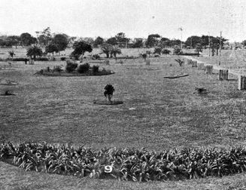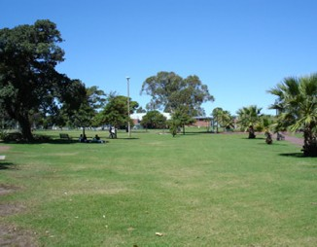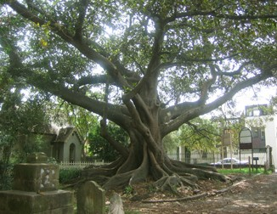

Figure 10. Enmore Park, Enmore

a Marrickville Council
5
Urban Forest Strategy

Early - Mid 20th Century

By the 1920’s and 1930’s Marrickville was heavily urbanised. Street tree planting at this time was limited to localised areas and commonly undertaken as depression labour work programs (refer Figure 9: Canonbury Grove, Dulwich Hill, c. 1936). In addition, in response to requests from residents, many of Council’s parks and reserves were created at this time, often reclaimed from post-industrial wasteland.

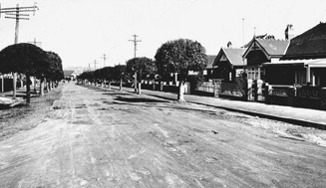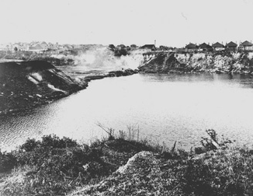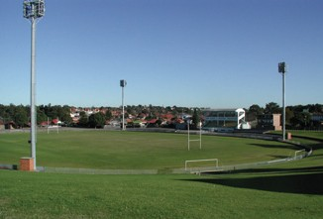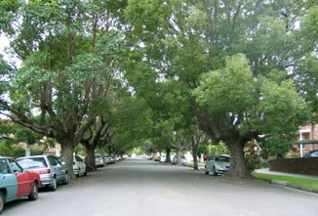
Figure 11. Henson Park , Marrickville, c. 1936 (Photographer Unknown, c. 1936, Marrickville Library Services — Local Studies Images Database 000/000858)

Figure 12. Henson Park , Marrickville

Figure 13. Canonbury Grove, Dulwich Hill, c. 1936 (Photographer Unknown, c. 1936, Marrickville Library services — Local Studies Images Database 000/000251).

Figure 14. Canonbury Grove, Dulwich Hill

The following major parks were created in the early 20th Century:
- Weekly Park 1905
- Marrickville Park early 1900’s
- Lewisham Park (now Johnson Park) 1911
- Cooks River Parks 1912-1930
(now Kendrick, Steel, Mackey, The Warrren, and Richardson Parks)
- Maundrell Park 1926
- Arlington Oval 1930’s
- Henson Park 1930’s
- Camperdown Memorial Rest Park 1950’s
- Camdenville Park 1957

Remnant plantings of the early to mid twentieth century have created a number of fine avenues and parks with grand trees that are local icons. Species commonly planted at that time include:
Brush Box Lophostemon confertus
Figs Ficus microcarpa var. hillii Ficus rubignosa
Ficus macrophylla Camphor laurel Cinnamomum camphora

Marrickville Council a
5
Urban Forest Strategy

Late 20th Century

Tree plantings of the late 20th century are predominantly associated with Council planted street trees and residential style ‘garden’ planting. Over time these plantings generally ‘filled-in’ the expansive urban subdivisions and gave many of Marrickville streetscapes a ‘treed-effect’ whilst creating a softened residential fabric at a human scale.

By 1972 Council maintained less than 1,500 street trees that were planted in the early part of that century. The few that survive today are fine large trees that contribute significantly to the urban environment (refer Figures 9 & 10: Canonbury Grove, Dulwich Hill, c. 1936 & 2005).

Between 1972 and 1992 approximately 33,500 street trees were planted in Marrickville, the main species (other than those previously listed) being:

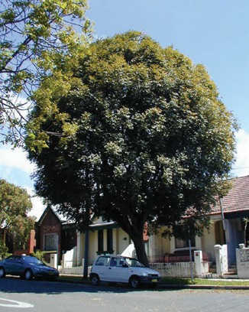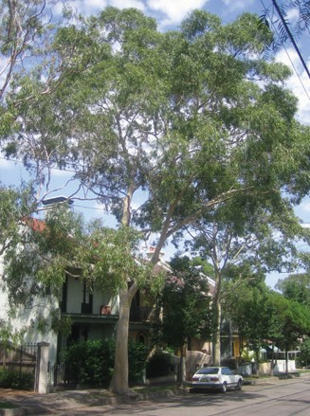
Broad-leaved Paper Bark Melaleuca quinquenervia Eucalyptus species Eucalyptus nicholii
Corymbia (Eucalyptus) citriodora| Eucalyptus scoparia
Corymbia (Eucalyptus) maculata Eucalyptus cinerea
Species causing concern
Weeping Bottlebrush Callistemon viminalis ‘Hannah Ray’
Bottlebrush Callistemon citrinus
Hibiscus Hibiscus sinensis
Jacaranda Jacaranda mimosifolia
Norfolk Island Hibiscus Lagunaria patersonia Melaleuca bracteata
Flowering Plum Prunus x blireana
Plum Pine Podocarpus elatus

In comparison to earlier planting, a larger variety of species have been used, with many chosen on the basis of trends or personal taste of the responsible Council Officers2. No approved master plan was developed to guide this work.

In the late 20th Century most of Council’s parkland works related to facility upgrades and associated planting to existing parks and reserves. Although land was far less available some new parks were created, for example:
  - Montague Gardens 1970’s
  - Louisa Lawson Reserve 1970’s
  - Mat Hogan Reserve 1980’s
  - Peace Park 1990’s
  - Sydenham Green 1990’s

These parks are regarded as quite young, and consequently, canopy trees may not yet be in a mature state.

Figure 15. Corymbia (Eucalyptus) citriodora, Brighton Street, Petersham

Figure 16. Flindersia australia, Hopetoun Street, Camperdown

2 P.7 Marrickville Street Trees Tree Policy review and Guidelines, Technical Services, Marrickville Council 1993

a Marrickville Council
5
Urban Forest Strategy

1992 - 2009

By 1992 Council’s focus was on the smooth administration of the Tree Preservation Order and the management of street trees. Adjustments to Council’s processes were formalised in response to growing pressure on the Park Section staff resources in dealing with private tree disputes and street tree liability issues (limb drop and removals etc) relating to Council trees. In addition, given the number of plantings in parks and streets, Council was now responsible for maintenance to a substantial tree asset.

This led to the preparation of the 1993 Street Tree Policy Review and Guidelines which described the existing tree asset, its condition, issues, and a recommended future policy and procedure. This report was the first comprehensive summary of the situation within Marrickville and made an effort to systematically review council’s practices. The recommendations while being current at that
time are now in need of review. The recommendations concentrated on TPO administration and the management of street trees, through the adoption by Council of the report and the 1994-1995 Street Tree implementation plan. Trees in parks, however, were generally not addressed.

The critical recommendations of the 1993 Street Tree Policy Review and Guidelines included:

Recommendation | Status | Comments
Prepare formal guidelines | prepared | Partially used/ functioning
Prepare education brochures etc | partially complete | Review required*
Define standard maintenance practices | partially complete | Review required*
Initiate basic staff qualifications | partially complete | Those implemented are functioning / others need review
Computerised Street Tree Survey | partially complete | List only —  needs review / update*
Significant Tree Register for  tree valuations | not started | Purpose and base criteria  need clarification
Street Tree Masterplan and species list | partially complete | List only needs review*
Accelerated policy of mature street tree removals | not started | Action required
Systematic street tree planting program | partially complete | Needs review*
* incorporated in MUFS

Marrickville Council a
5
Urban Forest Strategy

Street tree planting became Council’s main focus. Between 1993 and 2003 Council’s Business Units planted and maintained approximately 9,000 new trees.

The species mainly planted since 1993 are: White Cedar Melia azedarach
Blueberry Ash Elaeocarpus reticulatus
Fire Wheel Tree Stenocarpus sinuatus
Crepe Myrtle Lagerstroemia indica (cultivars)
Lilly Pilly Acmena smithii
Ornamental Pear Pyrus ussuriensis
Water Gum Tristaniopsis laurina
Evergreen Ash Fraxinus griffithii
Robinia pseudoacacia ‘Frisia’ Michelia doltsopa
Ivory Curl Tree Buckinghamia celsissima Harpulia pendula
Lilly Pilly Syzigium luehmannii
Lilly Pilly Syzigium paniculata
Bottlebrush Callistemon spp
Melaleuca bracteata ‘Revolution Green’ Ornamental Cherry Prunus spp.
Bacon & Egg Tree Gordonia axillaris Tuckeroo Cupaniopsis anacardioides

Figure 17. New street tree planting along Crystal Street, Marrickville

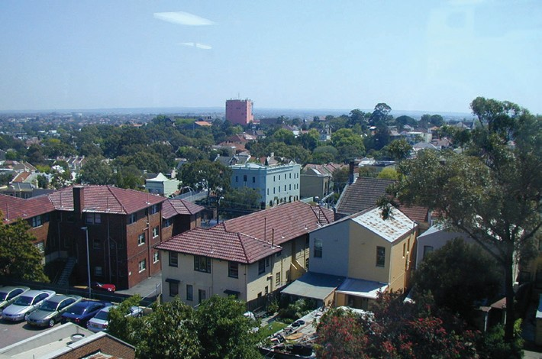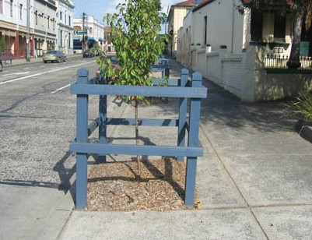

Figure 18. Trees in public and private spaces

a Marrickville Council
5
Urban Forest Strategy

Current Situation

The contemporary Marrickville skyline is a mosaic of industrial, residential and commercial buildings integrated with the urban forest. It is punctuated by isolated large mature ‘sentinel’ conifers, palms and flowering trees which are mostly located on private property. Most streets within the LGA include a high proportion of mature trees which make a substantial contribution to landscape amenity. Accordingly, there is significant community concern over any potential tree loss.

Council Owned and Managed Trees

Streets

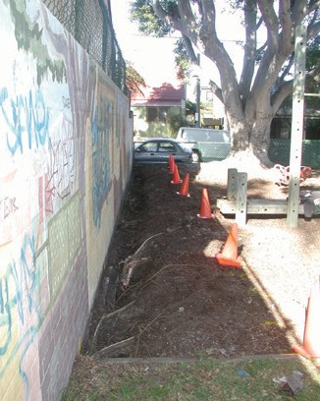

Figure 19. Ficus microcarpa var ‘Hilli’ at Collyer Playground, Newtown
Currently there are in the order of 20,000 street trees in Marrickville, although since 1972, Council has planted approximately 42,500 street trees. This indicates the substantial attrition of trees and the continual fluctuation in the total number of trees given a potentially high mortality rate of young trees, generally short life spans, and substantially difficult growing conditions.

Given the heavily urbanised nature of some suburbs (and the incremental nature of tree planting generally), not all areas or streets have trees. Tree planting in some industrial areas and narrow residential streets will remain problematic until traffic and pedestrian management issues are resolved.

Many monoculture avenues were planted in the period following 1972. A substantial number of these are relatively short lived trees or large shrub species planted under power-lines and in narrow streets. Today, much of this plant stock is of a similar age and is reaching the end of its life expectancy. In the stressful urban environment this may be shorter than otherwise expected and is heralded by the increased occurrence of disease and pest attack of the plant stock. Also, the naïve selection and planting of inappropriate native species during this period (eg. Eucalyptus nicholli, Eucalyptus scoparia) has led to many of these trees requiring frequent extensive maintenance or removal.

Other species planted prior to 1972 are over mature or unhealthy due to poor management practices and stressful urban conditions. Consequently, there is a need for a prioritised, systematic tree removal and replacement strategy. This will have immediate visual, environmental, and management implications. A summarised view of the existing street tree asset is illustrated graphically in Figure 15.

Marrickville Council a
5
Urban Forest Strategy

Parks

Although it is estimated that there are between 6,000 and 10,000 trees in Marrickville’s parks, reserves and natural areas, the exact number and condition of these trees is unknown.

Trees in parks generally have longer life spans and better growing conditions, consequently tree health and condition is usually more stable.

Losses are currently not great, although a number of Marrickville’s parks are now at an age where tree senescence is common. For example, a Ficus rubiginosa (Port Jackson Fig) in Enmore Park is in serious decline and the group of Ficus microcarpa var ‘Hilli’ (Hills Weeping Fig) at Collyer Playground, Newtown, had a safe life expectancy of approximately 4-7 years (removed September 2005).

Sustainable vegetation management for Council’s parks is currently not addressed. To date Marrickville Council has had no implementation strategy for the management of Council’s trees in parks. Plans of Management do not necessarily survey all trees or provide condition reports. The reliance has been on annual tree maintenance to monitor risks, and park or playground facility upgrades to provide new planting. The Marrickville Urban Forest Strategy 2010 proposes to define a strategy for the management of significant trees in Council’s parks. The strategy has been developed concurrently with the Parks Biodiversity Strategy (currently under development).

Private Trees

Today, Marrickville has blocks of ‘green space’ with mature canopy trees located consistently throughout area (although these are often located on private land such as churches and schools). These sites form a substantial portion of the overall percentage tree canopy of Marrickville and contribute substantially to the visual character of Marrickville and provide vegetation relief as viewed from the public streetscape.

A point of great concern to Council is the potential decrease in large canopy trees on private property and the change to the character of Marrickville’s built environment should the large scale trees on private property be removed over the next 15 to 20 years without a formal mechanism of replacement. The loss of trees in private gardens is commonly due to:

- 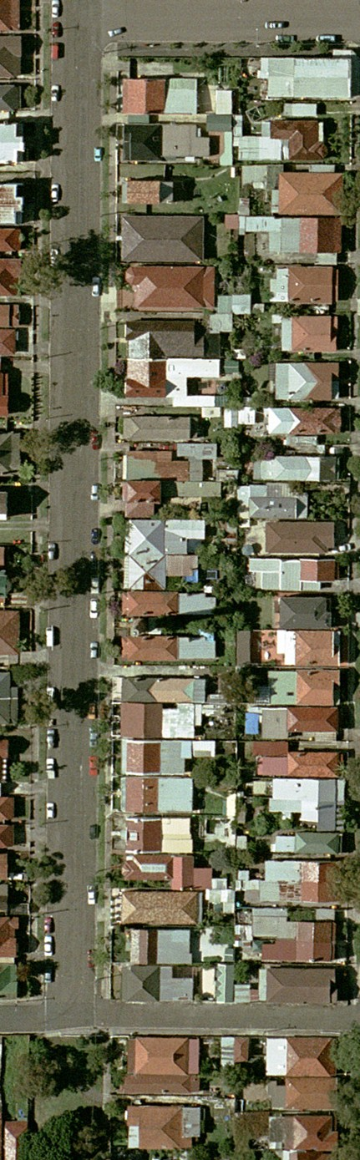direct removal: to make way for increased urban consolidation,
- incremental loss: as urban areas become more dense over time, existing trees become stressed and are removed on application due to risk management,
- senescence and removal: due to old age and death, there is a natural attrition of the tree population, and
- use of inappropriate planting by residents, which are a potential future maintenance problem.

Figure 20. Aerial photo of Day Street, Marrickville

- Marrickville Council
5
Urban Forest Strategy

Urban consolidation is limiting opportunity to plant trees on private land, in time the overall canopy cover of the LGA will be significantly reduced. To compensate for this change Council believes there needs to be a strategy in place to promote the maintaining and/ or replenish large tree canopy cover.

Small and medium sized trees (often exotic) are commonly planted as a requirement of residential developments, and by private citizens in existing gardens these trees contribute little to the canopy cover of the LGA.

Marrickville Council is currently undertaking a major review of its planning controls as a response to the NSW State Government’s planning reform program. The review will result in the preparation of a new comprehensive local environmental plan (LEP) and consolidated development control plan (DCP) for the Marrickville local government area. The existing
Marrickville Tree Preservation Order 2007 will be dissolved and all tree management provisions will be included in the new planning instruments. A working draft of the Marrickville LEP2010 has been adopted by Council. This will be available for public exhibition by late 2010 and it is anticipated that gazettal will in 2011.

GLOSSARY
Marrickville Council b
Urban Forest Strategy
5

Acronyms:
TMO = Tree Management Officer TPO = Tree Preservation Order DCP = Development Control Plan LEP = Local Environment Plan LGA = Local Goverment Area

Age Classes:
Young Tree: Recently planted tree to 5 years Established Tree: 5-10 years
Mature Tree: Tree reaching its mature height greater than 10 years Senescence Tree: Tree past its useful life span which is in decline

Amenity tree:
Trees planted to improve environmental or landscape quality (rather than naturally occurring vegetation or ecological planting)

Arboriculture:
Study and cultivation of woody plants predominantly trees

Council Tree:
Trees owned and / or managed by Council (see private trees) - generally in parks and streets

Cyclic Tree Maintenance:
The programmed annual maintenance to trees (usually undertaken in a systematic sequence)

Exotic tree:
Species not originating from Australia

Important Trees:
Trees which make a major contribution to the environment on the basis of natural or heritage factors or through a major contribution to the amenity of the place.

Indigenous tree:
Species that originates from the immediate area/region.

Life Cycle Planning:
Planting, life management and replacement of trees as a planned approach to trees in the built environment

- Marrickville Council
5
Urban Forest Strategy

Marrickville:
The current Local Government Area of Marrickville

Native tree:
Species originating from Australia

Private tree:
Trees located on private land - managed privately and regulated by Council

Reactive Tree Maintenance:
Operations carried out on the basis of complaints or applications by the public

Remnant Tree/Growth:
Tree/ group of trees, which is/are of the original vegetation of the area or is/are regrowth from the natural vegetation disturbance (same genetic material)

Succession Planning:
Planning replacement of trees within the landscape when older trees are removed due to old age

Sustainable:
Is the ability for a asset/resource to continue within an established framework of conditions (usually measured across environmental, social and economic considerations)

Tree Assessment Methods:
SULE — Safe Useful Life Expectancy
Hazard Assessment - Assessment of trees based on structural defects
Thyer Method — method of valuation of trees based on their age, condition and significance

Tree Size:
Small tree: 5-8m in height
Medium tree 8-15m in height
Large tree: greater than 15m in height

REFERENCE LIST
Marrickville Council c
Urban Forest Strategy
5

Richard Cashman and Chrys Meader, Marrickville Rural Outpost To Inner City, Alexandria, 1990.

Chrys Meader, Richard Cashman, Anne Coralan, Marrickville People and Places, Sydney, 1994.

Technical Services Division, Marrickville Street Tree Policy Review and Guidelines, 1993 (unpublished).

Marrickville Council, Marrickville Local Environmental Plan 2001, Consolidated 26 October 2004.

Web References:

www.marrickville.nsw.gov.au (Marrickville Library Services Local Studies Images Database).

www.austlii (Australasian Legal Information Institute, being a joint facility of UTS and UNSW Faculties of Law).

d Marrickville Council
5
Urban Forest Strategy

Tree Law Acts and Regulation Relating to Tree Management in Marrickville Municipality.

Common law allows a land owner to abate a nuisance. The law permits a land owner to prune a neighbour’s tree where the branches overhang a common boundary and are considered to be
affecting the enjoyment of the property. Generally the pruning is only permitted on that part of the tree that overhangs, and trespassing onto the neighbouring property to carryout the work is not permitted. Additionally any damage that may occur to the neighbour’s property in the process or as a result of the pruning may make the perpetrator liable for that damage. Likewise a property owner whos property is sustaining damage from a tree has the legal right to recover costs for the damage if it is proven that the tree is the cause of the damage.

The Environmental Planning and Assessment Act 1979 (EP&A Act) Section 26(e) empowers Council through environmental planning instruments to protect or preserve trees or vegetation, removing the common law right to abate the nuisance of an overhanging branch. The EP&A Act does not remove the right to recover the cost due to any damage that may occur due to the tree. Currently Council enacts this power through Clause 56 of the Council's Local Environmental Plan (LEP) 2001 adopting Clause 8 of the EP&A Act Model Provisions 1980 within the LEP. Recent changes to the EP&A Act will require Council to review how the TPO is enacted.

The Model Provisions Section 8 (2) dictates

“a tree preservation order may prohibit the ring-barking, cutting down, topping, lopping, removing, injuring or wilful destruction of any tree or trees specified in the order except with the consent of the council and any such consent may be given subject to such conditions as the council thinks fit. Persons who contravene or causes or permits to be contravened shall be guilty of an offence.”

Council does issue Penalty Infringement Notices for breaches of the TPO where th breach does not warrant prosecution through the courts.

Marrickville Council’s Tree Preservation Order (TPO) does define;
- what constitutes a tree within the Marrickville Local Government Area,
- what trees are covered by the TPO and those that are not,
- what work is restricted on or around trees, and
- what information is required by an application for a Council officer to undertake an inspection.

Marrickville Council d
5
Urban Forest Strategy

Council’s TPO restricts tree owners and neighbours from undertaking any work including excavation on and around a tree without the signed approval of both Council and the owner of the tree.

The need for approval from the owner of the tree for works to be undertaken often leads to disputes between neighbours. Tree management staff are regularly requested to intervene in such disputes. However Council officers cannot force a tree owner to undertake works unless the tree is a significant risk to the public or property. The majority of issues between neighbours and trees are considered a civil matter. When such cases arise residents are informed to seek legal advice or mediate with the aid of the Community Justice Centre to resolve the dispute. Often disputes
between neighbours are a result of a break down in communication and tree issues may be a small component of the larger issue.

Generally tree management staff will not approve works on a tree without the owners consent. Liability issues arise where tree management staff approve such work and that work cannot be undertaken to an acceptable industry practice or to the Australian Standards for the Pruning of Amenity Trees (AS 4373-1996).

Trespass is also an issue when approving works on a tree not owned by the applicant. The growth habit and the methods used to access a tree in restricted environments do not allow an inspecting officer to approve such work without exposing the officer to trespasses laws.

Under the Access to Neighbouring Land Act 2000, residents can seek approval from the local magistrate to undertake works within an adjacent property. Where a resident has gained the magistrate’s approval, tree management staff can approve the pruning of a tree where the work is to be undertaken to AS 4373-1996 industry best practice and by a suitably qualified Arborist.

Development applications involving trees are managed through the LEP process. Council’s Development Assessment section refers development application to the TMO when it is established there are tree management issues within or adjacent to the site. Trees are assessed in consideration of the TPO, and Council has the opportunity to set stringent controls for tree protection, maintenance and / or replacement. Not adhering to the control measures is an offence and on the spot penalty notices (currently $600) can be issued or the matter taken to court.

d Marrickville Council
5
Urban Forest Strategy

There are four NSW acts that override Council’s TPO;
- Electrical Supply Act 1995, Section 48 of the act states if the network operator believes a tree “could destroy, damage or interfere with its electrical works” or “cause a bush fire or potential risk to public safety” then the network operator can issue a written notice to the tree owner requiring them to remove or trim the tree. In circumstances where the works are not undertaken and the tree was planted after the installation of the electrical infrastructure, the Network operator may undertake the works and recover the cost from the tree owner. To date Energy Australia has not undertaken this option, with a significant cost saving to Council. This section does not apply to any trees subject to the Heritage Act 1997, National Parks and Wildlife Act or other similar law.
- Sydney Water Act 1994 Section 46 of the act is similar to section 48 Electrical Supply Act only it relates to Sydney Water infrastructure.
- Roads Act 1993 Section 88 of the act states “A roads authority may, despite any other Act or law to the contrary, remove or lop any tree or other vegetation that is on or overhanging a public road if, in its opinion, it is necessary to do so for the purpose of carrying out road work or removing a traffic hazard.”

Other Acts that apply to tree management and offer a degree of protection and enforcement include:
- Local Government Act 1993 (LGA), Section 629 of the act in reference to a public place states “A person who, without lawful excuse, wilfully or negligently injures, damages
or unnecessarily disturbs any plant, animal, rock or soil in a public place is guilty of an offence.” The offence carries a $220 on the spot penalty notice. Additionally an offence may occur if a persons acts contrary to notices erected by council (ie parking on the grass contrary
to a sign prohibiting that parking), the offence is a $110 penalty notice — for contravening a sign.
Section 124 Order 21 of the LGA allows Council to issue orders to ensure the land or premises are kept in a safe or healthy condition. This order is used in circumstances where it is evident the tree poses a risk to the adjoining properties and is for example, dead, unstable or damaged. A $330 penalty notice applies for failing to adhere to the order in this case.
- Roads Act 1993 Section 138 (1c) of the Act states “a person must not remove or interfere with a structure, work or tree on a public road otherwise with the consent of the appropriate roads authority”. Offences against this section of the Act are to be dealt with before a
Local Court.
Section 107 of the Roads Act authorises a roads authority to order an obstruction or encroachment to be removed from the road. This section is only enforceable if the obstruction or encroachment is not authorised by or under this or any other Act.
- Electricity Supply (General) Regulation 2001 section 102, identifies a service provider (energy provider) “must not remove any tree, or trim any tree in a way that substantially damages the tree, unless:

Marrickville Council d
5
Urban Forest Strategy

- it is of the opinion that it is necessary to do so to protect its powerlines or the safety of persons or property under or near its powerlines, and
- it has considered alternative methods and is of the opinion that none of those methods are feasible in the circumstances (including economically feasible), and
- the service provider is acting in accordance with a tree management plan.”

Section 103 of the regulation identifies a service provider may establish a tree management plan however it need to be prepared in consultation with councils and the public
- Heritage Act 1977 Section 57 states a person must not damage or destroy any tree or vegetation where an interim heritage order or listing on the State Heritage Register applies.
- Fisheries Management Act 1994 Section 205 states except under the authority of a permit issued by the Minster a person must not harm any such marine vegetation (mangroves) in a protected area (described as all public land submerged by water whether permanently or intermittently).

- Crimes Act 1900 Section 140 states it is a punishable offence to steal, destroy or damage with the intent to steal any part of a tree, including deadwood (Section 518) or be in the possession (section 517) of a tree growing in a park, garden and avenue.

