CHILDREN’S
BOOK WEEK 2020
‘CURIOUS CREATURES, WILD MINDS’ LIBRARY WRITING COMPETITION

Entry Form Open to children from grades 3-6

Write a short story about your favourite curious creature, real or imaginary.
There are lots prizes to be won!
Name: Age: School: Class: Phone: Email:
This competition managed by Inner West Libraries. Closes Friday 9 October 2020. Winners will be notified by Monday 19 October 2020.
Extra forms, prize details, terms and conditions at www.innerwest.nsw.gov.au/BookWeek Completed entry forms can be submitted at any Inner West Library or
email to Library.Promotion@innerwest.nsw.gov.au
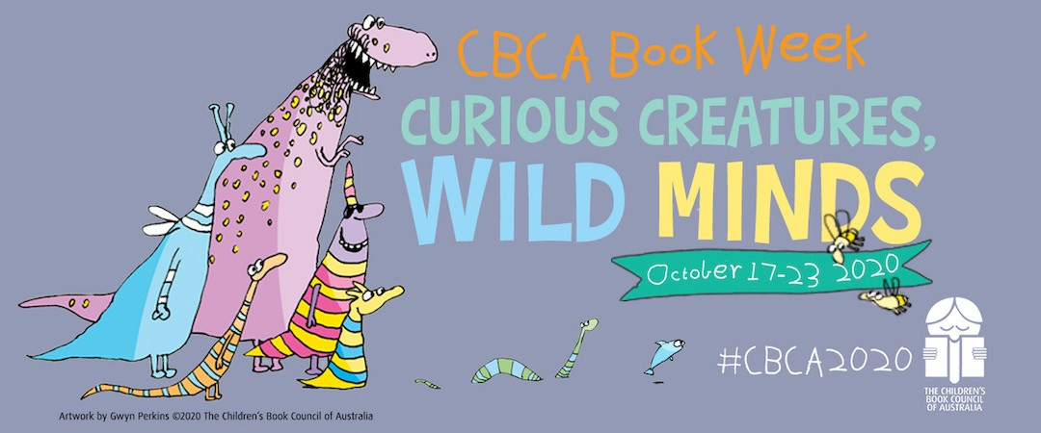

‘CURIOUS CREATURES, WILD MINDS’ LIBRARY WRITING COMPETITION
Write a short story about your favourite curious creature, real or imaginary.

